Futures Definition
Buying a futures contract on say, lean hogs (pigs), is just like buying the pigs right now at the market, except that you don’t actually pay anything to the seller right now, and he doesn’t give you the pigs yet either.
Buying a futures contract on pigs commits you to buying the pigs on the maturity date at the locked-in futures price.
What’s confusing about futures is that there’s two assets - the futures contract itself, and the underlying asset (the pigs) that it’s written on.
All derivatives are like this - their value derives from some underlying asset.
Last modified 19.1.17 KW
Long and Short
Buying futures is called being long futures.
Selling futures is called being short futures.

For every buyer there’s a seller
The number of long futures contracts equals the number of short futures contracts.
If you long a future, your counterparty is short the future.
If you short a future, your counterparty is long the future.
Futures are a zero-sum game: the winner wins at the expense of the loser.
Futures Payoff
Buying a futures contract (long future) locks in a price now (t=0) for you to buy the underlying asset (S) for the locked-in futures price (K) at maturity (t=T).
The payoff of a long futures (LF) contract at maturity is:
$$f_{T,LF}=S_{T}-K_{T}$$
The payoff of a short futures (SF) contract at maturity is the opposite:
$$f_{T,SF}=-f_{T, LF}=-\left(S_{T}-K_{T}\right)=K_{T}-S_{T}$$
Selling a future (short future) gives you the obligation to sell the underlying asset (S) to the long future trader for the locked-in futures price (K) at maturity (t=T).
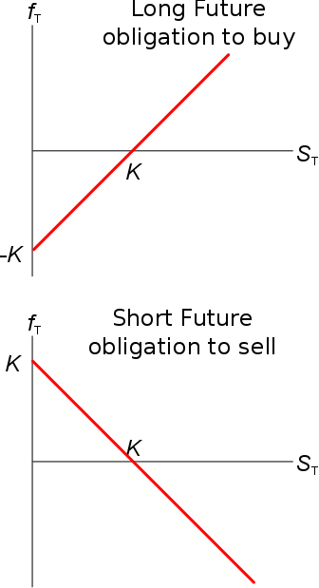
Cash and Physical Settlement
Many agricultural futures are physically settled (or deliverable), for example, live cattle futures on the CME.
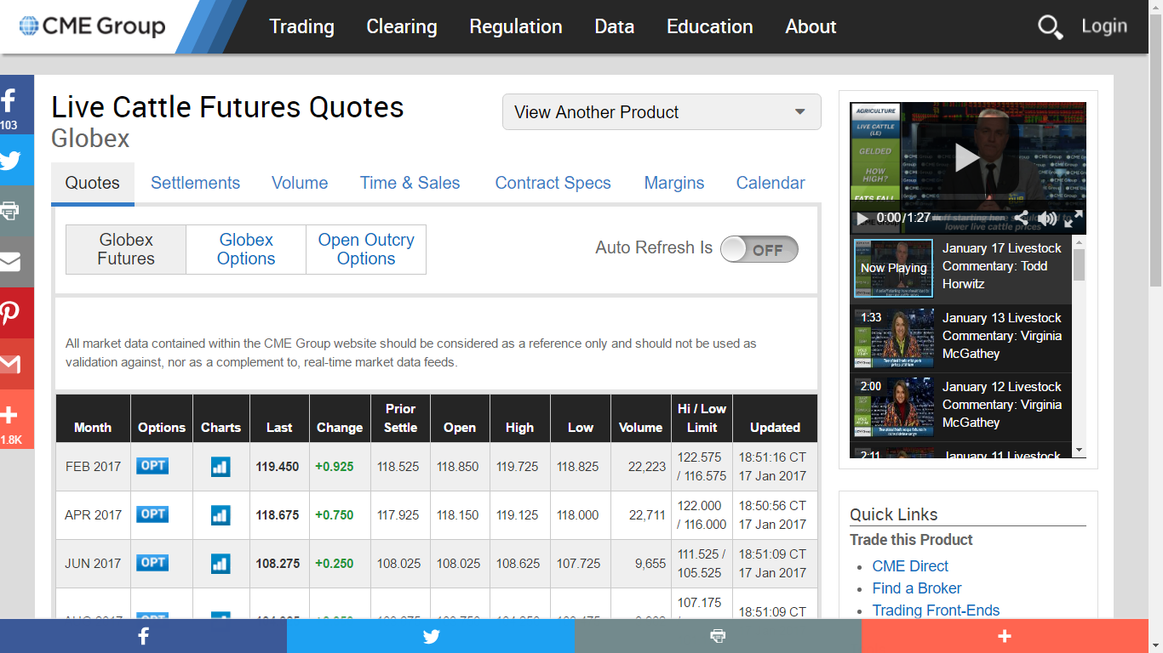
If you long one live cattle future then you have locked-in to buy 40,000 pounds (18 metric tons) of cattle at the futures price K, which was 119.450 cents per pound at market close on 17 Jan 2017, maturing in Feb 2017.
However, these days most futures contracts are cash-settled (also called financially settled), so the loser pays the winner the difference between the locked-in price K and the current underlying asset price S.

Futures: Locked-in physical trades or Bets?
Futures can be thought of in two different ways: as locking in to buy or sell something or as a bet.
- Buying (long) futures can be thought of as:
  - locking-in to buy the underlying asset for the futures price;
  - betting that the underlying price will rise more than the market expects.
- Selling (short) futures can be thought of as:
  - locking-in to sell the underlying asset for the futures price;
  - betting that the underlying price will fall more than the market expects.
Physically delivered agricultural futures are best thought of as locking-in to buy or sell the underlying physical asset, such as live cattle.
But many futures are written on things that cannot be physically owned. Interesting examples are weather futures.
A person who buys a US New York Heating Degree Day (HDD) future cannot actually buy a hotter temperature in New York. This trader must be betting that the temperature in New York will be hotter than the rest of the market thinks.
Perhaps she is a speculating scientist who anticipates faster than expected global warming and wants to make money from her prediction.
Or perhaps she is a hedging trader. For example, a New-York office tower manager who pays large air-conditioning electricity bills when it’s hot. The money she loses on larger-than-expected electricity bills could be offset by the gains on her long futures.

Futures Price
The futures price quote $F_{T}$ is equal to the expected price of the underlying asset price at that time T, less any storage costs.
Using continuously compounded returns $(r_{cc})$, the futures price is:
$$F_{T}=E\left[S_{T}\right]$$
$$=S_{0}.e^{(r_{total,cc}-r_{div,cc}+r_{cost,cc}).T}$$
Where: $S_{0}$ is the underlying asset price now;
$E\left[S_{T}\right]$ is the expected underlying asset price at time T;
$r_{total}$ is the total required return of the underlying asset;
$r_{div}$ is the dividend yield (or other income return such as rent or interest) of the underlying asset;
$r_{cost}$ is the storage cost of the underlying asset given as a proportion per period, think of it as a negative dividend yield;
$T$ is the time until maturity.

Using effective returns $\left(r_{eff}\right)$, the futures price is:$$F_{T}=E\left[S_{T}\right]$$
$$=S_{0}.{\left(1+r_{total,eff}-r_{div,eff}+r_{cost,eff}\right)}^{T}$$

Price quote ‘F’ versus the Locked-in price ‘K’
The futures price quote $F_{T}$ changes all the time with changes in $S$, $r$ and $T$.
Once the futures price is locked-in and written down on the futures contract, it’s designated $K_{T}$ and called the ‘locked in futures price’.
So the ‘futures price quote’ $F_{T}$ will become the legally binding ‘locked-in futures price’ $K_{T}$ when you agree to enter into the futures contract.
The locked-in futures price $K_{T}$ must be paid by the long futures trader to the short futures trader at maturity $T$.
When you look up prices on the futures exchange, such as the CME, you will see current futures price quotes (F), not the old locked-in futures prices (K) since nobody is interested in them except the parties who agreed to that futures contract in the past.

Price quote ‘F’ versus Payoff at maturity ‘f’
$F_{T}$ is the futures price quote for a future that matures at time T.
$f_{t}$ is the future contract’s payoff at time t.
$f$ is also often used to denote the payoff from other types of derivatives, such as the payoff at maturity from being long a call option $(f_{T LC})$, short a put option $(f_{T SP})$ or long a future $(f_{T LF})$.

Futures Profit
The profit at maturity $(π_{T})$ on a futures contract is exactly the same as the payoff at maturity $(f_{T})$ since nothing is paid to enter into the future at time zero.
$$π_{T,LF}=f_{T, LF}=S_{T}-K_{T}$$

