Futures Valuation
Remember that the payoff at maturity (T) of a long futures contract is: $f_{T,LF}=E[S_{T}]-K_{T}$
So the current (t=0) value of a long futures contract is the present value of this payoff at maturity. With continuously compounded rates $r_{cc}$:
$$f_{0,LF}=\frac{f_{T,LF}}{e^{r_{total,cc}.T}}=\frac{E[S_{T}]-K_{T}}{e^{r_{total,cc}.T}}$$
Similarly with effective rates $r_{eff}$:
$$f_{0,LF}=\frac{f_{T,LF}}{{\left(1+r_{total, eff}\right)}^{T}}=\frac{E[S_{T}]-K_{T}}{{\left(1+r_{total, eff}\right)}^{T}}$$
Last modified 13.3.19 KW
If there’s no storage costs and the underlying asset price is expected to grow by the total required return ($r_{total,cc}=r_{capital,cc}$, which means there’s no dividends), then:
$$f_{0,LF}=\frac{E[S_{T}]}{e^{r_{total,cc}.T}}-\frac{K_{T}}{e^{r_{total,cc}.T}}$$
$$=\frac{S_{0}.e^{r_{total,cc}.T}}{e^{r_{total,cc}.T}}-\frac{K_{T}}{e^{r_{total,cc}.T}}$$
$$=S_{0}-\frac{K_{T}}{e^{r_{total,cc}.T}}$$

Futures have Zero Value Initially
The initial value of a futures contract is usually zero.
This makes sense because you don’t pay anything for the future at the start, regardless of whether you’re long or short.
Another way of looking at it: If the future had a positive value to you, then it would have a negative value to your counterparty, so your counterparty shouldn’t have agreed to it!
It’s only fair if the future is worthless when it’s first agreed to.
Mathematically: When the contract is first signed (at t=0), the locked-in futures price $K_{T}$ equals the expected stock price at maturity $E[S_{T}]$ (pretend there’s no storage costs), so $K_{T}=E[S_{T}]$. Therefore the initial value of the futures contract is:
$$f_{0,LF}=\frac{f_{T,LF}}{e^{r.T}}=\frac{E[S_{T}]-K_{T}}{e^{r.T}}=\frac{E[S_{T}]-E[S_{T}]}{e^{r.T}}=\frac{0}{e^{r.T}}=0$$

This explains why futures are not recorded on the balance sheet by accountants when they’re first agreed to - the contracts are worthless.

Calculation Example: Futures Valuation
Question: You bought the 2 years futures contract from the previous example at a futures price of $6.05.
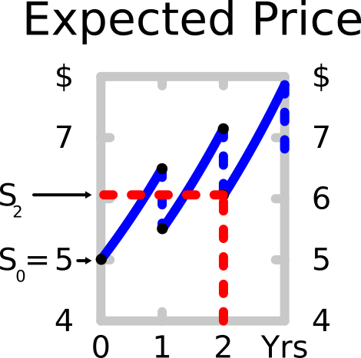
At the moment that you bought the futures contract (at t=0), what was its value?
Answer: Futures contracts have zero initial value. $f_{0,LF}=0$

Question: One year later, just after the $1 dividend at that time was paid, the underlying stock price is actually $7.
The dividend at time 2, one year from now, is still expected to be $1.10 and this dividend will continue to grow at 10% pa. The required total return of the stock is still 30% pa. All returns are given as effective annual rates.
What is the value of your long futures contract at this time t=1?

Answer: The capital return will no longer be 10% pa like it was before when the price was $5 and the dividend yield was 20% pa ($=r_{div, eff}=\frac{C_{1}}{S_{0}}=\frac{1}{5}=0.2$).
The dividend yield will now be:
$$r_{div, eff}=\frac{C_{2}}{S_{1}}=\frac{1.1}{7}=0.157142857$$
The capital return will therefore be:
$$r_{total, eff}=r_{div, eff}+r_{cap, eff}$$
$$0.3=0.157142857+r_{cap, eff}$$
$$r_{cap, eff}=0.142857143$$

To calculate the value of the long futures contract at t=1:
$$f_{0,LF}=\frac{f_{T,LF}}{{\left(1+r_{total, eff}\right)}^{T}}=\frac{E[S_{T}]-K_{T}}{{\left(1+r_{total, eff}\right)}^{T}}$$
$$f_{1,LF}=\frac{E[S_{2}]-K_{2}}{{\left(1+r_{total, eff}\right)}^{1}}$$
$$=\frac{S_{1}{\left(1+r_{cap,eff}\right)}^{1}-K_{2}}{{\left(1+r_{total, eff}\right)}^{1}}$$
$$=\frac{7{\left(1+0.142857143\right)}^{1}-6.05}{{\left(1+0.3\right)}^{1}}$$
$$=1.5$$

Alternatively, grow the stock price at time 1 by the total return ($r_{total, eff}$) and then subtract the dividend at time 2.
The dividend at time 2 will be:
$$C_{2}=C_{1}{\left(1+r_{cap,eff}\right)}^{1}=1{\left(1+0.1\right)}^{1}=1.1$$
$$f_{1,LF}=\frac{E[S_{2}]-K_{2}}{{\left(1+r_{total, eff}\right)}^{1}}$$
$$=\frac{(S_{1}{\left(1+r_{total}\right)}^{1}-C_{2})-K_{2}}{{\left(1+r_{total, eff}\right)}^{1}}$$
$$=\frac{(7{\left(1+0.3\right)}^{1}-1.1)-6.05}{{\left(1+0.3\right)}^{1}} =1.5$$

Calculation Example: Futures Pricing
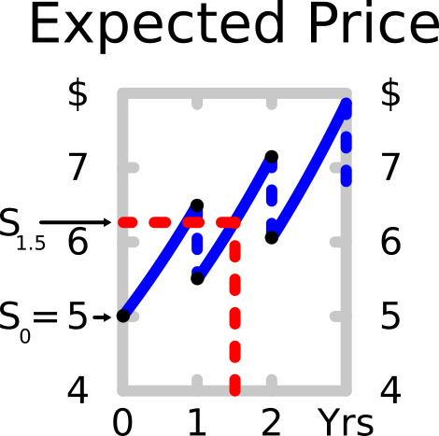
Question: What would be the 1.5 year futures price for a contract written on the same stock as before?
The stock has a current price of $5. Its next annual dividend of $1 will be paid in one year and the dividend will continue to be paid annually forever, growing at 10% pa.
The stock’s required total return is 30% pa. The perpetuity equation is suitable for valuing this share.
Answer: The futures price in 1.5 years is slightly harder to calculate since it is not a whole number of years away and the dividend is not continuous, so we can’t just do:
$$F_{1.5}=E\left[S_{1.5}\right]≠5×{\left(1+0.3-0.2+0\right)}^{1.5}$$
We have to grow the current stock price by the expected return between dividend payments which is the total return of 30% pa, then subtract the dividend of $1, then grow the price again by that total return for half a year.
$$F_{1.5}=(S_{0}{\left(1+r\right)}^{1}-C_{1}){\left(1+r\right)}^{0.5}$$
$$=(5{\left(1+0.3\right)}^{1}-1){\left(1+0.3\right)}^{0.5}$$
$$=6.270964838$$

