Long Call Option Payoff
Buying a call option (long call) gives you the right but not the obligation to buy the underlying asset (S) if you want for the exercise price (K or X) at maturity (T).
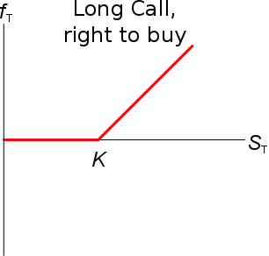
The payoff of a long call option contract at maturity is:
$c_{T, long}=max(S_{T}-K_{T}, 0)$
Last modified 21.2.17 KW
Short Call Option Payoff
The payoff of a short call option contract at maturity is the opposite:
$c_{T, short}=-c_{T, long}=-\max\left(S_{T}-K_{T}, 0\right)$
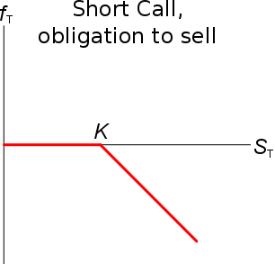
Selling a call option (short call) gives you the obligation to sell the underlying asset (S) to the long call trader for the exercise price (K or X) at maturity (t=T) if the long call trader chooses to exercise.
Of course the long trader will only exercise if the call is ‘in the money’ $(S_{T}>K_{T})$ which means that you’ll lose money.
If you’re short a call, you can say that you:
- Have sold the right for the long trader to buy the underlying asset from you if he wants;
- Have the obligation to sell the underlying asset to the long call trader if he wants to buy it.
Being short a call option means that you will either have a negative payoff at maturity if the call option is exercised, or you’ll lose nothing if it’s not exercised.
Either way, as a short call trader will have already gained the call option price (or premium, $c_{0}$) which you were paid at the start.
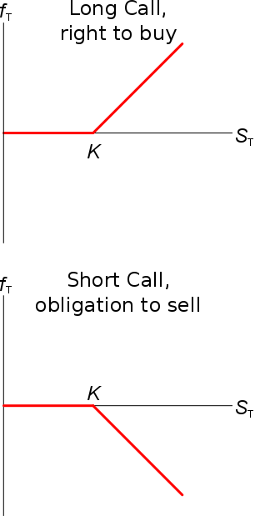
Call Option Price Now
The call premium or price now (t=0) is usually designated '$c_{0}$' (or $f_{0LC}$) and can be calculated using the Black-Sholes or binomial option pricing methods.
These methods are quite complicated but their aim is to find the present value of a long call’s payoff:$$c_{0long}=\frac{c_{Tlong}}{e^{r.T}}$$
$$=\frac{max(S_{T}-K_{T}, 0)}{e^{r.T}}$$
Call options’ prices before maturity are always greater than zero: $p_{0long}>0$
This is because there is some chance that the underlying asset price $S$ could be ‘in the money’ at maturity so $S_{T}>K_{T}$.

Note that $S_{T}$ is unknown right now (t=0), it’s a variable. This means that $c_{0long}$ is also a variable.
So we can’t actually find the current call option price using this equation. That’s why option pricing is so hard!
Later on we’ll see how to use Binomial Trees and the Black Scholes Merton Model to price options.

