FINAL EXAM – AUTUMN/1H SESSION 2016
School of Business

Complete your details in this section when instructed by the Exam Supervisor at the start of the exam.
You should also complete your details on any answer booklets provided.
STUDENT SURNAME:
STUDENT FIRST NAME:
STUDENT ID:

EXAM INSTRUCTIONS
Read all the information below and follow any instructions carefully before proceeding.
This exam is printed on both sides of the paper – ensure you answer all the questions.
You may begin writing when instructed by the Exam Supervisor at the start of the exam.
Clearly indicate which question you are answering on any Examination Answer Booklets used.
UNIT NAME: | Derivatives
UNIT NUMBER: | 200079
NUMBER OF QUESTIONS: | Part A has 5 questions, Part B has 5 questions.
VALUE OF QUESTIONS: | Part A questions are worth 2 mark each. Part B questions are worth 8 marks each. This gives a total of 50 marks.
ANSWERING QUESTIONS: | Part A: Answer multiple choice questions on the scan sheet provided.  Part B: Answer all other questions on the exam paper itself.
LECTURER/UNIT COORDINATOR: | Keith Woodward and Maria Varua
TIME ALLOWED: | 2 hours | TOTAL PAGES: | 14

RESOURCES ALLOWED
Only the resources listed below are allowed in this exam.
Any calculator which has the primary function of a calculator is allowed. For example, calculators on mobile phones or similar electronic devices are not allowed.

DO NOT TAKE THIS PAPER FROM THE EXAM ROOM

This page intentionally left blank

Part A
Question 1: Which of the following derivative instruments has a non-zero value when it is first issued?
(a) Call option.
(b) Futures contract.
(c) Forward contract.
(d) Forward rate agreement.
(e) Interest rate swap.

Question 2: Which of the following derivative instrument positions does NOT require a margin account?
(a) Long futures contract.
(b) Short futures contract.
(c) Long call option.
(d) Short call option.
(e) Short put option

Question 3: Which of the following best describes a long position in an American-style put option?
(a) The right to buy the underlying asset for the exercise price at the option’s exercise date.
(b) The right to sell the underlying asset for the exercise price at the option’s exercise date.
(c) The right to buy the underlying asset for the exercise price at any time on or before the option’s exercise date.
(d) The right to sell the underlying asset for the exercise price at any time on or before the option’s exercise date.
(e) The obligation to buy the underlying asset for the exercise price at the option’s exercise date.

Question 4: Which of the following statements about fixed-for-floating interest rate swaps is NOT correct?
(a) The principals are exchanged at the beginning and end of the swap.
(b) The fixed and floating payments throughout the life of the swap are netted.
(c) The fixed payments are called the ‘fixed leg’, and the floating payments are called the ‘floating leg’ of the swap.
(d) If the yield curve is normal, then at the beginning of a swap’s life the fixed leg payments are expected to be greater than the floating leg payments.
(e) If the yield curve is normal, then at the end of a swap’s life the floating leg payments are expected to be greater than the fixed leg payments.

Question 5: How is the value of a fixed-for-floating swap best calculated? Assume that the bonds mentioned below on which the swaps are based have $100 face values and have the same maturity as the swaps.
The value of a swap to the party paying the floating leg is equal to the swap’s notional principal divided by $100, multiplied by, in brackets, the:
(a) Price of a fixed coupon bond plus the price of a floating rate bond.
(b) Price of a fixed coupon bond less the price of a floating rate bond.
(c) Price of a fixed coupon bond multiplied by the price of a floating rate bond.
(d) Price of a fixed coupon bond divided by the price of a floating rate bond.
(e) Face value of a fixed coupon bond plus by the face value of a floating rate bond.

Part B
Question 1 (total of 8 marks): A stock index is expected to pay a continuously compounded dividend yield 4% pa for the foreseeable future. The index is currently at 5,000 points and the continuously compounded total required return is 9% p.a.. An investor has just taken a long position in an 8-month futures contract on the index.
Question 1a (3 marks): Compute the futures price in index points.

Question 1b (1 marks): Compute the initial value of the futures contract in index points.

Question 1c (4 marks): Six months later the index has fallen to 4,900 points and the expected total required return and dividend yields are unchanged.
Compute the new value of the long position in the futures contract in index points. Note that the new value of the contract should be found, not the new futures price.

Question 2 (8 marks): The below table summarises the borrowing costs confronting two companies.
Note that they can both borrow fixed at 6% pa, but the floating rates are different.
Suppose Firm A wants to borrow at a fixed rate and Firm B wishes to borrow floating.
Design an intermediated swap that provides a bank with a spread of 8 basis points p.a., and divides the remaining swap benefits equally between the two companies.
Use a clearly labelled diagram to summarise the terms of the arrangement.

Question 3 (total of 8 marks): Consider the below screen shot of the details of an American call option on Commonwealth Bank (CBA).

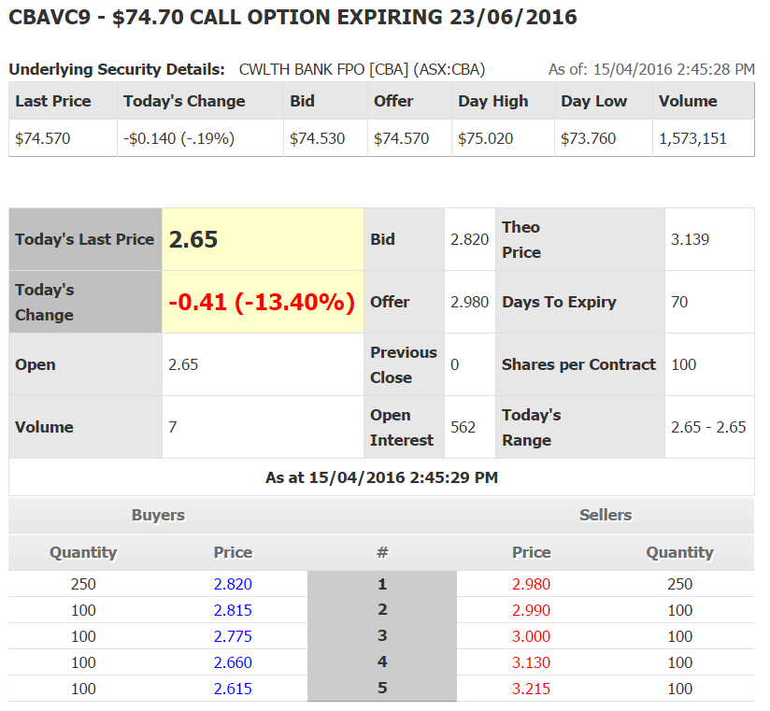
Question 3a (1 marks): What is the bid-ask spread on these options?

Question 3b (1 marks): What is your best estimate of the 'true price' of these call options?

Question 3c (1 marks): What is the best price that you could buy one call option contract when placing a market order? Be aware that one call option contract is on 100 shares and prices are listed on a per-share basis rather than a per contract basis.

Question 3d (1 marks): How much money could you sell 200 call options for? (Note that in this question you are selling, in the previous question, you are buying).

Question 3e (1 marks): What would be the implicit cost of selling these 200 call options, given your 'true price' answered above?

Question 3f (1 marks): Is this call option 'in-the-money' or 'out-of-the-money'?

Question 3g (1 marks): Why is the open interest larger than the daily volume?

Question 3h (1 marks): If the CBA stock price were to suddenly fall, would you expect the call option price to rise, fall or stay the same?

Question 4 (total of 8 marks): Consider a 6 month European call option with a strike price of $5, written on a dividend paying stock currently trading at $5.50. The dividend is paid annually and the next dividend is expected to be $0.30, paid in 3 months. The risk-free interest rate is 5% p.a. continuously compounded and the standard deviation of the stock’s returns is 40% p.a..
Question 4a (3 marks): Calculate $d_{1}$.

Question 4b (1 mark): Calculate $d_{2}$.

Question 4c (1 mark): Calculate $N\left(d_{1}\right)$ using the tables in the back of this exam paper.

Question 4d (1 mark): Calculate $N\left(d_{2}\right)$ using the tables in the back of this exam paper.

Question 4e (2 marks): Calculate the call option price.

Question 5 (total of 8 marks): Suppose a stock currently trades at $100. The stock’s semi-annual dividend is expected to be $6, paid in 3 months from now. A 6-month European call option with a strike price of $95 has a premium of $9.83. Assume a 10% continuously compounded risk-free rate.
Question 5a (3 marks): Calculate the price of a 6-month European put option with a strike price of $95 on this stock, as implied by the above information.

Question 5b (5 marks): If the call option price mentioned above suddenly rose to $11 but all else was unchanged and there was no news about the company, then explain how you could conduct a risk-free arbitrage. You're best able to show the steps using an arbitrage table.

This page has been intentionally left blank.
You can do your working here.
It will not be marked.

Formulas
$$r_{continuously compounded}=ln⁡(1+r_{discrete})$$
$$P_{0}=\frac{P_{t}}{e^{{t.r}_{continuously compounded}}}$$
$$P_{0}=\frac{P_{t}}{{\left(1+r_{discrete}\right)}^{t}}$$
$$r_{discrete}=e^{r_{continuously compounded}}-1$$
$$h^{*}=ρ_{S,F}.\frac{σ_{S}}{σ_{F}}$$
$$N_{no tailing}^{*}=h^{*}.\frac{Q_{S}}{Q_{F}}$$
$$N_{tailing}^{*}=h^{*}.\frac{V_{S}}{V_{F}}$$
$$F=S_{0}.e^{r.T}$$
$$f_{0,long}=S_{0}-K.e^{-r.T}$$
$$f_{long}=-f_{short}$$
$$p=\frac{e^{rt}-d}{u-d}$$
$$u=e^{σ\sqrt{t}}$$
$$d=\frac{1}{u}=e^{-σ\sqrt{t}}$$
$$c_{0}+K.e^{-r.T}=p_{0}+S_{0}$$
$$c_{0}=S_{0}.N\left(d_{1}\right)-K.e^{-r.T}.N\left(d_{2}\right)$$
$$p_{0}=-S_{0}.N\left({-d}_{1}\right)+K.e^{-r.T}.N\left({-d}_{2}\right)$$
$$d_{1}=\frac{\ln\left(\frac{S_{0}}{K}\right)+\left(r+\frac{σ^{2}}{2}\right).T}{σ.T^{0.5}}$$
$$d_{2}=d_{1}-σ.T^{0.5}=\frac{\ln\left(\frac{S_{0}}{K}\right)+\left(r-\frac{σ^{2}}{2}\right).T}{σ.T^{0.5}}$$

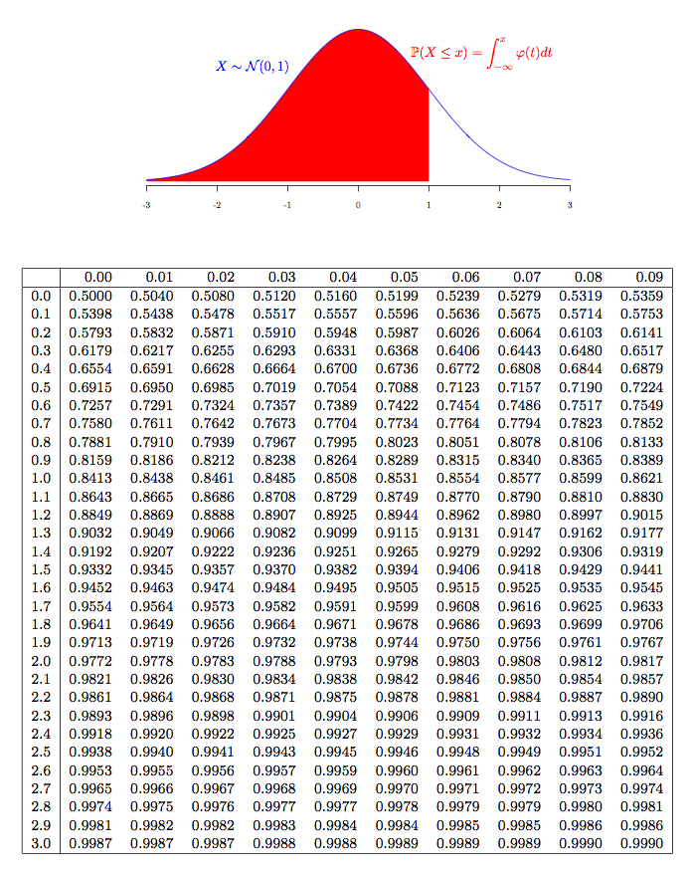

END OF EXAM PAPER

