FINAL EXAM – AUTUMN/1H SESSION 2017
School of Business

Complete your details in this section when instructed by the Exam Supervisor at the start of the exam.
You should also complete your details on any answer booklets provided.
STUDENT SURNAME:
STUDENT FIRST NAME:
STUDENT ID:

EXAM INSTRUCTIONS
Read all the information below and follow any instructions carefully before proceeding.
This exam is printed on both sides of the paper – ensure you answer all the questions.
You may begin writing when instructed by the Exam Supervisor at the start of the exam.
Clearly indicate which question you are answering on any Examination Answer Booklets used.
UNIT NAME: | Derivatives
UNIT NUMBER: | 200079
NUMBER OF QUESTIONS: | Part A has 5 questions, Part B has 5 questions.
VALUE OF QUESTIONS: | Part A questions are worth 2 marks each. Part B questions are worth 8 marks each. This totals to 50 marks.
ANSWERING QUESTIONS: | Part A: Answer multiple choice questions on the scan sheet provided.  Part B: Answer all other questions on the exam paper itself.
LECTURER/UNIT COORDINATOR: | Keith Woodward
TIME ALLOWED: | 2 hours | TOTAL PAGES: | 13

RESOURCES ALLOWED
Only the resources listed below are allowed in this exam.
Any calculator which has the primary function of a calculator is allowed. For example, calculators on mobile phones or similar electronic devices are not allowed.

DO NOT TAKE THIS PAPER FROM THE EXAM ROOM

This page intentionally left blank

Part A
Note that the next 3 questions have the same answer options, but different questions.
Question 1: Which of the following derivative instruments has a non-zero value when it’s first agreed to?
(a) Futures contract.
(b) Forward contract.
(c) Interest rate swap.
(d) Call option.

Question 2: Which of the following statements about fixed-for-floating interest rate swaps is NOT correct?
(a) No price is paid at the start when the swap is first agreed to.
(b) No face value is paid at the end when the swap matures.
(c) Payments throughout the life of the swap are netted out so only one party will pay their counterparty at each time.
(d) The ‘swap rate’ is the swap’s current floating benchmark rate that is specified in the contract, such as LIBOR.
(e) They’re traded OTC.

Question 3: Which of the following statements about the Black-Scholes-Merton option pricing equation is NOT correct?
(a) The return ‘r’ must be a continuously compounded return.
(b) If the option maturity time period is measured in years, then the return ‘r’ and the standard deviation of returns must also be per year.
(c) The return ‘r’ is the future expected return of the underlying asset in a world where investors are risk-averse.
(d) The standard deviation is the future expected volatility of the underlying asset.
(e) The model assumes that the underlying asset price is log-normally distributed.

Question 4: Which of the following statements about American-style options is NOT correct?
American-style:
(a) Options are always worth more than or equal to equivalent European-style options.
(b) Call options on dividend-paying stocks should sometimes be exercised just before the dividend.
(c) Put options on dividend-paying stocks should sometimes be exercised just after the dividend.
(d) Call options should be exercised now if the intrinsic option value (S-K) is greater than the expected present value of the option’s future payoffs.
(e) Put options should be exercised now if the intrinsic option value (K-S) is less than the expected present value of the option’s future payoffs.

Question 5: Which class of derivatives market trader is NOT principally focused on ‘buying low and selling high’?
(a) Hedgers.
(b) Speculators.
(c) Arbitrageurs.
(d) Market makers.
(e) Insider traders.

Part B
Question 1 (total of 8 marks): A stock index is expected to pay a continuously compounded dividend yield 5% pa for the foreseeable future. The index is currently at 5,800 points, the continuously compounded total required return is 8% p.a and its standard deviation of returns is 20% p.a.. An investor has just taken a long position in a one year put option contract on the index with a strike price of 5,700. Compute the put option price in index points using the Black-Scholes model.
Question 1a (3 marks): Calculate $d_{1}$.

Question 1b (1 mark): Calculate $d_{2}$.

Question 1c (1 mark): Calculate the put option delta using the tables in the back of this exam paper.

Question 1d (1 mark): Calculate the risk-neutral probability that the put option ends up being ‘in the money’ at maturity. You can use the tables in the back of this exam paper.

Question 1e (2 marks): Calculate the put option price in index points.

Question 2 (total of 8 marks): The below table summarises the borrowing costs confronting two companies.
Question 2a (6 marks): Suppose Firm A wants to borrow at a fixed rate and Firm B wishes to borrow floating.
Design an intermediated swap that provides a bank with a spread of 15 basis points p.a., and gives the remaining swap benefits to firm B only.
Use a clearly labelled diagram to summarise the terms of the arrangement.

Question 2b (2 marks): If the LIBOR rate unexpectedly rises after Firm A and B sign the swap contract, who will gain from the swap contracts (not from the physical bonds)? Firm A or B? Circle the correct answer:

Firm A, Firm B, both or neither.
Question 3 (total of 8 marks): Consider the below screen shot of the details of an American call option on BHP.

BHPN89 - $25.00 CALL OPTION EXPIRING 25/05/2017
Underlying Security Details: BHP BLT FPO [BHP] (ASX:BHP) | As of: 6/04/2017 3:15:04 PM

Last Price | Today's Change | Bid | Offer | Day High | Day Low | Volume
$24.610 | -$0.140 (-.57%) | $24.610 | $24.620 | $24.720 | $24.470 | 5,170,752

Today's Last Price | 0.9 | Bid | 0.740 | Theo  Price | 0.856
Today's  Change | 0.005 (0.56%) | Offer | 0.865 | Days To Expiry | 50
Open | 0 | Previous  Close | 0.9 | Shares per Contract | 100
Volume | 0 | Open  Interest | 2,032 | Today's  Range | 0 - 0
As at 6/04/2017 3:15:05 PM
Buyers |  |  | Sellers
Quantity | Price | # | Price | Quantity
400 | 0.740 | 1 | 0.865 | 400
200 | 0.735 | 2 | 0.870 | 200
400 | 0.725 | 3 | 0.875 | 200
0 | 0.000 | 4 | 0.880 | 200
0 | 0.000 | 5 | 0.000 | 0

Question 3a (1 marks): What is the bid-ask spread on these options (not the underlying stock)?

Question 3b (1 marks): What is your best estimate of the 'true price' of these call options?

Question 3c (1 marks): What is the best price that you could buy one call option contract when placing a market order? Be aware that one call option contract is on 100 shares and prices are listed on a per-share basis rather than a per contract basis.

Question 3d (1 marks): How much money could you sell 600 call options for? (Note that in this question you are selling, in the previous question, you are buying).

Question 3e (1 marks): What would be the implicit cost of selling these 600 call options, given your 'true price' answered above?

Question 3f (1 marks): Is this call option 'in-the-money' or 'out-of-the-money'?

Question 3g (1 marks): What’s more liquid, the stock or the option? Explain your answer.

Question 3h (1 marks): If the stock price were to remain at exactly the same level between now and the option expiry in Dec 2017, would you expect the call option price to rise, fall, or stay the same?

Question 4 (total of 8 marks): Consider a one year American call option with a strike price of $9, written on a dividend paying stock currently trading at $10. The dividend is paid annually and the next dividend is expected to be $1, paid in 6 months. The risk-free interest rate is 5% p.a. continuously compounded and the standard deviation of the stock’s returns is 20% pa.
Calculate the option price now (t=0) using either the no-arbitrage approach or the risk-neutral approach with a two-step binomial tree with 6 months per step. Remember that the option is American so it can be exercised before maturity. There are formulas on the formula sheet to help. You may wish to use the binomial tree below to work out the answer.

Question 5 (total of 8 marks): Suppose a stock currently trades at $60. The stock’s semi-annual dividend is expected to be $4, paid in 5 months from now. Note that the dividend is paid after the future expires. Assume a 7% continuously compounded risk-free rate.
Question 5a (3 marks): Calculate the futures price of a 3-month futures contract on this stock, as implied by the above information.

Question 5b (5 marks): If the fair futures price that you calculated above suddenly changed to $59 but all else was unchanged and there was no news about the company, then explain how you could conduct a risk-free arbitrage. Assume that the future is mis-priced. You're best able to show the steps using an arbitrage table.
Hint: Construct the arbitrage table by having some position in the physical mispriced future above and an offsetting position in a synthetic future. The synthetic future can be constructed using stocks and bonds.

Formulas
$$r_{continuouslycompounded}=ln⁡\left(1+r_{discrete}\right)$$
$$P_{0}=\frac{P_{t}}{e^{{t.r}_{continuouslycompounded}}}$$
$$P_{0}=\frac{P_{t}}{{\left(1+r_{discrete}\right)}^{t}}$$
$$r_{discrete}=e^{r_{continuouslycompounded}}-1$$
$$h^{}=ρ_{S,F}.\frac{σ_{S}}{σ_{F}}$$
$$N_{notailing}^{}=h^{}.\frac{Q_{S}}{Q_{F}}$$
$$N_{tailing}^{}=h^{}.\frac{V_{S}}{V_{F}}$$
$$F=S_{0}.e^{r.T}$$
$$f_{0,long}=S_{0}-K.e^{-r.T}$$
$$f_{long}=-f_{short}$$
$$p=\frac{e^{rt}-d}{u-d}$$
$$u=e^{σ\sqrt{t}}$$
$$d=\frac{1}{u}=e^{-σ\sqrt{t}}$$
$$c_{0}+K.e^{-r.T}=p_{0}+S_{0}$$
$$c_{0}=S_{0}.N\left(d_{1}\right)-K.e^{-r.T}.N\left(d_{2}\right)$$
$$p_{0}=-S_{0}.N\left({-d}_{1}\right)+K.e^{-r.T}.N\left({-d}_{2}\right)$$
$$d_{1}=\frac{ln\left(\frac{S_{0}}{K}\right)+\left(r+\frac{σ^{2}}{2}\right).T}{σ.T^{0.5}}$$
$$d_{2}=d_{1}-σ.T^{0.5}=\frac{ln\left(\frac{S_{0}}{K}\right)+\left(r-\frac{σ^{2}}{2}\right).T}{σ.T^{0.5}}$$
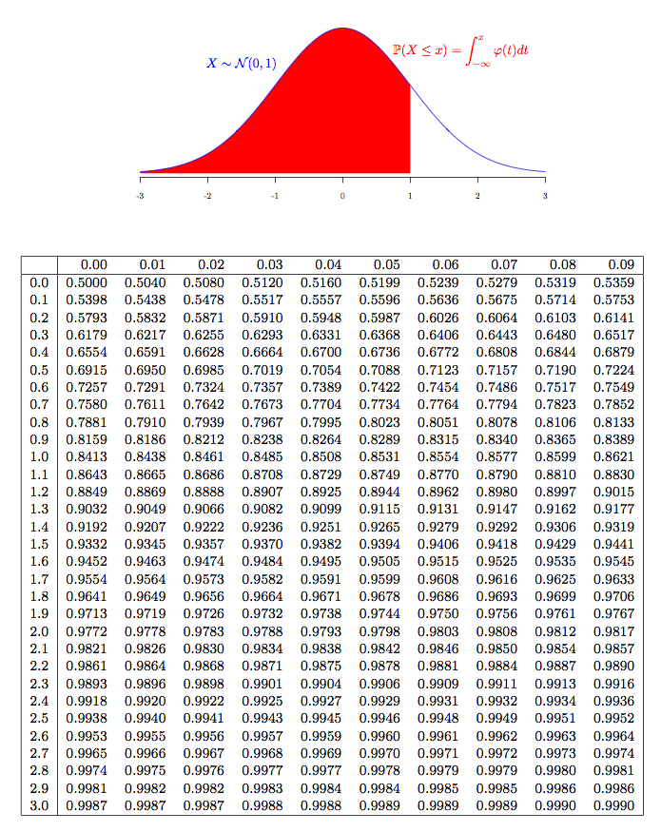

END OF EXAM PAPER

