***Internal Rate of Return (IRR)***

The internal rate of return is the discount rate that makes a project's NPV equal to zero.

$$NPV=C_{0}+\frac{C_{1}}{{\left(1+r\right)}^{1}}+\frac{C_{2}}{{\left(1+r\right)}^{2}}$$

$$0 =C_{0}+\frac{C_{1}}{{\left(1+r_{IRR}\right)}^{1}}+\frac{C_{2}}{{\left(1+r_{IRR}\right)}^{2}}$$

The decision rule is to accept projects with an IRR ($r_{IRR}$) that is more than the required return of the project ($r$).

|  |  |  |  |
| --- | --- | --- | --- |
| **Project Types** | | | |
|  | NPV | IRR | Decision |
| Good, under-priced | $$NPV>0$$ | $$IRR>r_{required}$$ | Accept, go ahead |
| Mediocre, fairly priced | $$NPV=0$$ | $$IRR=r_{required}$$ | Indifferent |
| Bad, over-priced | $$NPV<0$$ | $$IRR<r_{required}$$ | Reject, cancel |
|  |  |  |  |

IRR is very closely related to NPV.

* If a project's IRR is greater than the required return, the NPV will be positive.
* If a project's IRR is equal to the required return, the NPV will be zero.
* If a project's IRR is less than the required return, the NPV will be negative.

***Calculation Example: IRR***

**Question:** What is the IRR of the mining project from the previous example?

**Answer:** The IRR is the discount rate that makes the NPV zero. Mathematically we must solve the below equation for $r_{IRR}$:

$$0=C_{0}+\frac{C_{1}}{{\left(1+r_{IRR}\right)}^{1}}+\frac{C_{2}}{{\left(1+r_{IRR}\right)}^{2}}$$

$$=-9m+\frac{6m}{{\left(1+r_{IRR}\right)}^{1}}+\frac{5m}{{\left(1+r_{IRR}\right)}^{2}}$$

This is a quadratic equation which we could solve algebraically to get two possible answers: 0.149829914 or -1.483163963. Clearly a return less than negative one (-100%) is not possible since stocks have limited liability, prices can't be negative.

The only feasible solution is that the IRR is 14.98%. Since this is more than the 10% cost of capital (same as required return), this project should be accepted.

Note that it is often difficult or impossible to find the IRR algebraically if the time that the cash flows are received is any higher than 2. This is because the quadratic equation cannot be used. A mathematician would say that our problem reduces to finding the 'roots of a polynomial', which is best done with trial and error. Using a spreadsheet such as MS Excel, the function which uses trial and error automatically is '=IRR(...)'.

Here are some graphs of the problem for the visual learners.

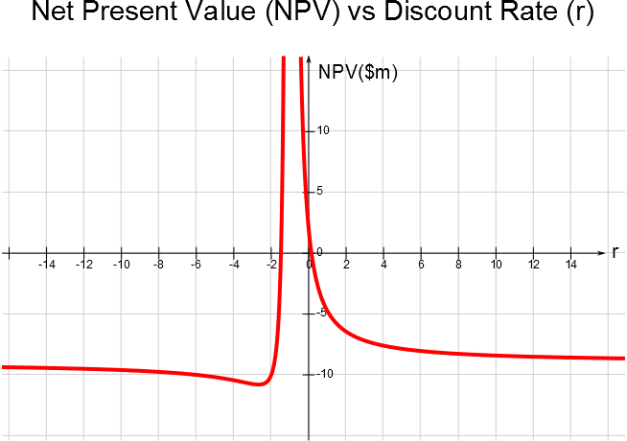

***IRR Problems***

Similarly to NPV, IRR takes the time value of money and risk into account.

IRR is also very intuitive since people and managers are familiar with returns.

But, there are some problems with using IRR that include:

* Scale effects when comparing mutually exclusive projects.
* Multiple feasible IRR's for projects with non-conventional cash flows.