Dividend Discount Model (DDM)
$$P_{t-1}=\frac{C_{t}}{r-g}$$
Some important assumptions that you need to be aware of:
- The price given by the formula will be one period before the first cash flow.
- The returns must be effective rates that have a period matching the frequency of the cash flows. So if the cash flow ($C_{t}$) is annual, then $r$ and $g$ must be effective annual rates.
- The constant dividend growth rate 'g' must occur in perpetuity (forever).
- $r$ is the total required return of the stock ($r_{total}$).

Dividend Discount Model and Returns
Re-arranging the DDM,
$$P_{0}=\frac{C_{1}}{r-g}$$
$$r = \frac{C_{1}}{P_{0}} + g$$
$$r_{total}=r_{income}+r_{capital}$$
This illustrates the surprising fact that the long term capital return of a stock should be equal to its dividend growth rate: $r_{capital}=g$.
Note that in the short term, $g$ is the stock's expected capital return as measured from just after a dividend payment to just after the next dividend payment (from trough to trough).
Similarly the expected capital return is $g$ as measured from just before a dividend payment to just before the next dividend payment (from peak to peak).
However, in between two consecutive dividend payments (from trough to peak), the expected capital return is $r$, not $g$. This stock must grow by the higher total required return $r$ to accumulate enough cash to pay its dividend, fall in price and still have grown by $g$ overall.
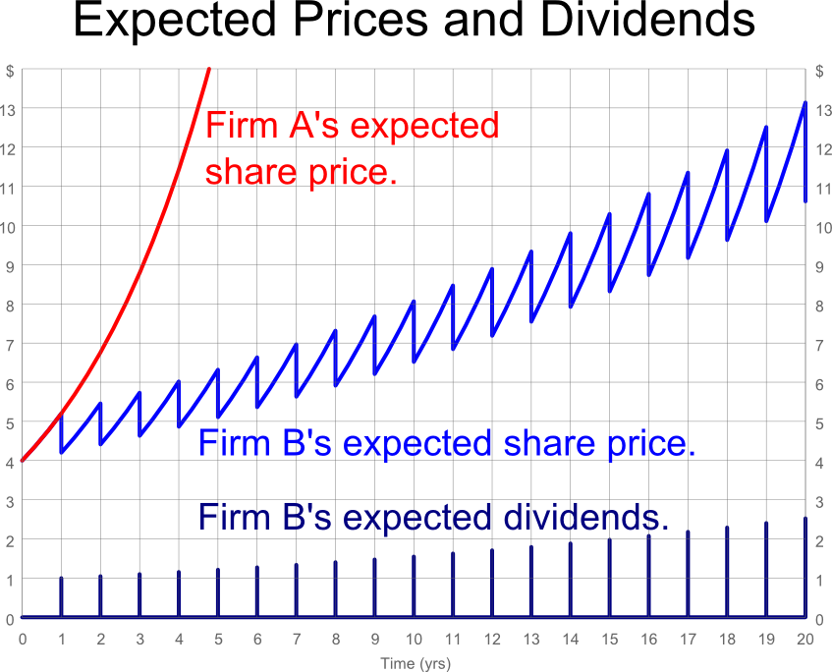
The dividend yield (or income return) is $\frac{C_{1}}{P_{0}}$.
Expected Share Prices and Dividends
Expected share prices and dividends of firms A and B are shown in the graph above. Both firms have a total expected return of 30% pa and a current (t=0) share price of $4.
Firm A pays no dividends, for at least the next 5 years. All of its free cash flows are reinvested to expand and grow its business which means that its capital return is 30% pa, equal to its total return.
Firm B has a dividend return of 25% pa, so the capital return is 5% pa. The growth rate of the dividend is also 5% pa. Firm B pays most of its cash flows out as dividends, and every time it pays a dividend its price falls.
Firm A and B’s share price and dividend graphs are not linear, they are curves that get steeper and steeper. We say that they grow exponentially. Albert Einstein is quoted as saying: “The strongest force in the universe is Compound Interest.”

Note that the share prices shown in the graph are expectations. The realization of the share prices will be different as investors’ expectations of future dividends and total returns change through time as news about the firm and the economy becomes available.
The realized share prices will be highly volatile, but they will still depict the familiar ‘exponential’ price growth graph.

Dividend and Stock Price Growth Rates
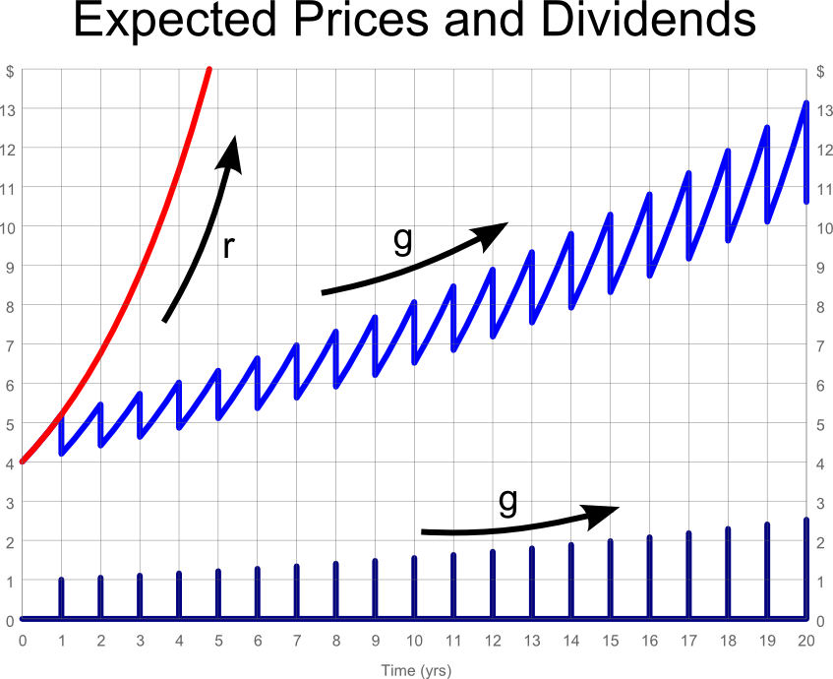
The growth rate (g) of the stock price and the dividend should be equal in perpetuity if the assumptions of the DDM hold.
Of course, if the dividends are re-invested back into the stock, the growth rate will be the total return (r).
Dividend Discount Model in Practice
A common mistake when applying the DDM is to use a growth rate that is too high. Remember that the DDM’s dividend growth rate is perpetual, so it goes forever. Also, the dividend growth rate is the capital return (proportional price increase).
Say there is a stock, 'Growth Corp', that has a high average historical dividend growth rate of 7% pa. An inexperienced analyst forecasts that dividends will continue to grow at this high rate forever.
Since the average stock in the economy grows by approximately the level of GDP growth, which is around 5% pa, then Growth Corp will outgrow the average stock. But since this occurs in perpetuity, Growth Corp will take over the world since it is always getting bigger than the average firm forever.
So there is an upper limit on the nominal dividend growth rate. This limit is nominal GDP growth. Similarly for real growth rates.

