Calculation Examples: DDM
Question: The Telstra (TLS) stock price is $6. Its next annual dividend of $0.30 will be paid in exactly one year from now. Dividends are expected to grow by 2% pa forever.
What is the stock's required return on equity, given as an effective annual rate?
Answer:
$$P_{0}=\frac{C_{1}}{r_{total}-g}$$
$$6=\frac{0.30}{r_{total}-0.02}$$
$$r_{total}=\frac{0.3}{6}+0.02$$
$$=0.07=7\% pa$$
Question: Estimate the future stock price in 2 years and 6 months (2.5 years).
Answer: We can use a number of methods to find the price. All are best visualised by following the path of the ‘saw tooth’ diagram of price versus time.

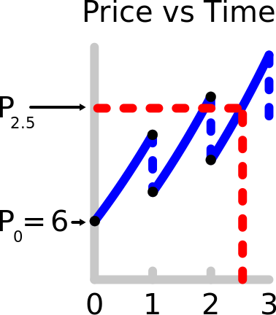
Method 1: Grow the current price by g from trough to trough for two periods, then by r for half a period from trough to peak.
$$P_{2.5}=P_{0}{\left(1+g\right)}^{2}{\left(1+r\right)}^{0.5}$$
$$=6{\left(1+0.02\right)}^{2}{\left(1+0.07\right)}^{0.5}$$
$$=6.457188769$$

Method 2: Grow the current price by r from trough to peak, then subtract the dividend, and repeat for another one and a half periods. Note that $C_{2}=C_{1}{\left(1+g\right)}^{1}$.
$$P_{2.5}=\left(\left(P_{0}{\left(1+r\right)}^{1}-C_{1}\right){\left(1+r\right)}^{1}-C_{2}\right){\left(1+r\right)}^{0.5}$$
$$=\left(\left(P_{0}{\left(1+r\right)}^{1}-C_{1}\right){\left(1+r\right)}^{1}-C_{1}{\left(1+g\right)}^{1}\right){\left(1+r\right)}^{0.5}$$
$$=\left(\left(6{\left(1+0.07\right)}^{1}-0.30\right){\left(1+0.07\right)}^{1}-0.30{\left(1+0.02\right)}^{1}\right){\left(1+0.07\right)}^{0.5}$$
$$=6.457188769$$

Method 3: The price in 2.5 periods will be the price in 2 periods, grown forward from trough to peak by r for half a period.
$$P_{2.5}=P_{2}{\left(1+r\right)}^{0.5}$$
$$=\frac{C_{3}}{r-g}{\left(1+r\right)}^{0.5}$$
$$=\frac{C_{1}{\left(1+g\right)}^{2}}{r-g}{\left(1+r\right)}^{0.5}$$
$$=\frac{0.30{\left(1+0.02\right)}^{2}}{0.07-0.02}{\left(1+0.07\right)}^{0.5}$$
$$=6.457188769$$

Questions: Dividend Discount Model
http://www.fightfinance.com/?q=479,3,4,451,7,28,201,216,497,217,264,289,352,31,161,36,39,40,41,148,158,441,51,50,270,488,465,

