Reconciling DCF and PE-Ratio Valuation
Discounted Cash Flow (DCF) valuation and Price/Earnings (PE) ratio valuation can be seen as two sides of the same coin.
Assume that a firm pays out all of its earnings as dividends. In this case, there will be no real growth in earnings, dividends or stock price since there is no re-investment back into the firm to buy new assets and make higher earnings. Note that nominal growth will be equal to inflation.
Applying the Dividend Discount Model (DDM) and assuming that cash flows and discount rates are nominal:
$$P_{0}=\frac{C_{1}}{r-g}$$
Because the dividend cash flow ($C_{1}$) equals earnings (earnings per share, ${EPS}_{1}$),
$$P_{0}=\frac{{EPS}_{1}}{r-g}$$
Re-arranging,
$$\frac{P_{0}}{{EPS}_{1}}=\frac{1}{r-g}$$
The left hand side of this equation is actually the forward-looking PE ratio formula, it's the ratio the current share price (at t=0) to next year's earnings (at t=1).

So the forward-looking PE ratio can be seen as 1/(r-g), the inverse of the nominal dividend yield which (since g is inflation) is also the real total required return on equity.

If earnings equal dividends ($EPS=C$), then the multiples approach:
$$P_{0}={EPS}_{1}×(Average of comparable {firms}^{'} PE ratios)$$
Is equivalent to the dividend discount model approach:
$$P_{0}={EPS}_{1}×\left(\frac{1}{r-g}\right)$$

In the listed stock market, PE ratios are generally around 15. This makes sense because judging by history, the market portfolio's nominal total required return is around 10%, inflation 3%, so the real total required return is expected to be around 7% and (1/0.07) is approximately 15.
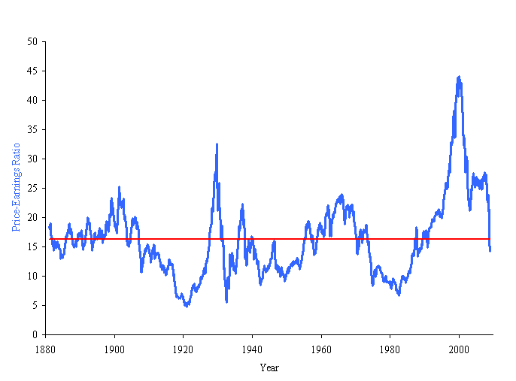
The historical Price-Earnings graph on the next slide was used by Robert Shiller in his famous book 'Irrational Exuberance', published in the same month as the dot-com bust in March 2000. Shiller argued that there was a stock market bubble because PE ratios were too high.
Why Firms Have Different PE ratios
There are many reasons why PE ratios vary between firms:
- Growth stocks tend to have high PE ratios. This is because their earnings are low now but are expected to grow significantly in the future. Therefore the current share price is high (since it's the PV of future high earnings) and next year's expected earnings are low.

- Stocks with high systematic risk tend to have low PE ratios. This is because their required return is high so the present value of their cash flows (price) is low.

- Illiquid stocks tend to have low PE ratios. This is because the stocks take a long time to sell or have high transaction costs such as brokerage or taxes. Potential buyers know that if they want to sell later on then they will suffer these significant costs. So they are only willing to buy at a low price now to make up for those costs later on.

Questions: Multiples Valuation
http://www.fightfinance.com/?q=348,358,341,347,354,357,364,457,463,

