Fully Amortising Loans
Most home loans are fully amortising or ‘Principal and Interest’ (P&I) loans.
When a fully amortising home loan borrower makes their last payment, the loan is fully paid off.
We can value fully amortising home loans using the annuity formula assuming that the interest rate r is expected to be constant.
$$V_{0 fully amortising}=\frac{C_{1}}{r}\left(1-\frac{1}{{\left(1+r\right)}^{T}}\right)$$

Example: Fully Amortising Loans
Question: Mortgage rates are currently 6% and are not expected to change.
You can afford to pay $2,000 a month on a mortgage loan.
The mortgage term is 30 years (matures in 30 years).
What is the most that you can borrow using a fully amortising mortgage loan?
Answer: Since the mortgage is fully amortising, at the end of the loan's maturity the whole loan will be paid off.
The bank will lend you the present value of your monthly payments for the next 30 years. This can be calculated using the annuity formula.
The $2,000 payments are monthly, therefore the interest rate and time periods need to be measured in months too.
$$t=30×12=360 months$$
$$r_{eff monthly}=\frac{r_{APR comp monthly}}{12}=\frac{0.06}{12}=0.005=0.5\%$$
$$V_{0 fully amortising}=\frac{C_{1}}{r}\left(1-\frac{1}{{\left(1+r\right)}^{T}}\right)$$
$$=\frac{2000}{0.005}\left(1-\frac{1}{{\left(1+0.005\right)}^{360}}\right)=\$333,583$$

Example: Fully Amortising Loans
Question: You wish to borrow $10,000 for 2 years as an unsecured personal loan.
Interest rates are quite expensive at 60% pa and are not expected to change.
What will be your monthly payments on a fully amortising loan?

Answer:
$$V_{0 fully amortising}=\frac{C_{1}}{r}\left(1-\frac{1}{{\left(1+r\right)}^{T}}\right)$$
$$10000 =\frac{C_{1}}{0.6/12}\left(1-\frac{1}{{\left(1+0.6/12\right)}^{2×12}}\right)$$
$$10000 =C_{1}×\frac{1}{0.6/12}\left(1-\frac{1}{{\left(1+0.6/12\right)}^{2×12}}\right)$$
$$C_{1} =\frac{10000}{\frac{1}{0.6/12}\left(1-\frac{1}{{\left(1+0.6/12\right)}^{2×12}}\right)}$$
$$=\frac{10000}{13.7986417943}$$
$$=724.709007529$$
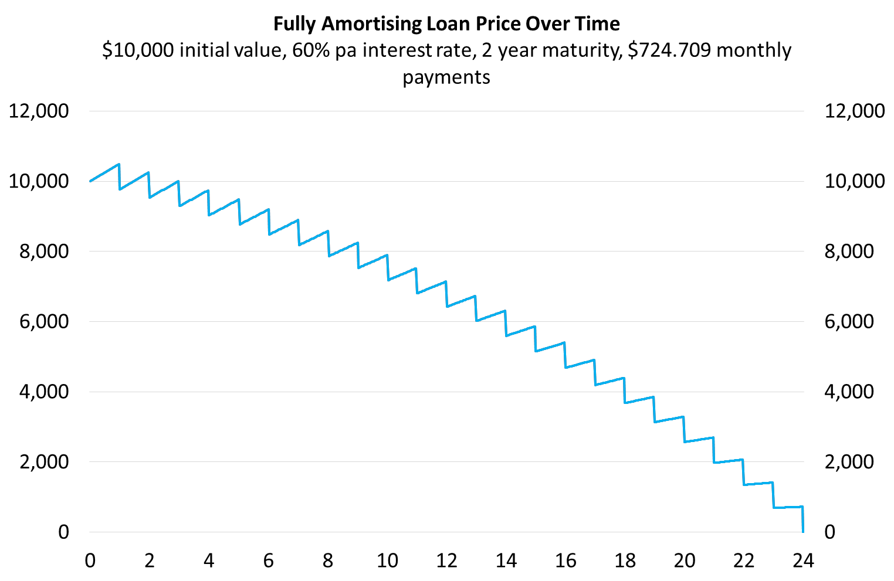
Interest and Principal Components
Each total loan payment ($C_{total}$) can be broken into interest ($C_{interest}$) and principal ($C_{principal}$) components:
$$C_{total}=C_{interest}+C_{principal}$$
The interest component at time one ($C_{1interest}$) is defined as the interest rate over the first period ($r_{0→1}$) multiplied by the initial (time zero) loan price or value ($V_{0}$):
$$C_{1interest}=V_{0}.r_{0→1}$$
The principal component is the remaining part:
$$C_{1principal}=C_{total}-C_{1interest}$$
For a general formula, replace time 1 with $t$ and 0 with $t-1$.
Calculation Example: Loan Schedule
Fully Amortising Home Loan Schedule
$1 million initial value, 3.6% pa interest rate, 30 year maturity, monthly payments
Time | Value | Total payment | Interest component | Principal component
months | $ | $/month | $/month | $/month
0 | 1000000.00
1 | 998453.55 | 4546.45 | 3000.00 | 1546.45
2 | 996902.45 | 4546.45 | 2995.36 | 1551.09
3 | 995346.71 | 4546.45 | 2990.71 | 1555.75
4 | 993786.29 | 4546.45 | 2986.04 | 1560.41
5 | 992221.20 | 4546.45 | 2981.36 | 1565.09
… | … | … | … | …
357 | 13557.93 | 4546.45 | 54.15 | 4492.30
358 | 9052.15 | 4546.45 | 40.67 | 4505.78
359 | 4532.85 | 4546.45 | 27.16 | 4519.30
360 | 0.00 | 4546.45 | 13.60 | 4532.85
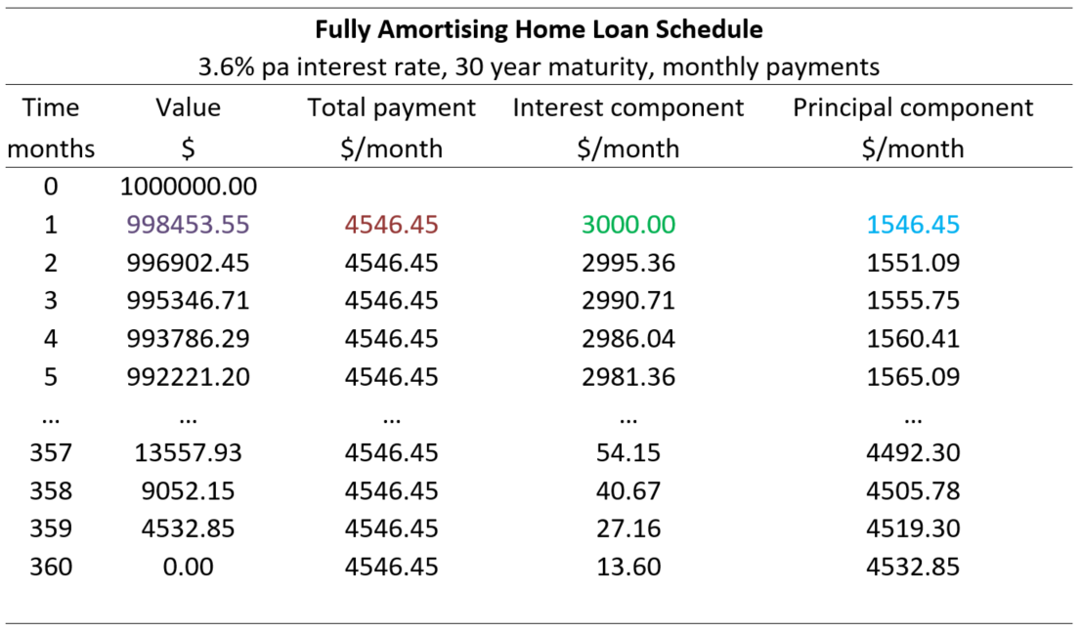
$C_{1total}=\frac{V_{0}}{\frac{1}{r_{eff monthly}}\left(1-\frac{1}{{\left(1+r_{eff monthly}\right)}^{T_{months}}}\right)}$
$= \frac{1,000,000}{\frac{1}{\left(\frac{0.036}{12}\right)}\left(1-\frac{1}{{\left(1+\frac{0.036}{12}\right)}^{30×12}}\right)}=4,546.45$
$C_{1interest}=V_{0}.r_{eff monthly, 0→1}=V_{0}.\frac{r_{APR comp monthly, 0→1}}{12}$
$=1,000,000×\frac{0.036}{12}=3,000$
$C_{1principal}=C_{1total}-C_{1interest}$
$$=4,546.45-3,000$$
$=1,546.45$
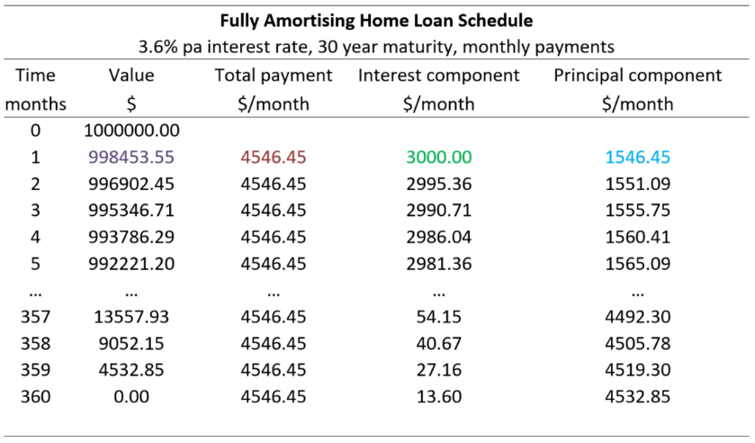
Loan Valuation: Prospective vs Retrospective
Prospective loan valuation: The value (price) of any asset is the present value of its future cash flows.
So discount the future cash flows to the present. For example, to find the month 1 loan value just after that first payment:
$V_{1}=\frac{C_{2}}{r_{eff monthly}}\left(1-\frac{1}{{\left(1+r_{eff monthly}\right)}^{T_{months remaining}}}\right)$
$= \frac{4,546.4535}{\left(\frac{0.036}{12}\right)}\left(1-\frac{1}{{\left(1+\frac{0.036}{12}\right)}^{30×12-1}}\right)=998,453.55$

Retrospective loan valuation: Deduct the principal portion of the loan payment from the prior value:
$$V_{1}=V_{0}-C_{1principal}$$
$=1,000,000-1,546.45=998,453.55$
Comment: Prospective over Retrospective
The retrospective method only works when credit risk remains unchanged and everything goes to plan.
Using the home loan in the previous example, say a volcano explodes underneath the borrower’s house and they lose their job at month 4 just after the payment at that time, and they only have enough savings for one more monthly loan payment.
The prospective method would correctly value the month 4 loan as the present value of that one remaining $4,546.45 month 5 payment, since the remaining payments at month 6, 7 and so on will not occur and there’s no property to re-possess.
But the retrospective method would incorrectly value the month 4 loan at $993,786.29 which is far too high.
The retrospective method should be discouraged since past cash flows are sunk and shouldn’t be considered when pricing assets. Always think about the future, not the past.

Questions: Fully Amortising Loans
http://www.fightfinance.com/?q=19,87,134,149,172,187,203,204,222,259,

