Interest-Only Loans
Borrowers with interest-only loans don’t make any principal payments. Their entire loan payments are interest. So the loan is not paid off until the very last payment when the original amount must be fully repaid, plus the interest over that last month.
Often this big amount is paid off by re-financing (rolling over) the debt which means borrowing again, or by selling the house.
Most interest-only loans in Australia are actually interest-only for 5 years or less. After this, they convert to fully amortising loans.

Interest-Only Loan Valuation
Interest only loans are easily valued using the ‘perpetuity without growth’ formula:
$$V_{0 interest only}=\frac{C_{1}}{r}=\frac{C_{1 monthly}}{r_{eff monthly}}=\frac{C_{1 monthly}}{\left(\frac{r_{APR comp monthly}}{12}\right)}$$
This makes sense since an interest-only loan that is repeatedly refinanced always has the same principal, it’s never paid off. If the interest rate is constant forever, then the borrower will pay constant interest cash flows $(C_{1}=C_{2}=C_{3}=…)$ perpetually.
Another way of looking at the interest-only loan is to assume that the final principal payment is paid off without refinancing. The initial price ($V_{0}$) is the present value of the interest payments ($C_{1}$, $C_{2},$…) and also the final principal payment ($V_{T}$):

$$V_{0}=\frac{C_{1}}{r}\left(1-\frac{1}{{\left(1+r\right)}^{T}}\right)+\frac{V_{T}}{{\left(1+r\right)}^{T}}$$
Substitute $V_{T}=V_{0}$
$$V_{0}=\frac{C_{1}}{r}\left(1-\frac{1}{{\left(1+r\right)}^{T}}\right)+\frac{V_{0}}{{\left(1+r\right)}^{T}}$$
$$V_{0}-\frac{V_{0}}{{\left(1+r\right)}^{T}}=\frac{C_{1}}{r}\left(1-\frac{1}{{\left(1+r\right)}^{T}}\right)$$
$$V_{0}\left(1-\frac{1}{{\left(1+r\right)}^{T}}\right)=\frac{C_{1}}{r}\left(1-\frac{1}{{\left(1+r\right)}^{T}}\right)$$
$$V_{0}=\frac{C_{1}}{r}$$

Calculation Example: Interest Only Loans
Question: Mortgage rates are currently 6% and are not expected to change. You can afford to pay $2,000 a month on a mortgage loan. The loan term is 30 years (matures in 30 years). What is the most that you can borrow using an interest-only loan?
Answer: Interest-only loans are equivalent to perpetuities with no growth.
$$V_{0 interest only}=\frac{C_{1}}{r}=\frac{C_{1 monthly}}{r_{eff monthly}}=\frac{C_{1 monthly}}{\left(\frac{r_{APR comp monthly}}{12}\right)}$$
$$=\frac{2000}{(0.06/12)}=\$400,000$$
Calculation Example: Interest Only Loans
Question: You wish to borrow $10,000 for 2 years as an unsecured personal loan.
Interest rates are quite expensive at 60% pa and are not expected to change.
What will be your monthly payments on an interest-only loan?
Answer:
$$V_{0 finterest only}=\frac{C_{1}}{r}$$
$$10000 =\frac{C_{1}}{0.6/12}$$
$$C_{1} =10000×0.6/12=500$$
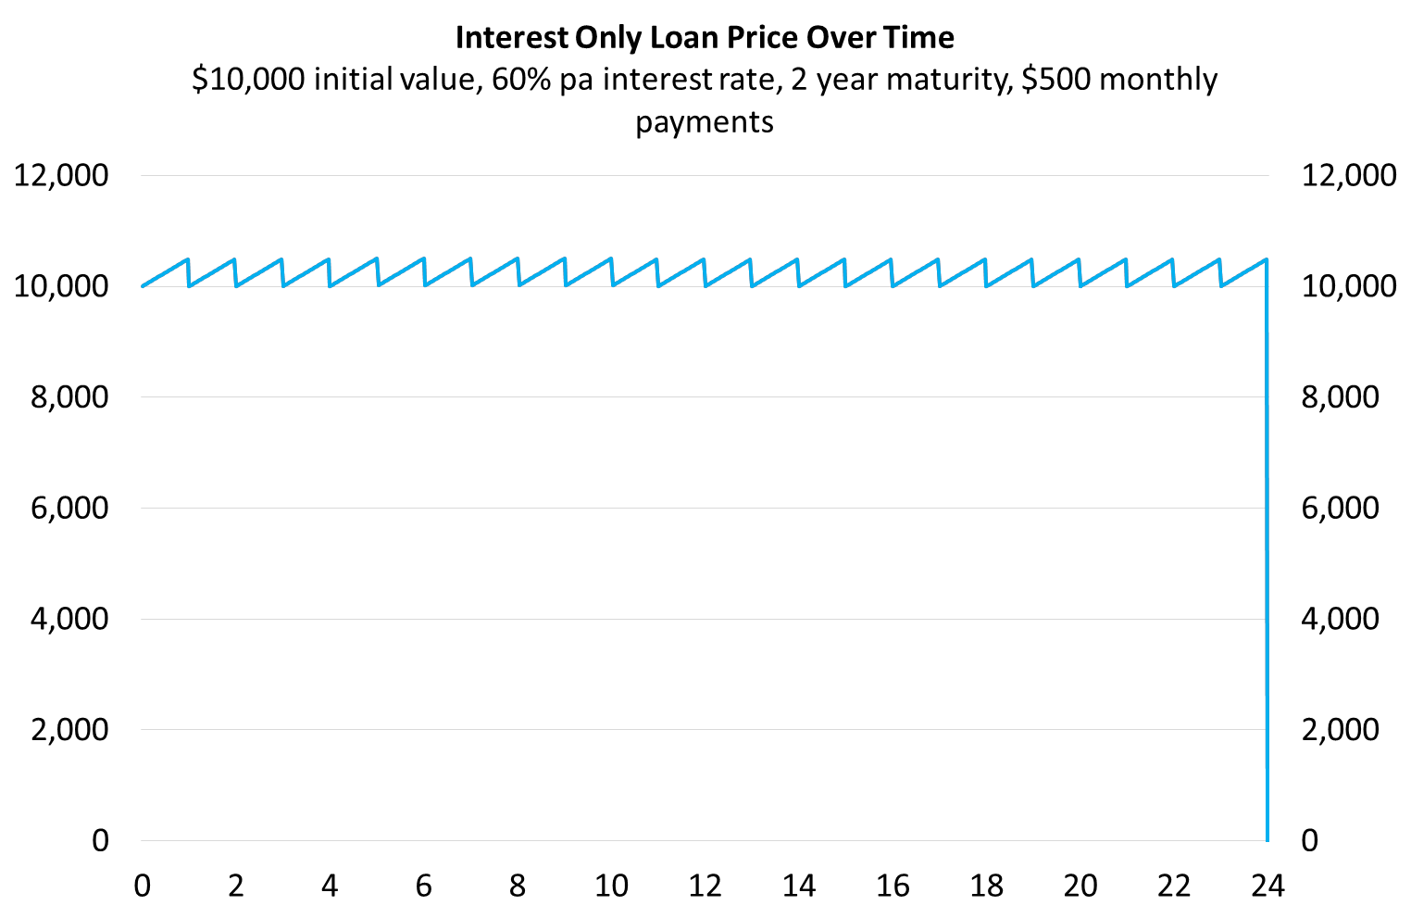
Calculation Example: Loan Schedule
Interest-Only Home Loan Schedule
$1 million initial value, 3.6% pa interest rate, 30 year maturity, monthly payments
Time | Value | Total payment | Interest component | Principal component
months | $ | $/month | $/month | $/month
0 | 1000000.00
1 | 1000000.00 | 3000.00 | 3000.00 | 0.00
2 | 1000000.00 | 3000.00 | 3000.00 | 0.00
3 | 1000000.00 | 3000.00 | 3000.00 | 0.00
4 | 1000000.00 | 3000.00 | 3000.00 | 0.00
5 | 1000000.00 | 3000.00 | 3000.00 | 0.00
… | … | … | … | …
357 | 1000000.00 | 3000.00 | 3000.00 | 0.00
358 | 1000000.00 | 3000.00 | 3000.00 | 0.00
359 | 1000000.00 | 3000.00 | 3000.00 | 0.00
360 | 0.00 | 1003000.00 | 3000.00 | 1000000.00
$C_{1total}=V_{0}.r_{eff monthly, 0→1}=V_{0}.\frac{r_{APR comp monthly, 0→1}}{12}$
$= 1,000,000×\frac{0.036}{12}=3,000$
$C_{1interest}=V_{0}.r_{eff monthly, 0→1}=V_{0}.\frac{r_{APR comp monthly, 0→1}}{12}$
$=1,000,000×\frac{0.036}{12}=3,000$
$C_{1principal}=C_{1total}-C_{1interest}$
$=3,000 -3,000=0$

Questions: Interest Only Loans
http://www.fightfinance.com/?q=29,42,57,107,160,239,298,459,

