Bond Pricing exactly one period before the next coupon
The price of a bond is the present value of the coupons and the principal. The coupons are an annuity and the principal (also called the face or par value) is a single payment, therefore:
$$P_{0, bond}=PV\left(annuity of coupons\right)+PV\left(principal\right)$$
$$=\frac{C_{1}}{r_{eff}}\left(1-\frac{1}{{\left(1+r_{eff}\right)}^{T}}\right) + \frac{{Face}_{T}}{{\left(1+r_{eff}\right)}^{T}}$$
Note that this equation assumes that the next coupon is paid in exactly one period. This will be the case for a bond that was just issued or a bond that just paid a coupon.
Care must be taken when choosing $r_{eff}$ and T so that they are consistent with the time period between coupon payments ($C_{1}$).
Remember that bond yields are given as APR's compounding at the same frequency as coupons are paid, so they normally have to be converted to effective rates before using them in the above equation.

Bond Pricing Conventions
US, Japanese and Australian fixed coupon bonds often pay semi-annual coupons. Therefore the yields are quoted as APR's compounding semi-annually.
Many European bonds often pay annual coupons. Therefore the yields are quoted as APR's compounding annually, which is the same thing as an effective annual rate.

Calculation Example: Bond Pricing exactly one period before the next coupon
Question: An Australian company issues a fixed-coupon bond. The bond will mature in 3 years, has a face value of $1,000 and a coupon rate of 8% pa paid semi-annually. Yields are currently 5% pa. What is the price of the bond?
Answer: Each 6 month coupon will be:
$$C_{semi-annual}=Face value×\frac{coupon rate}{2}$$
$$=1,000×\frac{0.08}{2}=\$40$$

The number of time periods T must be consistent with the coupon payment frequency of 6 month periods, so
$$T=3 years ×2$$
$=6$ semi-annual periods
The yield of 5% pa can be assumed to be an APR compounding every 6 months, the same frequency as the coupon payments. We need to find the effective 6 month rate to discount the 6-month coupons, so:
$$r_{eff 6month}=r_{APR comp semi annually}÷2$$
$$=0.05÷2=0.025$$

To find the bond price,
$${Price}_{bond}=PV\left(annuity of coupons\right)+PV\left(principal\right)$$
$$=\frac{C_{1}}{r_{eff}}\left(1-\frac{1}{{\left(1+r_{eff}\right)}^{T}}\right) + \frac{Face_{T}}{{\left(1+r_{eff}\right)}^{T}}$$
$$=\frac{1000×0.08/2}{0.05/2}\left(1-\frac{1}{{\left(1+0.05/2\right)}^{3×2}}\right)+\frac{1000}{{\left(1+0.05/2\right)}^{3×2}}$$
$$=\frac{40}{0.025}\left(1-\frac{1}{{\left(1+0.025\right)}^{6}}\right) + \frac{1,000}{{\left(1+0.025\right)}^{6}}$$
$$=220.3250145 + 862.296866$$
$$=\$1,082.62$$

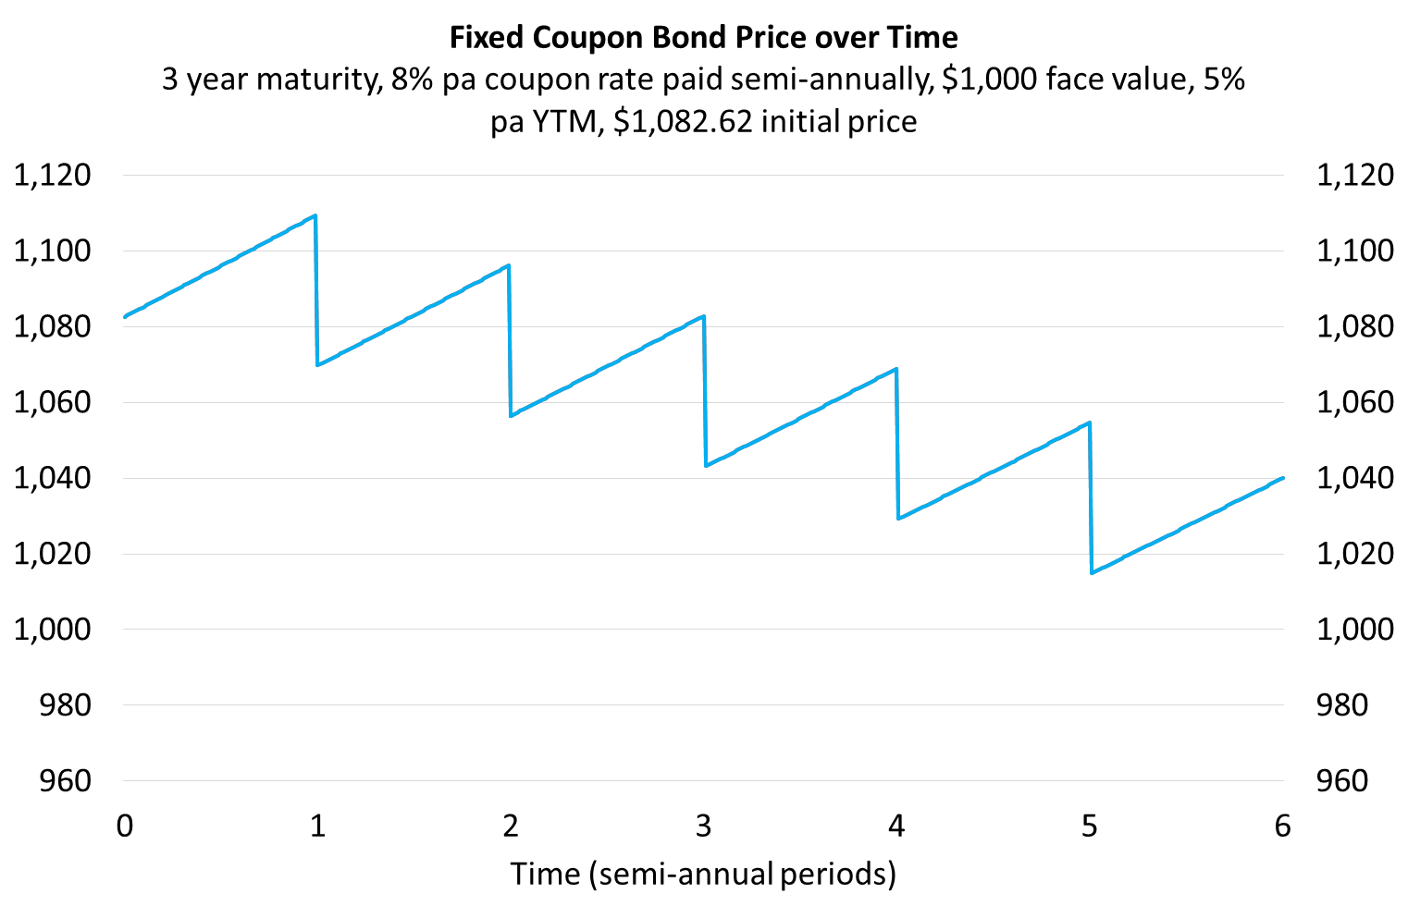
Bond Yields and Coupon Rates - Important
A company issues three similar bonds which differ only in their coupon rates. Coupons are paid semi-annually.
Bond | Maturity or tenor | Yield to maturity | Coupon  rate | Face or par value | Price | Bond type
 | (years) | (% pa) | (% pa) | ($) | ($)
A | 3 | 5 | 0 | 100 | 86.23 | Discount
B | 3 | 5 | 5 | 100 | 100.00 | Par
C | 3 | 5 | 10 | 100 | 113.77 | Premium
Discount bonds: CouponRate < YTM, Price < FaceValue
Par bonds: CouponRate = YTM, Price = FaceValue
Premium bonds: CouponRate > YTM, Price > FaceValue
P_{0A} = 100/(1+0.05/2)^(3*2) = 86.2297
P_{0B} = 100*0.05/2 * 1/(0.05/2)*(1-1/(1+0.05/2)^(2*3)) + 100/(1+0.05/2)^(3*2) = 100
P_{0C} = 100*0.1/2 * 1/(0.05/2)*(1-1/(1+0.05/2)^(2*3)) + 100/(1+0.05/2)^(3*2) = 113.7703
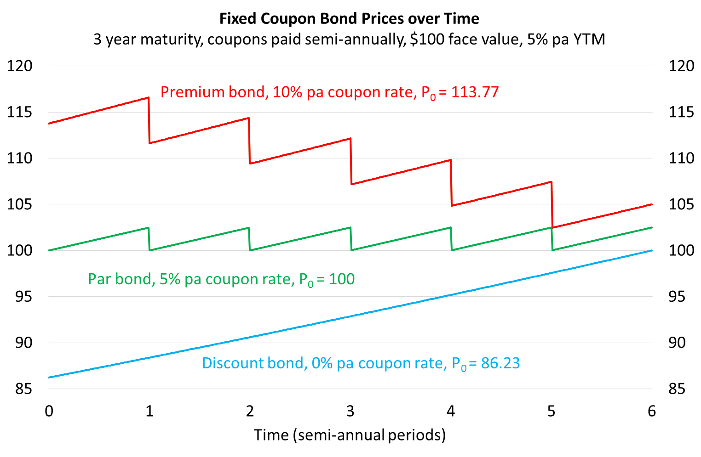
Calculation Example: Bonds issued at par
Question: An Australian company issues a bond at par. The bond will mature in 3 years, has a face value of $1,000 and a coupon rate of 8%. What is the price of the bond?
Answer: This is a trick question, no calculations are required. Since the bond was issued at par, the price must be equal to the face value. Therefore the price is $1,000. Current yields in the bond market must also be equal to 8% pa, the same as the bond's coupon rate.

Calculation Example: Zero coupon bonds
Question: An Australian company issues a zero coupon bond. The bond will mature in 3 years and has a face value of $1,000. If the current price of the bond is $700, what is the current yield on the bond, given as an APR compounding semi-annually?
Answer: Zero coupon bonds pay no coupons. Therefore the price of the bond is just the present value of the principal.
To find current yields we need to solve for the discount rate:
$${Price}_{bond} =PV\left(annuity of coupons\right)+PV\left(principal\right)$$
$$=0+\frac{Face}{{\left(1+r_{eff}\right)}^{T}}$$
$$700 =\frac{1,000}{{\left(1+r_{eff 6mth}\right)}^{6}}$$
$${700×\left(1+r_{eff 6mth}\right)}^{6}=1,000$$
$${\left(1+r_{eff 6mth}\right)}^{6}=\frac{1,000}{700}$$
$$1+r_{eff 6mth}={\left(\frac{1,000}{700}\right)}^{\frac{1}{6}}$$
$$r_{eff 6mth}={\left(\frac{1,000}{700}\right)}^{\frac{1}{6}}-1$$
$$=0.061248265$$
We need to convert this rate to an APR compounding every 6 months since that is how bond yields are quoted in Australia.
$$r_{APR comp per 6mths}=r_{eff 6mth}×2$$
$$=0.061248265×2$$
$$=0.12249653=12.249653\%$$
For the exam, note that you will not be asked to find the yield on coupon-paying bonds since that requires trial-and-error or a computer that can do it for you (use a spreadsheet's IRR or YIELD formula).
But you may be asked to find the yield on a simple zero coupon bond like we did in this question.
Note that instead of finding the effective semi-annual rate and converting to an APR compounding semi-annually at the end, the bond pricing equation can be set up so that the APR compounding semi-annually is calculated from the start:
$$700 =\frac{1,000}{{\left(1+\frac{r_{APR comp 6mth}}{2}\right)}^{6}}$$
$$r_{APR comp 6mth}=2\left({\left(\frac{1,000}{700}\right)}^{\frac{1}{6}}-1\right)$$
$$=2×0.061248265$$
$$=0.12249653$$
$$=12.249653\%$$
Questions: Bond Pricing
http://www.fightfinance.com/?q=509,510,11,15,23,33,38,48,53,56,63,133,138,153,159,163,168,178,179,183,193,194,207,213,227,229,230,233,255,257,266,287,328,332,460,

