Bond Pricing in between coupons
To price a bond in between coupon periods at time t, grow the bond price $P_{0}$ forward by the yield to maturity:
$P_{t} =P_{0}{\left(1+r_{eff}\right)}^{t}$ where:
$P_{t}$ is the bond price at the current time t and 0<t<1;
$C_{1}$ is the next coupon payment at time one;
T is the number of coupons remaining to be paid;
$r_{eff}$ is the yield to maturity as an effective rate per coupon period;
$P_{0}$ is the bond price one period before the next coupon $C_{1}$;
$$P_{0} =\frac{C_{1}}{r_{eff}}\left(1-\frac{1}{{\left(1+r_{eff}\right)}^{T}}\right)+\frac{F_{T}}{{\left(1+r_{eff}\right)}^{T}}$$
Calculation Example: Bond pricing in between coupons
Question: A 3 year government bond paying 10% pa semi-annual coupons with a face value of $100 was issued 4 months ago at a yield of 5% pa. Find the current price of the bond.
Ignore the actual number of days in each month and assume that every month is 1/12 of a year.
Answer: Let the next coupon payment in 6 months be time 1. Let’s find the bond price one (semi-annual) coupon period before, which is time zero, with 6 semi-annual coupons left:
$$P_{0}=\frac{0.1×100/2}{0.05/2}\left(1-\frac{1}{{\left(1+0.05/2\right)}^{3×2}}\right)+\frac{100}{{\left(1+0.05/2\right)}^{3×2}}$$
$$P_{0}=\frac{0.1×100/2}{0.05/2}\left(1-\frac{1}{{\left(1+0.05/2\right)}^{3×2}}\right)+\frac{100}{{\left(1+0.05/2\right)}^{3×2}}$$
$$=\frac{5}{0.025}\left(1-\frac{1}{{\left(1+0.025\right)}^{6}}\right)+\frac{100}{{\left(1+0.025\right)}^{6}}$$
$$=113.770313404$$
Now grow the bond price that extra 4 months forward, which is 4/6 (=0.66667) semi-annual periods, to get to the current time:
$$P_{4months}=P_{0}{\left(1+r_{APR comp 6 months}/2\right)}^{4/6}$$
$$=113.770313404×{\left(1+0.05/2\right)}^{4/6}$$
$$=115.6586711$$
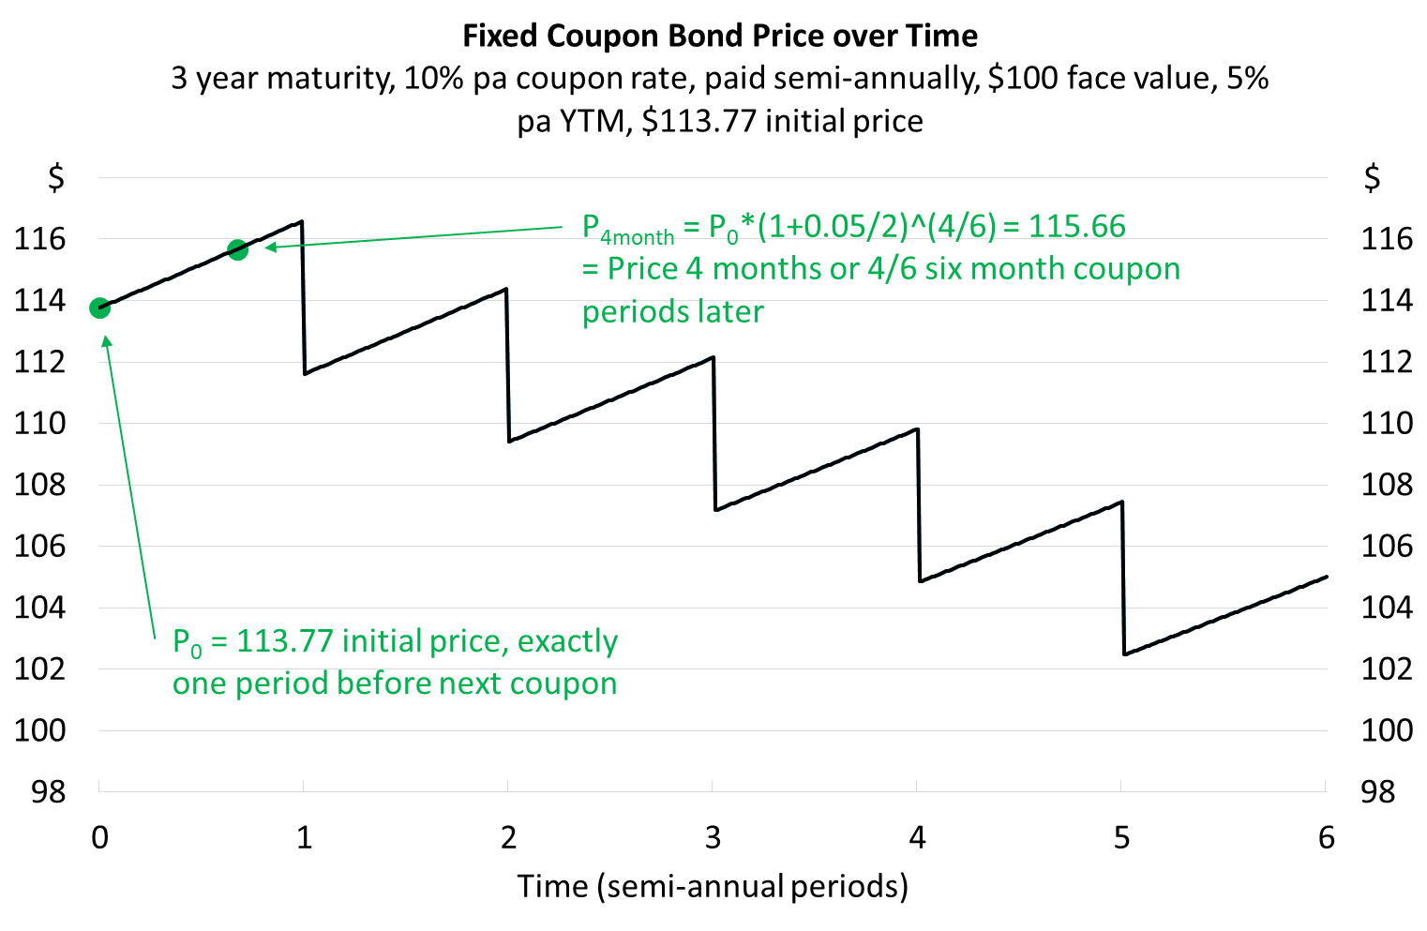
Calculation Example: Bond pricing in between coupons
Question: A 10 year government bond paying 3% pa semi-annual coupons with a face value of $100 was issued 8 months ago on 15 December 2021 at a yield of 3% pa.
Today is 15 August 2022 and yields are now 2.8% pa. What is the current price of the bond?
Ignore the actual number of days in each month and assume that every month is 1/12 of a year, so the bond was issued 8 months ago from today, 15 August 2022.

Answer: Let the issue date 15 December 2021 be time zero. There are only 19 semi-annual coupons left, since the first was already paid on 15 June 2022. The bond’s next coupon ($C_{2}$) will be paid on 15 December 2022. The bond price one period before coupon $C_{2}$ is:
$$P_{1}=\frac{C_{2}}{r_{eff}}\left(1-\frac{1}{{\left(1+r_{eff}\right)}^{19}}\right)+\frac{F_{19}}{{\left(1+r_{eff}\right)}^{19}}=P_{\begin{aligned}15Jun2022, \\ 6 months \\ after issue\end{aligned}}$$
$$=\frac{0.03×100/2}{0.028/2}\left(1-\frac{1}{{\left(1+0.028/2\right)}^{19}}\right)+\frac{100}{{\left(1+0.028/2\right)}^{19}}$$
$$=24.87274706+76.78543608=101.6581831$$
$$P_{1.3333}=P_{1}{\left(1+0.028/2\right)}^{0.3333}=P_{\begin{aligned}15Aug2022, \\ 8 months \\ after issue\end{aligned}}$$
$$=101.6581831×{\left(1+0.028/2\right)}^{2/6}=102.1303912$$
The subscripts are in coupon periods so they correspond to the graph and exponents shown in the formula. So for example:
- $P_{0}$ is the initial price when the bond was issued on 15 December 2021.
- $P_{1}$ is the price 1 semi-annual period (6 months) after the bond was issued and corresponds to 15 June 2022.
- $P_{1.3333}$ is the price 1.3333 semi-annual period (8 months) after the bond was issued and corresponds to 15 August 2022. It’s the current time that we’re trying to price the bond.
- $C_{2}$ is the coupon 2 semi-annual periods (1 year) after the bond was issued and corresponds to 15 December 2022.
The graph helps visualize the problem.
