Promised versus Expected YTM’s
For a high-rated (AAA) government bond with no credit risk, its promised yield to maturity is equal to its total required total return or discount rate.
However, for corporate bonds where default is possible, expected YTM’s are always lower than promised YTM’s.
This is because the expected value of the coupons and principal is a fraction of what’s promised.

Grexit
This explains why the Greek government’s promised bond yields were so high compared to the German government’s during the 2012 European Sovereign debt crisis where Greek exit out of the Euro-area currency was feared (potential Grexit).
The Greek government promised a very high YTM, but the expected YTM would have been equal to or less than the lowest YTM euro-area country which is Germany.
We can compare yields among different countries in this case without taking into account inflation and forward exchange rate differences since all Euro-area countries share the same currency.
Graph source: https://www.rba.gov.au/publications/fsr/2015/mar/
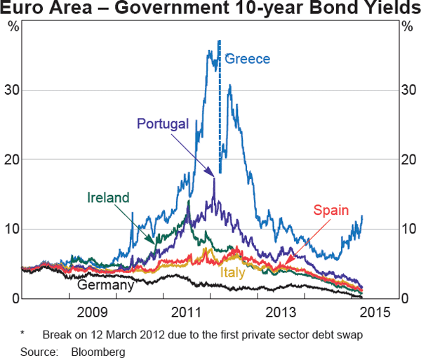
Calculation Example: Expected YTM
In late 2011, suppose that 10 year 3% pa coupon bonds issued by the government of:
- Germany promised 4% pa yields to maturity; while
- Greece promised 30% pa yields to maturity.
Assume that the market believe that:
- German government bonds have no credit risk, so the face value and coupons will be fully repaid on time; while the
- Greek government will repay only a fraction of the face value at maturity and nothing after. Though the coupons will be fully repaid on time.
Find the Greek government bonds’ expected yield to maturity (YTM) of debt and estimate the proportion of the face value that the Greek government will repay at maturity.
$$P_{0}=\frac{C_{1}}{r_{expected}}\left(1-\frac{1}{{\left(1+r_{expected}\right)}^{T}}\right)+\frac{F_{T}}{{\left(1+r_{expected}\right)}^{T}}$$
$$P_{0}=\frac{C_{1}}{r_{promised}}\left(1-\frac{1}{{\left(1+r_{promised}\right)}^{T}}\right)+\frac{F_{T}}{{\left(1+r_{promised}\right)}^{T}}$$

Expected YTM = IRR of Buying Bond
If a bond’s coupons can be re-invested in other bonds at the same expected YTM, then this expected YTM is also the internal rate of return (IRR) of buying the bond.
$$NPV=C_{0}+\frac{C_{1}}{{\left(1+r_{req}\right)}^{1}}+\frac{C_{2}}{{\left(1+r_{req}\right)}^{2}}$$
$$0 =C_{0}+\frac{C_{1}}{{\left(1+r_{IRR}\right)}^{1}}+\frac{C_{2}}{{\left(1+r_{IRR}\right)}^{2}}$$
$$P_{0bond}=\frac{C_{1}}{r_{IRR}}\left(1-\frac{1}{{\left(1+r_{IRR}\right)}^{T}}\right)+\frac{F_{T}}{{\left(1+r_{IRR}\right)}^{T}}$$
$$0 =-P_{0bond}+\frac{C_{1}}{r_{IRR}}\left(1-\frac{1}{{\left(1+r_{IRR}\right)}^{T}}\right)+\frac{F_{T}}{{\left(1+r_{IRR}\right)}^{T}}$$

