Markowitz Portfolio Theory
- Expected returns, variance, covariance and correlation.
- Portfolio return and risk with two assets.
- Short selling.
- Two stock portfolio combination lines.
- Three or more stock portfolios.
- Markowitz bullet of risky assets
- Tangent portfolio, Sharpe ratio and CML.
- Two fund separation theorem.
- Portfolio optimisation using spreadsheets.
Single Period Returns
Total discretely compounding return from time $0$ to $1$:

$$r_{0-1}=\frac{p_{1}-p_{0}+div_{1}}{p_{0}}=\frac{p_{1}+div_{1}}{p_{0}}-1$$

Where
$p_{0}=$ price at time zero, or the buy price
$p_{1}=$ price at time one, or the sell price
$div_{1}=$ dividend cash flow received at time one.
Arithmetic Average Returns

Arithmetic average return from time $0$ to $n$:
$${\overline{r}}_{ 0-n}=\frac{\sum_{i=1}^{n}{\left(r_{i}\right)}}{n}=\frac{r_{1}+r_{2}+…+r_{n}}{n}$$

Risk
The common sense idea of risk is the chance of losing money.
However, in finance risk tends to be measured as the deviation of returns around the expected (average) return because this makes the mathematics more tractable. Note that this definition of risk means that deviation below and above the expected return is classified as risk.

Measures of Risk: Variance and
Standard Deviation

Variance of returns over n periods:
$$var\left(r\right)=σ^{2}=\frac{\sum_{i=1}^{n}{\left[{\left(r_{i}-\overline{r}\right)}^{2}\right]}}{n-1}$$

Standard deviation of returns over n periods:
$$sd\left(r\right)=σ=\sqrt{var\left(r\right)}=\sqrt{\frac{\sum_{i=1}^{n}{\left[{\left(r_{i}-\overline{r}\right)}^{2}\right]}}{n-1}}$$
Sample and Population Statistics
- Note that the above variance and standard deviation formulas are sample statistics since we divide by (n-1).
- For population versions of these formulas, divide by (n) instead of (n-1).
- We almost always use the sample statistic formulas since we usually work with a sample of time series data.
- Strictly, the symbol for sample variance and sample standard deviation should be written as $s^{2}$ and $s$, not $σ^{2}$ and $σ$. But in this course we’ll use the latter notation.

Covariance and Correlation over Time
Covariance of returns between stocks A and B over n periods:
$$cov\left(r_{A}, r_{B}\right)=σ_{A,B}=\frac{\sum_{i=1}^{n}{\left[\left(r_{A,i}-{\overline{r}}_{A}\right)\left(r_{B,i}-{\overline{r}}_{B}\right)\right]}}{n-1}$$
Correlation coefficient of returns between stocks A and B:
$$correl\left(r_{A}, r_{B}\right)=ρ_{A,B}=\frac{cov\left(r_{A}, r_{B}\right)}{sd\left(r_{A}\right).sd\left(r_{B}\right)}=\frac{σ_{A,B}}{σ_{A}{.σ}_{B}}$$
The correlation coefficient is more intuitively useful since it will always be between -1 and 1, whereas the covariance could be anything from +∞ to -∞.
Strictly, the correlation coefficient is only defined between two variables. The correlation between a constant (with zero standard deviation) and a variable will lead to a division by zero which is undefined.

Correlation: How It Looks
$$ρ=1$$  Perfectly positive | $$ρ=0$$  Independent | $$ρ=-1$$  Perfectly negative
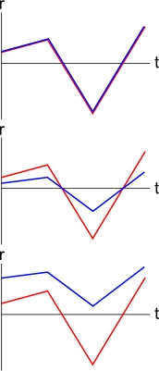 | 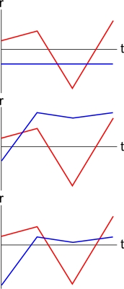 | 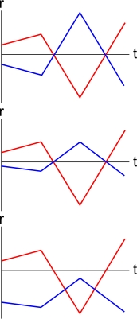
Diversification and Correlation
Diversification is the reduction of risk by combining assets in a portfolio.
The amount of diversification achievable is inversely related to the correlation of returns between assets in a portfolio.
The higher the correlation between two assets, the less diversification that’s possible when combining them in a portfolio, which is a pity. For example, two bank stocks are likely to have a high correlation with each other (close to one), so a portfolio of these two similar stocks is unlikely to reduce risk much at all.
Ideally, negative correlations are the best.

Calculation Example
Q1) Find the discrete yearly returns of stocks CBA and BHP from the following price data.
Date | Adjusted Closing Price ($)
 | CBA | BHP
1/1/2007 | 48.39 | 25.17
2/1/2008 | 47.77 | 36.31
2/1/2009 | 26.01 | 30.11
4/1/2010 | 51.47 | 38.9
4/1/2011 | 52.46 | 44.25

To find CBA’s return from 2010 to 2011,
$$r_{CBA, 2010→2011}=\frac{p_{4/1/2011}}{p_{4/1/2010}}-1$$
$$=\frac{52.46}{51.47}-1=0.0192$$
And so on. Here are the complete results:
Date | Return (p.a.)
 | CBA | BHP
1/1/2007
2/1/2008 | -0.0128 | 0.4426
2/1/2009 | -0.4555 | -0.1708
4/1/2010 | 0.9789 | 0.2919
4/1/2011 | 0.0192 | 0.1375
Q2) Calculate the arithmetic mean, variance and standard deviation of returns.
$${\overline{r}}_{\begin{aligned}CBA, \\ 2007→ \\ 2011,pa\end{aligned}}=\frac{r_{CBA,07→08}+r_{CBA,08→09}+r_{CBA,09→10}+r_{CBA,10→11}}{n}$$
$$=\frac{-0.0128-0.4555+0.9789+0.0192}{4} =0.1324$$
$$var\left(r\right)=σ^{2}=\frac{\sum_{i=1}^{n}{\left[{\left(r_{i}-\overline{r}\right)}^{2}\right]}}{n-1}$$
$$σ_{CBA, 2007→2011,p.a.}^{2}=\frac{\left[\begin{aligned}{\left(-0.0128-0.1324\right)}^{2}+ \\ {\left(-0.4555-0.1324\right)}^{2}+ \\ {\left(0.9789-0.1324\right)}^{2}+ \\ {\left(0.0192-0.1324\right)}^{2}\end{aligned}\right]}{4-1}=0.3653$$
$$σ_{CBA, 2007→2011,p.a.}^{2}=0.3653$$
$$σ_{CBA, 2007→2011,p.a.}=\sqrt{0.3653}$$
$$=0.6044$$
Similarly for BHP. Here are the complete results:
 | CBA | BHP
Return | 0.1324 | 0.1753
Variance | 0.3653 | 0.0687
St. dev. | 0.6044 | 0.2622

Q3) Calculate the covariance and correlation of their returns.
$$cov\left(r_{A}, r_{B}\right)=σ_{A,B}=\frac{\sum_{i=1}^{n}{\left[\left(r_{A,i}-{\overline{r}}_{A}\right)\left(r_{B,i}-{\overline{r}}_{B}\right)\right]}}{n-1}$$
$$σ_{CBA,BHP, 2007→2011,p.a.}=$$
$$\frac{\left[\begin{aligned}\left(-0.0128-0.1324\right)×\left(0.4426-0.1753\right)+ \\ \left(-0.4555-0.1324\right)×\left(-0.1708-0.1753\right)+ \\ \left(0.9789-0.1324\right)×\left(0.2919-0.1753\right)+ \\ \left(0.0192-0.1324\right)×\left(0.1375-0.1753\right)+\end{aligned}\right]}{4-1}$$
$$σ_{CBA,BHP, 2007→2011,p.a.}=0.0892$$

$$correl\left(r_{1}, r_{2}\right)=ρ_{1,2}=\frac{cov\left(r_{1}, r_{2}\right)}{sd\left(r_{1}\right).sd\left(r_{2}\right)}=\frac{σ_{1,2}}{σ_{1}{.σ}_{2}}$$
$$ρ_{CBA,BHP, 2007-2011,p.a.}=\frac{0.0892}{0.6044×0.2622}$$
$$=0.5629$$
 | CBA | BHP
Covariance | 0.0892
Correlation | 0.5629

In conclusion, BHP has a higher return and lower risk than CBA. The correlation is not near one so a fair amount of diversification is possible.
Expected Returns: $E[r_{i}]=μ_{i}={\overline{r}}_{i}$
Stock returns are random variables that change all of the time.
The expected return of a stock is what you expect the stock’s return to be in the future. Usually the best estimate of the expected return is the historical average of the stock’s random returns. So expected return is equal to the average return.
The expected return $E[r_{i}]$ is a constant since it doesn’t change.
$r_{i}$ represents stock $i$’s random return. It’s a variable.
$E[r_{i}]$ represents stock $i$’s expected return. It’s a constant.
$μ_{i}$ is another common notation for $E(r_{i})$, pronounced ‘mu’.
${\overline{r}}_{i}$ represents the average return, pronounced ‘r-bar’.
Graphs of Random and Expected Returns
The difference between $r_{i}$ and $E[r_{i}]$ or $μ_{i}$ or ${\overline{r}}_{i}$ can be seen in the below graphs. The graph on the left has time on the x-axis. $r_{i,t}$ is stock i’s random return over day t, that is from time t-1 to t. The blue line is the average. On the graph on the right, stock i is plotted on the $μ$-$σ$ graph as a single point.
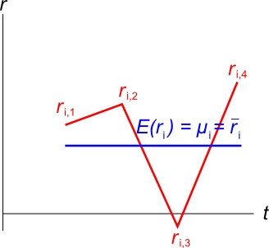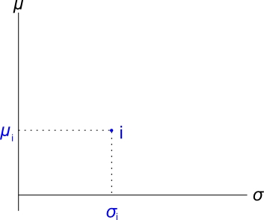
Stock Choice
For each diagram which is better, A or B?

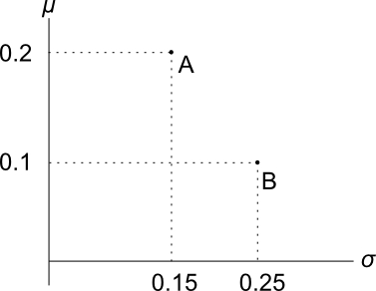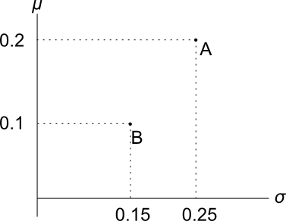

- In the left diagram, A is clearly better than B since it has more return and less risk.
- In the right diagram, A has a higher return than B, but more risk. So the best stock will depend on the investor’s preferences or ‘risk appetite’.
  - But investors are not limited to invest in just one. They could buy a portfolio - some of A and some of B.
  - Having more portfolios and more choices is good.
  - By mixing stocks overall portfolio risk should be reduced due to diversification.
  - The effect is that the risk of the whole (the portfolio) is less than the sum of the parts (the stocks).

Portfolios and Diversification
Let P be a $100 portfolio with $50 invested in A and $50 in B.
- Therefore P is an equal-weighted portfolio in A and B. So:
$x_{A}=0.5$, $x_{B}=0.5$
- Return will be exactly halfway at 0.15.
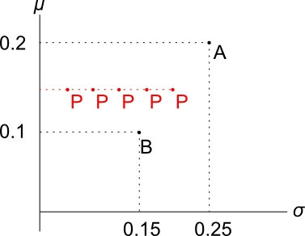
- Standard deviation is likely to be less than halfway (0.2) due to diversification - we didn’t “put all of our eggs in one basket”.
- So P will be somewhere along the dashed red line. The standard deviation of P depends on the correlation between A and B.
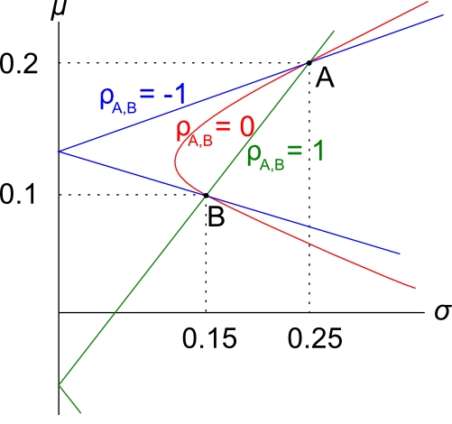
How Correlation Affects Diversification
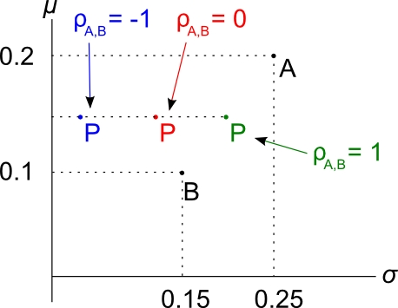
- $ρ_{A,B}=-1$, lots of diversification since A and B move in opposite directions.
- $ρ_{A,B}=0$, diversification since A and B move independently and will sometimes cancel each other out.
- $ρ_{A,B}=1$, no diversification at all since A and B move with each other in the same ratio. In this case $σ_{P}=0.2$.
Portfolio Return and Variance
Portfolio return for $n$ stocks with weights $x$:
$$r_{P}=x_{1}.r_{1}+x_{2}.r_{2}+…+x_{n}.r_{n}=\sum_{i=1}^{n}{(x_{i}.r_{i})}$$
Note that the weights must sum to one:
$$x_{1}+x_{2}+…+x_{n}=1$$
Portfolio variance for 2 stocks with weights $x_{1}$ and $x_{2}$:
$${σ_{P}}^{2}=x_{1}^{2} .σ_{1}^{2}+x_{2}^{2} .σ_{2}^{2}+2{{.x}_{1}.x_{2}.σ}_{1,2}$$

Portfolio Return and Variance Example
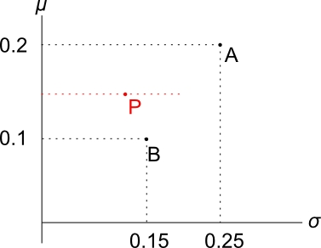
Question: Portfolio P in the diagram has a weight of 0.5 in A and 0.5 in B. The correlation between A and B is 0.05. Find the return and variance of portfolio P.
Answer:
$$r_{P}=x_{A}.r_{A}+x_{B}.r_{B}$$
$$=0.5×0.2+0.5×0.1$$
$$=0.15$$

Since $ρ_{A,B}=0.05$, portfolio variance is:
$${σ_{P}}^{2}=x_{A}^{2} .σ_{A}^{2}+x_{B}^{2} .σ_{B}^{2}+2{.x}_{A}.x_{B}.σ_{A,B}$$
and
$$σ_{A,B}=ρ_{A,B}.σ_{A}.σ_{B}$$
So:
$${σ_{P}}^{2}=x_{A}^{2} .σ_{A}^{2}+x_{B}^{2} .σ_{B}^{2}+2{.x}_{A}.x_{B}.ρ_{A,B}.σ_{A}.σ_{B}$$
$$={0.5}^{2}×{0.25}^{2} + {0.5}^{2}×{0.15}^{2} +$$
$$+ 2×0.5×0.5×0.05×0.25×0.15$$
$${σ_{P}}^{2}=0.0221875$$
$σ_{P}=0.1490$ Notice that the standard deviation of P is less than both A and B’s standard deviation. This shows how diversification can lower risk.
Portfolio Weights: to be Long or Short
- Portfolio weights in an investment must sum to one:
$$x_{1}+x_{2}+…+x_{n}=1$$
- Individual weights may be negative. This corresponds to selling or short selling.
- Short selling can be achieved by borrowing a stock and selling it, and then later buying another of the same stock and returning it to the stock lender.
- Investors who are:
  - ‘short’ must have sold the stock. They make money when prices fall.
  - ‘long’ must have bought the stock. They make money when prices rise.
Combination Lines: Weights and Returns
For a portfolio P invested in only 2 stocks A and B,
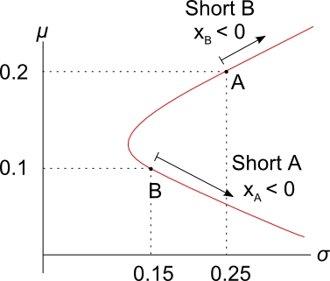
- P must lie on the combination line.
- If P has a positive weight in A and B (long A and B), its return must be between 0.1 and 0.2.
- If P has a negative weight in B (short B), then it must have a weight of more than one in A (long A), and a return of more than 0.2.
- Vice versa for a negative weight in A (short A).
Calculation Example: Short Selling
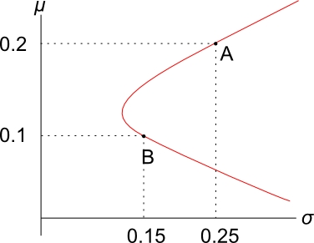
Question: An investor starts with $100 of wealth. She short sells $150 of stock B by borrowing stock B from an investment bank (paying a small fee which you can ignore). Then she sells stock B for $150 on the stock exchange. With the $250 that she now has, she buys $250 of stock A. This all happens at t=0.
Later, at t=1, she will sell stock A and then buy stock B on the exchange to give back to the investment bank.
Using the information in the diagram, what is the expected return of her portfolio?
Answer 1 (using weights, the quick way):
Calculate the weights in each stock:
$x_{A}=\frac{+250}{100}=2.5$, we use +$250 since we longed stock A.
$x_{B}=\frac{-150}{100}=-1.5$, we use -$150 since we shorted stock B.
Check that the weights sum to one: $x_{A}+x_{B}=2.5-1.5=1$
To find the portfolio return,
$$μ_{P}=x_{1}μ_{1}+x_{2}μ_{2}+…+x_{n}μ_{n}$$
$$μ_{P}=x_{A}μ_{A}+x_{B}μ_{B}$$
$$=2.5×0.2+ -1.5×0.1$$
$$=0.35$$
Answer 2 (using dollars, the long way):
Note that returns are expressed per year and the investment is over one year. Let $P_{it}$ be the price of stock ‘i’ at time ‘t’:
$P_{A0}=250$ (Price of stock A at time 0)
$P_{B0}=150$ (Price of stock B at time 0)
The portfolio price ($P_{P}$) at t = 0 is long 1 stock A ($n_{A}=1$) and short 1 stock B ($n_{B}=-1$):
$$P_{port0}=n_{A}.P_{A0}+n_{B}.P_{B0}$$
$$=1×250-1×150$$
$=100$ which was her wealth at the start.

Having a negative number of stock B ($n_{B}=-1$) seems strange.
But if you look at the portfolio from the point of view of the balance sheet, where assets (V=D+E) equals liabilities (D) plus equity (E), the portfolio price is the equity or net wealth, stock A is the asset and stock B is the liability since it’s borrowed:
$$E = V - D$$
$$100 = 250 -150$$

Let’s find stock A and B’s expected prices $P_{A1}$ and $P_{B1}$.
In one year the lady will have to pay back the stock lender a single stock B. She owes one stock.
Stock B’s price in one year is expected to be:
$P_{B1}=P_{B0}{\left(1+μ_{B}\right)}^{1}$ (Expected price of stock B at time 1)
$$=\$150×\left(1+0.1\right)$$
$$=\$165$$
So in one year the lady expects to have to pay $165 to buy stock B from some other third party owner, and give that newly purchased share B to the stock lending bank.
There might appear to be a problem here because stock B’s price should grow by the capital return (=total return minus dividend yield) rather than the total return $μ_{B}$, since the lady will have to buy one stock B from somebody and pay its price, not any dividends.
However, usually short selling contracts specify that the stock borrower (lady) must pay the dividends back to the stock lender (bank) when the dividends are paid from company B to the lady who holds the title to the stock.
Therefore if you regard the ‘prices’ $P_{B0}$ and $P_{B1}$ instead as values of the price and dividends, then it’s correct to grow the value at time zero into the value at time 1 by the total return.
Alternatively, for simplicity you can assume that the stock pays no dividends so the total return is the capital return.

The lady’s stock A asset it’s much simpler, its expected price is:
$$P_{A1}=P_{A0}{\left(1+μ_{A}\right)}^{1}$$
$$=\$250×\left(1+0.2\right)$$
$$=\$300$$
The portfolio value at t = 1 is:
$$P_{port1}=n_{A}.P_{A1}+n_{B}.P_{B1}$$
$$=1×300-1×165$$
$$=135$$
Now we can calculate the portfolio return over the year:
$$μ_{port0→1}=\frac{P_{port1}}{P_{port0}}-1 =\frac{135}{100}-1 =0.35$$
Constructing the 2-stock Markowitz Bullet
- In a two-stock world, the combination line is the Markowitz bullet.
- The line passes through the 2 stocks on the return-standard deviation graph.
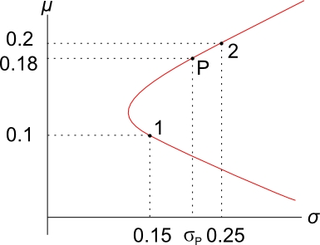
Calculation Example
Q) Using the information in the diagram, find the variance of a portfolio with a target return of 0.18. Assume $ρ_{1,2}=0.3$.
A) There are 2 steps:
- Find the weight in stock 1 that yields the given return using the portfolio return equation:
$$r_{P}=x_{1}.r_{1}+x_{2}.r_{2}$$
Together with the ‘weights sum to one’ equation:
$x_{1}+x_{2}=1$, so $x_{2}=1-x_{1}$
So,
$$r_{P}=x_{1}.r_{1}+\left(1-x_{1}\right).r_{2}$$
$$0.18=x_{1}×0.1+\left(1-x_{1}\right)×0.2$$
After solving to find $x_{1}$,
$$x_{1}=0.2$$
Therefore
$$x_{2}=1-0.2=0.8$$
These weights make sense since the target return of 0.18 is between stock 1 and 2’s returns so we should be long both stocks, which we are since both weights are positive.

- Now calculate the portfolio variance by substituting the weights $x_{1}$ and $x_{2}$ into the portfolio variance equation:

$${σ_{P}}^{2}=x_{1}^{2} .σ_{1}^{2}+x_{2}^{2} .σ_{2}^{2}+2{.x}_{1}.x_{2}.ρ_{1,2}.σ_{1}.σ_{2}$$

$$=\begin{matrix}{0.2}^{2}×{0.15}^{2}+{0.8}^{2}×{0.25}^{2}+ \\ 2×0.2×0.8×0.3×0.15×0.25\end{matrix}$$
$$=0.0445$$

$$σ_{P} =0.2110$$

Portfolios of 3 or More Stocks
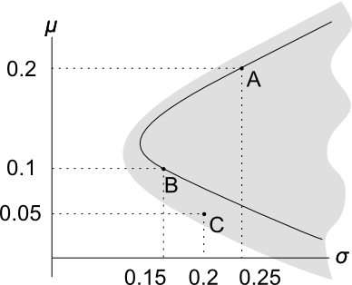
- Portfolios of only 2 stocks are restricted to a combination line. The combination line comprising stocks A and B is shown in black.

- After adding stock C, a whole area of portfolios are possible. There is a portfolio possibility ‘cloud’, which is the grey area in the graph.

Constructing the 3+ Stock Markowitz Bullet
This requires a formula for multi-stock portfolio variance.
 | $$x_{1}$$ | $$x_{2}$$ | $$x_{3}$$ | $$x_{4}$$ |  | The grey-shaded part of the table is called the variance-covariance matrix. It has the variance of each stock along the diagonal, and covariances elsewhere.  Note that $σ_{1,2}=σ_{2,1}$ and $σ_{1,1}=σ_{1}^{2}$
$$x_{1}$$ | $${σ_{1}}^{2}$$ | $$σ_{1,2}$$ | $$σ_{1,3}$$ | $$σ_{1,4}$$
$$x_{2}$$ | $$σ_{2,1}$$ | $${σ_{2}}^{2}$$ | $$σ_{2,3}$$ | $$σ_{2,4}$$
$$x_{3}$$ | $$σ_{3,1}$$ | $$σ_{3,2}$$ | $${σ_{3}}^{2}$$ | $$σ_{3,4}$$
$$x_{4}$$ | $$σ_{4,1}$$ | $$σ_{4,2}$$ | $$σ_{4,3}$$ | $${σ_{4}}^{2}$$
Portfolio variance is equal to the sum of each term in the variance-covariance matrix multiplied by its corresponding two weights.
$${σ_{P}}^{2}=x_{1}x_{1}σ_{1,1}+x_{1}x_{2}σ_{1,2}+…+x_{4}x_{3}σ_{4,3}+x_{4}x_{4}σ_{4,4}$$
After collecting like terms and re-arranging, we have the 4-stock portfolio variance equation:
$${σ_{P}}^{2}=x_{1}^{2}σ_{1}^{2} +x_{2}^{2}σ_{2}^{2} +x_{3}^{2}σ_{3}^{2} +x_{4}^{2}σ_{4}^{2}+$$
$${2x_{1}x}_{2}σ_{1,2}+{{2x}_{1}x}_{3}σ_{1,3}+{{2x}_{1}x}_{4}σ_{1,4}+$$
$$2{x_{2}x}_{3}σ_{2,3}+2{x_{2}x}_{4}σ_{2,4}+$$
$$2{x_{3}x}_{4}σ_{3,4}$$
Here’s the 3-stock portfolio variance equation:
$${σ_{P}}^{2}=x_{1}^{2}σ_{1}^{2} +x_{2}^{2}σ_{2}^{2} +x_{3}^{2}σ_{3}^{2}$$
$${2x_{1}x}_{2}σ_{1,2}+{{2x}_{1}x}_{3}σ_{1,3}+$$
$$2{x_{2}x}_{3}σ_{2,3}$$

The Markowitz Bullet and the Efficient Frontier of Risky Assets (excluding r_{f})
- The Markowitz bullet is the boundary line that contains the minimum risk portfolios for each return.
- Also called the Minimum Variance Set (MVS) of risky assets or the portfolio possibility frontier.
- The top half of the Markowitz bullet is called the efficient frontier.
- The portfolios that comprise the efficient frontier are the only ones worth investing in because they give the highest return for a given standard deviation.
- Mathematically, the bullet shaped graph is a hyperbola.
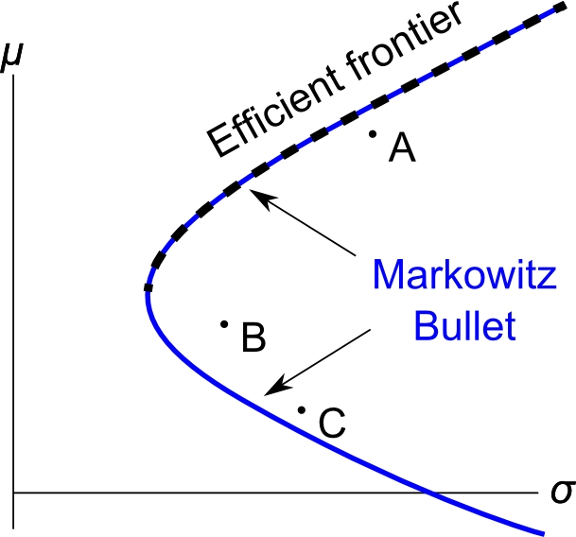
The Markowitz Bullet with Short Selling Restrictions
- To short sell stock, investors must locate a stock lender, usually a broker or investment bank. The broker charges a fee for lending the stock.
- Sometimes a stock lender cannot be found or the fee is prohibitive.
- In 2008/09, shorting financial stocks was made illegal for some time.
- Restrictions on short selling lead to a shrunk Markowitz bullet.

- Without short selling, the highest return possible is that of the highest return stock. You cannot have a weight of more than 1 in the highest return stock because weights must sum to 1 and negative weights in other stocks means short selling.
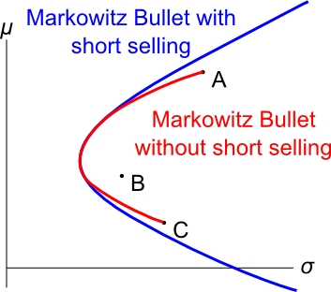
- In common sense terms, you can’t earn a return more than the highest return stock since you can’t invest more than your wealth. To over-invest you must borrow some asset which is short-selling that asset.

The Risk Free Rate (r_{f}) and the Minimum Variance Set of All Assets
- Risk-free securities have zero standard deviation of returns. Government bonds (also called Treasuries) are assumed to be risk free securities.
- The return of the risk-free security is referred to as $r_{f}$. It’s also used to refer to the security itself.
- When $r_{f}$ is included, the new MVS becomes a line from $r_{f}$ through the tangency portfolio (T) on the Markowitz bullet.
- $r_{f}$ is a constant, so it has zero variance, and zero covariance with other securities.
- $r_{f}=E\left(r_{f}\right)=μ_{rf}$, since $r_{f}$ is a constant.
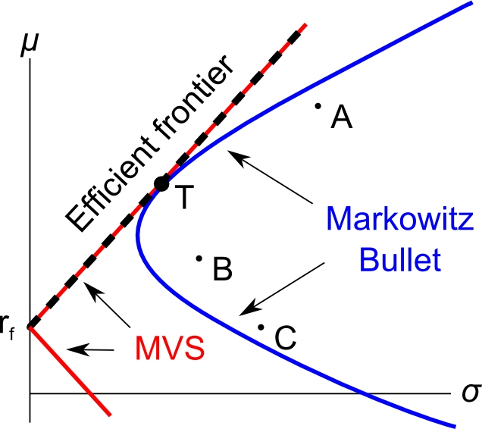
The Tangency Portfolio
- The tangency portfolio T is the only risky portfolio worth investing in. It is comprised of the stocks A, B and C.
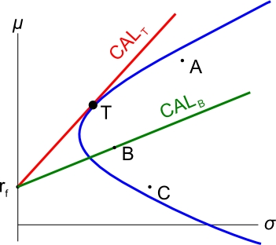
- For any level of risk (standard deviation), the highest return possible can be achieved by investing in T and $r_{f}$.
- Lines from $r_{f}$ through any portfolio are called Capital Allocation Lines.
- The CAL through T has the best risk-return trade off. It has the steepest gradient (rise/run).
- The gradient of the CAL is also called the Sharpe ratio.
Sharpe Ratio
The Sharpe ratio (S) of a stock is the gradient of the line from $r_{f}$ through the stock. It is the gradient of the stock’s CAL.
$S_{i}=\frac{μ_{i}-r_{f}}{σ_{i}}$
Where $S_{i}$ is the Sharpe ratio of stock ‘i’, $μ_{i}$ is its expected return and $σ_{i}$ is its standard deviation.
In the diagram, portfolio T’s Sharpe ratio is greater than stock B’s since the CAL through T is steeper. Therefore portfolio T is preferable to stock B.
The Market Portfolio
- The market portfolio M is the tangency portfolio of all risky assets.
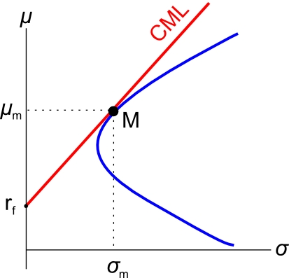
- The line through M and $r_{f}$is called the Capital Market Line (CML).

- The CML has the steepest gradient, therefore the market portfolio has the highest Sharpe ratio.
Equation of the Capital Market Line (CML)
$μ=r_{f}+σ\left(\frac{μ_{m}-r_{f}}{σ_{m}}\right)$
This is easy to see since the:
- y-axis is expected return $μ$
- x-axis is standard deviation $σ$
- y-intercept is $r_{f}$
- gradient $\frac{rise}{run}$ between $r_{f}$ and M is $\frac{μ_{m}-r_{f}}{σ_{m}}$
So in $y=mx+b$ form:
$$μ=\left(\frac{μ_{m}-r_{f}}{σ_{m}}\right)σ+r_{f}$$
Calculation Example
Question: Assume a 3-stock world consisting of A, B and C, as well as the risk free security. The market portfolio has been calculated to have weights 1/3 in each of A, B and C. The risk free rate $r_{f}=0.05$, the market return is $r_{m}=0.3$ and the market’s standard deviation is $σ_{m}=0.2$.
Find the weights in stocks A, B, C and $r_{f}$ which makes an efficient portfolio (P) with a return of $r_{p target}=0.1$. Also find this portfolio’s standard deviation $σ_{p target}$.
Answer: An efficient portfolio has minimum variance (or st. dev.) for a given return. All portfolios on the CML are efficient. Therefore we need only consider investing in the market portfolio (M) and the risk free rate ($r_{f}$).
To find the weights we need to invest in M and $r_{f}$, we will use the portfolio return equation, with a target portfolio return of 0.1:
$$r_{P}=x_{1}.r_{1}+x_{2}.r_{2}+…+x_{n}.r_{n}$$
$$0.1=x_{M}×0.3 + x_{rf}×0.05$$
Now we’re stuck since we have 2 unknowns ($x_{M}$ and $x_{rf}$) and only one equation so we can’t find either of the weights. But there is another equation, the ‘sum of the weights equals one’:
$$x_{1}+x_{2}+…+x_{n}=1$$
$$x_{M}+x_{rf}=1$$
$$x_{rf}=1-x_{M}$$
Substitute this into the portfolio return equation to get:
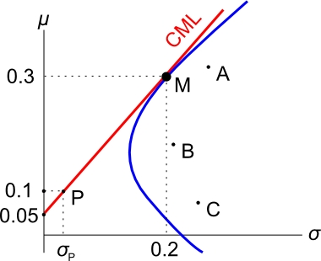
$0.1=x_{M}×0.3 +(1-x_{M})×0.05$
$$x_{M}=0.2$$
So, $x_{rf}=1-0.2=0.8$
This makes sense since the target return of 0.1 is closer to $r_{f}$ so it should have a larger weight in $r_{f}$ than M.
Since M is 1/3 in each of A, B and C, the weights in A, B and C are simply 1/3 of the weight in M:
$$x_{A}=x_{B}=x_{C}=\frac{1}{3}×x_{M}$$
$$=\frac{1}{3}×0.2=\frac{3}{15}=0.0666667$$
To find this efficient portfolio’s standard deviation, we could use the 2-stock portfolio variance equation with $r_{f}$ and M and the weights we just found, together with the fact that the covariance of $r_{M}$ with $r_{f}$is zero since $r_{f}$ is a constant:

$${σ_{P}}^{2}=x_{1}^{2} .σ_{1}^{2}+x_{2}^{2} .σ_{2}^{2}+2{{.x}_{1}.x_{2}.σ}_{1,2}$$

But another faster method is to use the CML equation instead:
$r_{P}=\left(\frac{μ_{m}-r_{f}}{σ_{m}}\right)σ_{P}+r_{f}$
Where $r_{P}$ is the return of our efficient portfolio of 0.1, and $σ_{P}$ is the variable we are trying to find.
$$0.1=\left(\frac{0.3-0.05}{0.2}\right)σ_{P}+0.05$$
$σ_{P}=0.04$

Tobin’s Two Fund Separation Theorem
The Two Fund Separation Theorem says that the investing and financing decision are separate problems:
- The investment decision: which risky assets comprise the market portfolio? It is the purely technical problem of identifying the market portfolio – finding the weights in the risky assets which give the tangency portfolio.

- The financing decision: how much to invest in $r_{f}$ and how much to invest in the market portfolio M? This depends on the investor’s risk preferences.

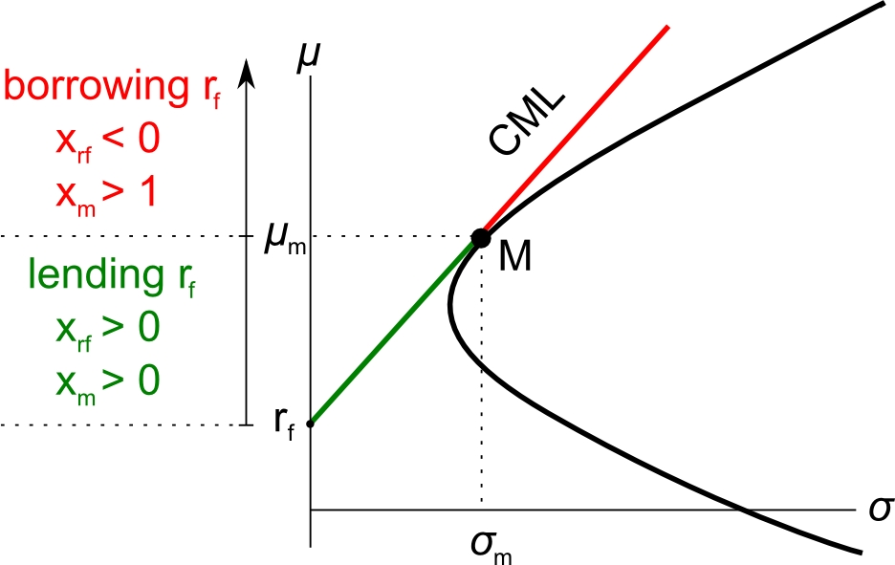
Time Series Calculations
Question: Using the following data, calculate the discrete yearly returns of the stocks, as well as the arithmetic average return, standard deviation, variance, covariance and correlation of their returns.
Date | Adjusted Closing Price ($)
 | CBA | BHP
4/1/2011 | 52.46 | 44.25
4/1/2010 | 51.47 | 38.9
2/1/2009 | 26.01 | 30.11
2/1/2008 | 47.77 | 36.31
1/1/2007 | 48.39 | 25.17
Time Series Calculations – MS Excel
 | A | B | C
1 | Date | Return (p.a.) | Return (p.a.)
2 |  | CBA | BHP
3 | 4/1/2011
4 | 4/1/2010 | 0.0192 | 0.1375
5 | 2/1/2009 | 0.9789 | 0.2919
6 | 2/1/2008 | -0.4555 | -0.1708
7 | 1/1/2007 | -0.0128 | 0.4426
8
9 | average | =average(B4:B7) | =average(C4:C7)
10 | var | =var(B4:B7) | =var(C4:C7)
11 | stdev | =stdev(B4:B7) | =var(C4:C7)^(1/2)
12 | covar | =covar(B4:B7, C4:C7)*4/(4-1)
13 | correl | =correl(B4:B7, C4:C7)
14
Multi-stock Portfolio Variance
Question: Assume there are 3 stocks with the following variances and covariances:
$σ_{1}^{2}=0.01$
$$σ_{2}^{2}=0.04$$
$$σ_{3}^{2}=0.09$$
$$σ_{1,2}=0.01$$
$$σ_{1,3}=0.015$$
$$σ_{2,3}=0.03$$
Find the variance of an equi-weighted portfolio of these 3 stocks.
 | A | B | C | D
1 | weights | =1/3 | =1/3 | =1/3
2 | =B1 | 0.01 | 0.01 | 0.015
3 | =C1 | =C2 | 0.04 | 0.03
4 | =D1 | =D2 | =D3 | 0.09
5 | Sumproduct method
6 |  | =sumproduct(B2:B4,$A$2:$A$4) | =sumproduct(C2:C4,$A$2:$A$4) | =sumproduct(D2:D4,$A$2:$A$4)
7 | var(P) | =sumproduct(B6:D6,B1:D1) | 0.027777778
8 | Matrix method
9 | var(P) | =mmult(mmult(B1:D1, B2:D4), A2:A4) | 0.027777778
10 | Note: you must press ctrl+shift+enter after
11 | typing the matrix formula in B9.
12
MS Excel: Tangency Portfolio
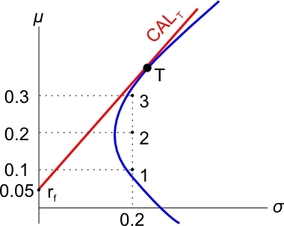
Question:
Find the tangency portfolio T by investing in the 3 stocks whose returns and standard deviations are given in the below graph. The return of the risk free rate is also given in the graph. Additionally, the correlations between the stocks are all 0.5.

Answer:
Graphically, we are trying to find the weights in stocks 1, 2 and 3 which give the tangency portfolio T. We’ll do this by maximizing the gradient of the CAL. The gradient is the Sharpe ratio.
The maximization part requires the MS Excel add-in ‘solver’.
First enter the below cells:

 | A | B | C | D
1 | stock | 1 | 2 | 3
2 | stock return | 0.1 | 0.2 | 0.3
3 | weight in P | =1/3 | =1/3 | =1/3
4
5 | var-cov matrix | 0.04 | 0.02 | 0.02
6 |  | =C5 | 0.04 | 0.02
7 |  | =D5 | =D6 | 0.04
8
9 | rf | 0.05
10 | var(P) | =MMULT(MMULT(B3:D3, B5:D7), TRANSPOSE(B3:D3))
11 | stdev(P) | =B10^0.5
12 | return(P) | =MMULT(B2:D2, TRANSPOSE(B3:D3))
13 | sum of weights | =SUM(B3:D3)
14 | Sharpe ratio(P) | =(B12-B9)/B11
15 | Note: you must press ctrl+shift+enter after
16 | typing the matrix formulas in B10 and B12.
17

Now we have to install the solver add-in.
- Click the ‘File’ button in the top left of MS Excel, and a menu should pop up.
- Click ‘Options’ in the bottom of the menu, and a window should pop up.
- Click ‘Add-Ins’ on the left margin of the menu.
- Click on the ‘Solver Add-in’ and then click on the ‘Go’ button. Don’t click OK, that does nothing!
- Another menu will pop up. Make sure ‘Solver Add-in’ is ticked, then click OK.
- Click on the ‘Data’ tab at the top of the excel window.
- You should now see a ‘Solver’ button on the right.
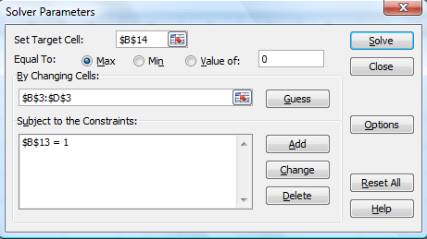
- Click the solver button and fill out the solver menu as follows:
- What we’re trying to do is maximize the Sharpe ratio (B14) by changing the weights (B3:D3), while keeping the sum of the weights equal to one (B13).
- Click solve, and hopefully you get the following results, which gives us the weights in the tangency portfolio, as well as its return and standard deviation:
 | A | B | C | D
1 | stock | 1 | 2 | 3
2 | stock return | 0.1 | 0.2 | 0.3
3 | weight in P | -0.555570888 | 0.3333 | 1.2222
4
5 | var-cov matrix | 0.04 | 0.02 | 0.02
6 |  | 0.02 | 0.04 | 0.02
7 |  | 0.02 | 0.02 | 0.04
8
9 | rf | 0.05
10 | var(P) | 0.058273088
11 | stdev(P) | 0.241398194
12 | return(P) | 0.377781949
13 | sum of weights | 1
14 | Sharpe ratio(P) | 1.357847561
15 | Note: you must press ctrl+shift+enter after
16 | typing the matrix formulas in B10 and B12.
17
Note that portfolio P here is actually the tangency portfolio T.

