Single Period Returns
Total discretely compounding return from time $0$ to $1$:

$$r_{0-1}=\frac{p_{1}-p_{0}+div_{1}}{p_{0}}=\frac{p_{1}+div_{1}}{p_{0}}-1$$

Where
$p_{0}=$ price at time zero, or the buy price
$p_{1}=$ price at time one, or the sell price
$div_{1}=$ dividend cash flow received at time one.
Arithmetic Average Returns

Arithmetic average return from time $0$ to $n$:
$${\overline{r}}_{ 0-n}=\frac{\sum_{i=1}^{n}{\left(r_{i}\right)}}{n}=\frac{r_{1}+r_{2}+…+r_{n}}{n}$$

Risk
The common sense idea of risk is the chance of losing money.
However, in finance risk tends to be measured as the deviation of returns around the expected (average) return because this makes the mathematics more tractable. Note that this definition of risk means that deviation below and above the expected return is classified as risk.

Measures of Risk: Variance and
Standard Deviation

Variance of returns over n periods:
$$var\left(r\right)=σ^{2}=\frac{\sum_{i=1}^{n}{\left[{\left(r_{i}-\overline{r}\right)}^{2}\right]}}{n-1}$$

Standard deviation of returns over n periods:
$$sd\left(r\right)=σ=\sqrt{var\left(r\right)}=\sqrt{\frac{\sum_{i=1}^{n}{\left[{\left(r_{i}-\overline{r}\right)}^{2}\right]}}{n-1}}$$
Sample and Population Statistics
- Note that the above variance and standard deviation formulas are sample statistics since we divide by (n-1).
- For population versions of these formulas, divide by (n) instead of (n-1).
- We almost always use the sample statistic formulas since we usually work with a sample of time series data.
- Strictly, the symbol for sample variance and sample standard deviation should be written as $s^{2}$ and $s$, not $σ^{2}$ and $σ$. But in this course we’ll use the latter notation.

Covariance and Correlation over Time
Covariance of returns between stocks A and B over n periods:
$$cov\left(r_{A}, r_{B}\right)=σ_{A,B}=\frac{\sum_{i=1}^{n}{\left[\left(r_{A,i}-{\overline{r}}_{A}\right)\left(r_{B,i}-{\overline{r}}_{B}\right)\right]}}{n-1}$$
Correlation coefficient of returns between stocks A and B:
$$correl\left(r_{A}, r_{B}\right)=ρ_{A,B}=\frac{cov\left(r_{A}, r_{B}\right)}{sd\left(r_{A}\right).sd\left(r_{B}\right)}=\frac{σ_{A,B}}{σ_{A}{.σ}_{B}}$$
The correlation coefficient is more intuitively useful since it will always be between -1 and 1, whereas the covariance could be anything from +∞ to -∞.
Strictly, the correlation coefficient is only defined between two variables. The correlation between a constant (with zero standard deviation) and a variable will lead to a division by zero which is undefined.

Correlation: How It Looks
$$ρ=1$$  Perfectly positive | $$ρ=0$$  Independent | $$ρ=-1$$  Perfectly negative
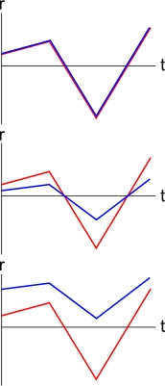 | 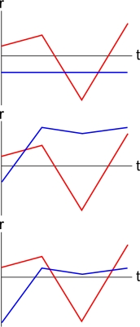 | 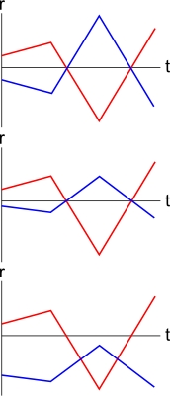
Diversification and Correlation
Diversification is the reduction of risk by combining assets in a portfolio.
The amount of diversification achievable is inversely related to the correlation of returns between assets in a portfolio.
The higher the correlation between two assets, the less diversification that’s possible when combining them in a portfolio, which is a pity. For example, two bank stocks are likely to have a high correlation with each other (close to one), so a portfolio of these two similar stocks is unlikely to reduce risk much at all.
Ideally, negative correlations are the best.

