Expected Returns: $E[r_{i}]=μ_{i}={\overline{r}}_{i}$
Stock returns are random variables that change all of the time.
The expected return of a stock is what you expect the stock’s return to be in the future. Usually the best estimate of the expected return is the historical average of the stock’s random returns. So expected return is equal to the average return.
The expected return $E[r_{i}]$ is a constant since it doesn’t change.
$r_{i}$ represents stock $i$’s random return. It’s a variable.
$E[r_{i}]$ represents stock $i$’s expected return. It’s a constant.
$μ_{i}$ is another common notation for $E(r_{i})$, pronounced ‘mu’.
${\overline{r}}_{i}$ represents the average return, pronounced ‘r-bar’.
Graphs of Random and Expected Returns
The difference between $r_{i}$ and $E[r_{i}]$ or $μ_{i}$ or ${\overline{r}}_{i}$ can be seen in the below graphs. The graph on the left has time on the x-axis. $r_{i,t}$ is stock i’s random return over day t, that is from time t-1 to t. The blue line is the average. On the graph on the right, stock i is plotted on the $μ$-$σ$ graph as a single point.
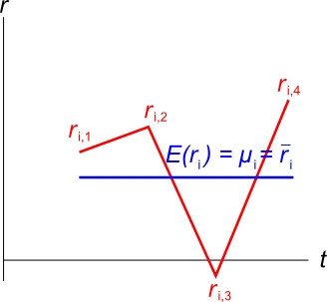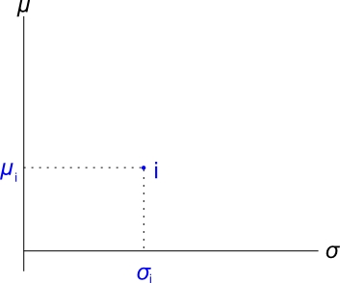
Stock Choice
For each diagram which is better, A or B?

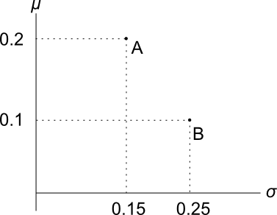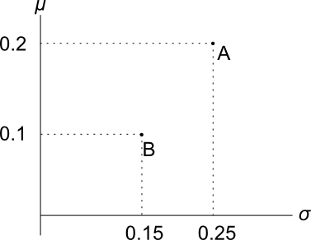

- In the left diagram, A is clearly better than B since it has more return and less risk.
- In the right diagram, A has a higher return than B, but more risk. So the best stock will depend on the investor’s preferences or ‘risk appetite’.
  - But investors are not limited to invest in just one. They could buy a portfolio - some of A and some of B.
  - Having more portfolios and more choices is good.
  - By mixing stocks overall portfolio risk should be reduced due to diversification.
  - The effect is that the risk of the whole (the portfolio) is less than the sum of the parts (the stocks).

