Portfolios and Diversification
Let P be a $100 portfolio with $50 invested in A and $50 in B.
- Therefore P is an equal-weighted portfolio in A and B. So:
$x_{A}=0.5$, $x_{B}=0.5$
- Return will be exactly halfway at 0.15.
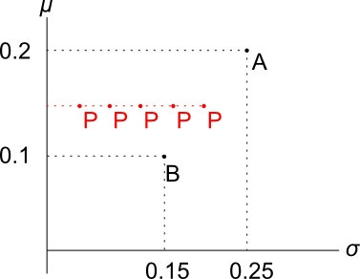
- Standard deviation is likely to be less than halfway (0.2) due to diversification - we didn’t “put all of our eggs in one basket”.
- So P will be somewhere along the dashed red line. The standard deviation of P depends on the correlation between A and B.
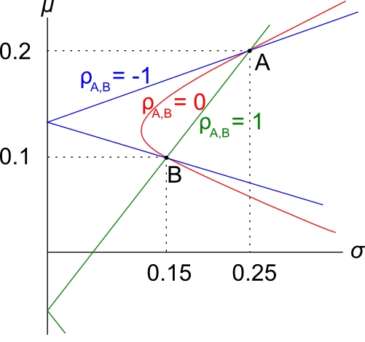
How Correlation Affects Diversification
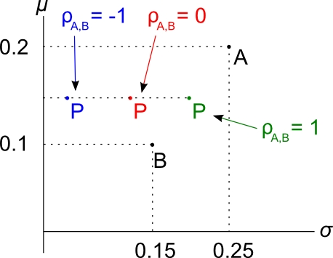
- $ρ_{A,B}=-1$, lots of diversification since A and B move in opposite directions.
- $ρ_{A,B}=0$, diversification since A and B move independently and will sometimes cancel each other out.
- $ρ_{A,B}=1$, no diversification at all since A and B move with each other in the same ratio. In this case $σ_{P}=0.2$.
Portfolio Return and Variance
Portfolio return for $n$ stocks with weights $x$:
$$r_{P}=x_{1}.r_{1}+x_{2}.r_{2}+…+x_{n}.r_{n}=\sum_{i=1}^{n}{(x_{i}.r_{i})}$$
Note that the weights must sum to one:
$$x_{1}+x_{2}+…+x_{n}=1$$
Portfolio variance for 2 stocks with weights $x_{1}$ and $x_{2}$:
$${σ_{P}}^{2}=x_{1}^{2} .σ_{1}^{2}+x_{2}^{2} .σ_{2}^{2}+2{{.x}_{1}.x_{2}.σ}_{1,2}$$

Portfolio Return and Variance Example
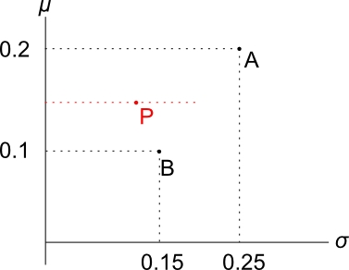
Question: Portfolio P in the diagram has a weight of 0.5 in A and 0.5 in B. The correlation between A and B is 0.05. Find the return and variance of portfolio P.
Answer:
$$r_{P}=x_{A}.r_{A}+x_{B}.r_{B}$$
$$=0.5×0.2+0.5×0.1$$
$$=0.15$$

Since $ρ_{A,B}=0.05$, portfolio variance is:
$${σ_{P}}^{2}=x_{A}^{2} .σ_{A}^{2}+x_{B}^{2} .σ_{B}^{2}+2{.x}_{A}.x_{B}.σ_{A,B}$$
and
$$σ_{A,B}=ρ_{A,B}.σ_{A}.σ_{B}$$
So:
$${σ_{P}}^{2}=x_{A}^{2} .σ_{A}^{2}+x_{B}^{2} .σ_{B}^{2}+2{.x}_{A}.x_{B}.ρ_{A,B}.σ_{A}.σ_{B}$$
$$={0.5}^{2}×{0.25}^{2} + {0.5}^{2}×{0.15}^{2} +$$
$$+ 2×0.5×0.5×0.05×0.25×0.15$$
$${σ_{P}}^{2}=0.0221875$$
$σ_{P}=0.1490$ Notice that the standard deviation of P is less than both A and B’s standard deviation. This shows how diversification can lower risk.

