Portfolio Weights: to be Long or Short
- Portfolio weights in an investment must sum to one:
$$x_{1}+x_{2}+…+x_{n}=1$$
- Individual weights may be negative. This corresponds to selling or short selling.
- Short selling can be achieved by borrowing a stock and selling it, and then later buying another of the same stock and returning it to the stock lender.
- Investors who are:
  - ‘short’ must have sold the stock. They make money when prices fall.
  - ‘long’ must have bought the stock. They make money when prices rise.
Combination Lines: Weights and Returns
For a portfolio P invested in only 2 stocks A and B,
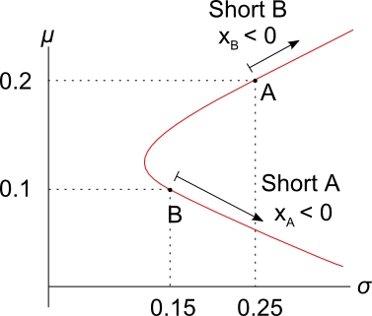
- P must lie on the combination line.
- If P has a positive weight in A and B (long A and B), its return must be between 0.1 and 0.2.
- If P has a negative weight in B (short B), then it must have a weight of more than one in A (long A), and a return of more than 0.2.
- Vice versa for a negative weight in A (short A).
Calculation Example: Short Selling
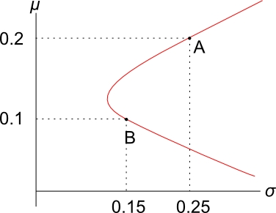
Question: An investor starts with $100 of wealth. She short sells $150 of stock B by borrowing stock B from an investment bank (paying a small fee which you can ignore). Then she sells stock B for $150 on the stock exchange. With the $250 that she now has, she buys $250 of stock A. This all happens at t=0.
Later, at t=1, she will sell stock A and then buy stock B on the exchange to give back to the investment bank.
Using the information in the diagram, what is the expected return of her portfolio?
Answer 1 (using weights, the quick way):
Calculate the weights in each stock:
$x_{A}=\frac{+250}{100}=2.5$, we use +$250 since we longed stock A.
$x_{B}=\frac{-150}{100}=-1.5$, we use -$150 since we shorted stock B.
Check that the weights sum to one: $x_{A}+x_{B}=2.5-1.5=1$
To find the portfolio return,
$$μ_{P}=x_{1}μ_{1}+x_{2}μ_{2}+…+x_{n}μ_{n}$$
$$μ_{P}=x_{A}μ_{A}+x_{B}μ_{B}$$
$$=2.5×0.2+ -1.5×0.1$$
$$=0.35$$
Answer 2 (using dollars, the long way):
Note that returns are expressed per year and the investment is over one year. Let $P_{it}$ be the price of stock ‘i’ at time ‘t’:
$P_{A0}=250$ (Price of stock A at time 0)
$P_{B0}=150$ (Price of stock B at time 0)
The portfolio price ($P_{P}$) at t = 0 is long 1 stock A ($n_{A}=1$) and short 1 stock B ($n_{B}=-1$):
$$P_{port0}=n_{A}.P_{A0}+n_{B}.P_{B0}$$
$$=1×250-1×150$$
$=100$ which was her wealth at the start.

Having a negative number of stock B ($n_{B}=-1$) seems strange.
But if you look at the portfolio from the point of view of the balance sheet, where assets (V=D+E) equals liabilities (D) plus equity (E), the portfolio price is the equity or net wealth, stock A is the asset and stock B is the liability since it’s borrowed:
$$E = V - D$$
$$100 = 250 -150$$

Let’s find stock A and B’s expected prices $P_{A1}$ and $P_{B1}$.
In one year the lady will have to pay back the stock lender a single stock B. She owes one stock.
Stock B’s price in one year is expected to be:
$P_{B1}=P_{B0}{\left(1+μ_{B}\right)}^{1}$ (Expected price of stock B at time 1)
$$=\$150×\left(1+0.1\right)$$
$$=\$165$$
So in one year the lady expects to have to pay $165 to buy stock B from some other third party owner, and give that newly purchased share B to the stock lending bank.
There might appear to be a problem here because stock B’s price should grow by the capital return (=total return minus dividend yield) rather than the total return $μ_{B}$, since the lady will have to buy one stock B from somebody and pay its price, not any dividends.
However, usually short selling contracts specify that the stock borrower (lady) must pay the dividends back to the stock lender (bank) when the dividends are paid from company B to the lady who holds the title to the stock.
Therefore if you regard the ‘prices’ $P_{B0}$ and $P_{B1}$ instead as values of the price and dividends, then it’s correct to grow the value at time zero into the value at time 1 by the total return.
Alternatively, for simplicity you can assume that the stock pays no dividends so the total return is the capital return.

The lady’s stock A asset it’s much simpler, its expected price is:
$$P_{A1}=P_{A0}{\left(1+μ_{A}\right)}^{1}$$
$$=\$250×\left(1+0.2\right)$$
$$=\$300$$
The portfolio value at t = 1 is:
$$P_{port1}=n_{A}.P_{A1}+n_{B}.P_{B1}$$
$$=1×300-1×165$$
$$=135$$
Now we can calculate the portfolio return over the year:
$$μ_{port0→1}=\frac{P_{port1}}{P_{port0}}-1 =\frac{135}{100}-1 =0.35$$

