Constructing the 2-stock Markowitz Bullet
- In a two-stock world, the combination line is the Markowitz bullet.
- The line passes through the 2 stocks on the return-standard deviation graph.
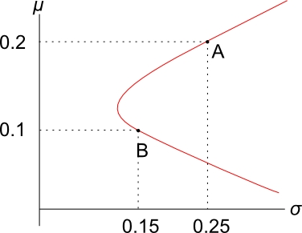
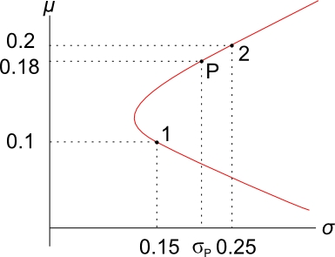
Calculation Example
Q) Using the information in the diagram, find the variance of a portfolio with a target return of 0.18. Assume $ρ_{1,2}=0.3$.
A) There are 2 steps:
- Find the weight in stock 1 that yields the given return using the portfolio return equation:
$$r_{P}=x_{1}.r_{1}+x_{2}.r_{2}$$
Together with the ‘weights sum to one’ equation:
$x_{1}+x_{2}=1$, so $x_{2}=1-x_{1}$
So,
$$r_{P}=x_{1}.r_{1}+\left(1-x_{1}\right).r_{2}$$
$$0.18=x_{1}×0.1+\left(1-x_{1}\right)×0.2$$
After solving to find $x_{1}$,
$$x_{1}=0.2$$
Therefore
$$x_{2}=1-0.2=0.8$$
These weights make sense since the target return of 0.18 is between stock 1 and 2’s returns so we should be long both stocks, which we are since both weights are positive.

- Now calculate the portfolio variance by substituting the weights $x_{1}$ and $x_{2}$ into the portfolio variance equation:

$${σ_{P}}^{2}=x_{1}^{2} .σ_{1}^{2}+x_{2}^{2} .σ_{2}^{2}+2{.x}_{1}.x_{2}.ρ_{1,2}.σ_{1}.σ_{2}$$

$$=\begin{matrix}{0.2}^{2}×{0.15}^{2}+{0.8}^{2}×{0.25}^{2}+ \\ 2×0.2×0.8×0.3×0.15×0.25\end{matrix}$$
$$=0.0445$$

$$σ_{P} =0.2110$$

