Portfolios of 3 or More Stocks
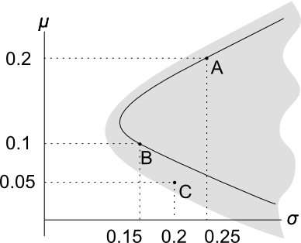
- Portfolios of only 2 stocks are restricted to a combination line. The combination line comprising stocks A and B is shown in black.

- After adding stock C, a whole area of portfolios are possible. There is a portfolio possibility ‘cloud’, which is the grey area in the graph.

Constructing the 3+ Stock Markowitz Bullet
This requires a formula for multi-stock portfolio variance.
 | $$x_{1}$$ | $$x_{2}$$ | $$x_{3}$$ | $$x_{4}$$ |  | The grey-shaded part of the table is called the variance-covariance matrix. It has the variance of each stock along the diagonal, and covariances elsewhere.  Note that $σ_{1,2}=σ_{2,1}$ and $σ_{1,1}=σ_{1}^{2}$
$$x_{1}$$ | $${σ_{1}}^{2}$$ | $$σ_{1,2}$$ | $$σ_{1,3}$$ | $$σ_{1,4}$$
$$x_{2}$$ | $$σ_{2,1}$$ | $${σ_{2}}^{2}$$ | $$σ_{2,3}$$ | $$σ_{2,4}$$
$$x_{3}$$ | $$σ_{3,1}$$ | $$σ_{3,2}$$ | $${σ_{3}}^{2}$$ | $$σ_{3,4}$$
$$x_{4}$$ | $$σ_{4,1}$$ | $$σ_{4,2}$$ | $$σ_{4,3}$$ | $${σ_{4}}^{2}$$
Portfolio variance is equal to the sum of each term in the variance-covariance matrix multiplied by its corresponding two weights.
$${σ_{P}}^{2}=x_{1}x_{1}σ_{1,1}+x_{1}x_{2}σ_{1,2}+…+x_{4}x_{3}σ_{4,3}+x_{4}x_{4}σ_{4,4}$$
After collecting like terms and re-arranging, we have the 4-stock portfolio variance equation:
$${σ_{P}}^{2}=x_{1}^{2}σ_{1}^{2} +x_{2}^{2}σ_{2}^{2} +x_{3}^{2}σ_{3}^{2} +x_{4}^{2}σ_{4}^{2}+$$
$${2x_{1}x}_{2}σ_{1,2}+{{2x}_{1}x}_{3}σ_{1,3}+{{2x}_{1}x}_{4}σ_{1,4}+$$
$$2{x_{2}x}_{3}σ_{2,3}+2{x_{2}x}_{4}σ_{2,4}+$$
$$2{x_{3}x}_{4}σ_{3,4}$$
Here’s the 3-stock portfolio variance equation:
$${σ_{P}}^{2}=x_{1}^{2}σ_{1}^{2} +x_{2}^{2}σ_{2}^{2} +x_{3}^{2}σ_{3}^{2}$$
$${2x_{1}x}_{2}σ_{1,2}+{{2x}_{1}x}_{3}σ_{1,3}+$$
$$2{x_{2}x}_{3}σ_{2,3}$$

