The Markowitz Bullet and the Efficient Frontier of Risky Assets (excluding r_{f})
- The Markowitz bullet is the boundary line that contains the minimum risk portfolios for each return.
- Also called the Minimum Variance Set (MVS) of risky assets or the portfolio possibility frontier.
- The top half of the Markowitz bullet is called the efficient frontier.
- The portfolios that comprise the efficient frontier are the only ones worth investing in because they give the highest return for a given standard deviation.
- Mathematically, the bullet shaped graph is a hyperbola.
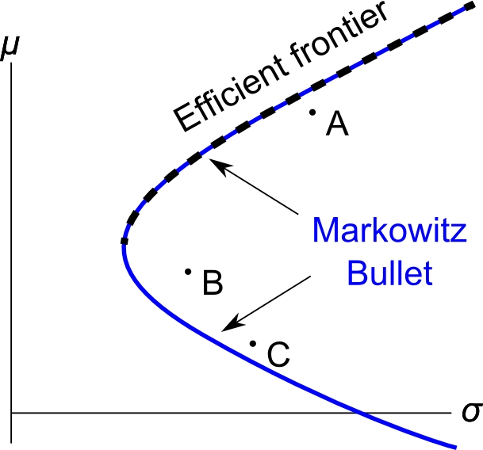
The Markowitz Bullet with Short Selling Restrictions
- To short sell stock, investors must locate a stock lender, usually a broker or investment bank. The broker charges a fee for lending the stock.
- Sometimes a stock lender cannot be found or the fee is prohibitive.
- In 2008/09, shorting financial stocks was made illegal for some time.
- Restrictions on short selling lead to a shrunk Markowitz bullet.

- Without short selling, the highest return possible is that of the highest return stock. You cannot have a weight of more than 1 in the highest return stock because weights must sum to 1 and negative weights in other stocks means short selling.
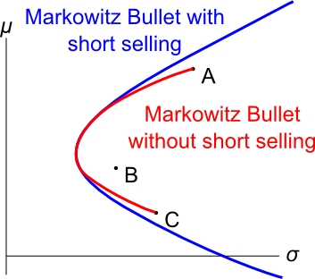
- In common sense terms, you can’t earn a return more than the highest return stock since you can’t invest more than your wealth. To over-invest you must borrow some asset which is short-selling that asset.

