The Risk Free Rate (r_{f}) and the Minimum Variance Set of All Assets
- Risk-free securities have zero standard deviation of returns. Government bonds (also called Treasuries) are assumed to be risk free securities.
- The return of the risk-free security is referred to as $r_{f}$. It’s also used to refer to the security itself.
- When $r_{f}$ is included, the new MVS becomes a line from $r_{f}$ through the tangency portfolio (T) on the Markowitz bullet.
- $r_{f}$ is a constant, so it has zero variance, and zero covariance with other securities.
- $r_{f}=E\left(r_{f}\right)=μ_{rf}$, since $r_{f}$ is a constant.
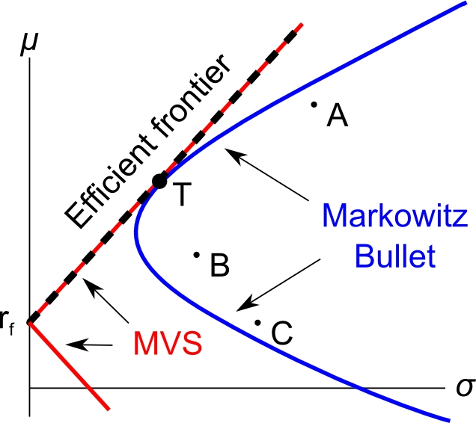
The Tangency Portfolio
- The tangency portfolio T is the only risky portfolio worth investing in. It is comprised of the stocks A, B and C.
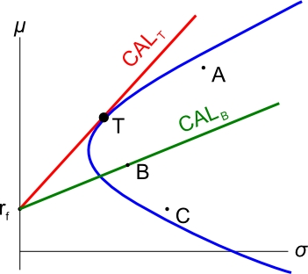
- For any level of risk (standard deviation), the highest return possible can be achieved by investing in T and $r_{f}$.
- Lines from $r_{f}$ through any portfolio are called Capital Allocation Lines.
- The CAL through T has the best risk-return trade off. It has the steepest gradient (rise/run).
- The gradient of the CAL is also called the Sharpe ratio.
Sharpe Ratio
The Sharpe ratio (S) of a stock is the gradient of the line from $r_{f}$ through the stock. It is the gradient of the stock’s CAL.
$S_{i}=\frac{μ_{i}-r_{f}}{σ_{i}}$
Where $S_{i}$ is the Sharpe ratio of stock ‘i’, $μ_{i}$ is its expected return and $σ_{i}$ is its standard deviation.
In the diagram, portfolio T’s Sharpe ratio is greater than stock B’s since the CAL through T is steeper. Therefore portfolio T is preferable to stock B.
The Market Portfolio
- The market portfolio M is the tangency portfolio of all risky assets.
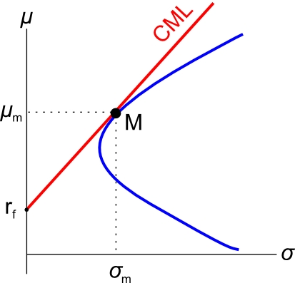
- The line through M and $r_{f}$is called the Capital Market Line (CML).

- The CML has the steepest gradient, therefore the market portfolio has the highest Sharpe ratio.
Equation of the Capital Market Line (CML)
$μ=r_{f}+σ\left(\frac{μ_{m}-r_{f}}{σ_{m}}\right)$
This is easy to see since the:
- y-axis is expected return $μ$
- x-axis is standard deviation $σ$
- y-intercept is $r_{f}$
- gradient $\frac{rise}{run}$ between $r_{f}$ and M is $\frac{μ_{m}-r_{f}}{σ_{m}}$
So in $y=mx+b$ form:
$$μ=\left(\frac{μ_{m}-r_{f}}{σ_{m}}\right)σ+r_{f}$$
Calculation Example
Question: Assume a 3-stock world consisting of A, B and C, as well as the risk free security. The market portfolio has been calculated to have weights 1/3 in each of A, B and C. The risk free rate $r_{f}=0.05$, the market return is $r_{m}=0.3$ and the market’s standard deviation is $σ_{m}=0.2$.
Find the weights in stocks A, B, C and $r_{f}$ which makes an efficient portfolio (P) with a return of $r_{p target}=0.1$. Also find this portfolio’s standard deviation $σ_{p target}$.
Answer: An efficient portfolio has minimum variance (or st. dev.) for a given return. All portfolios on the CML are efficient. Therefore we need only consider investing in the market portfolio (M) and the risk free rate ($r_{f}$).
To find the weights we need to invest in M and $r_{f}$, we will use the portfolio return equation, with a target portfolio return of 0.1:
$$r_{P}=x_{1}.r_{1}+x_{2}.r_{2}+…+x_{n}.r_{n}$$
$$0.1=x_{M}×0.3 + x_{rf}×0.05$$
Now we’re stuck since we have 2 unknowns ($x_{M}$ and $x_{rf}$) and only one equation so we can’t find either of the weights. But there is another equation, the ‘sum of the weights equals one’:
$$x_{1}+x_{2}+…+x_{n}=1$$
$$x_{M}+x_{rf}=1$$
$$x_{rf}=1-x_{M}$$
Substitute this into the portfolio return equation to get:
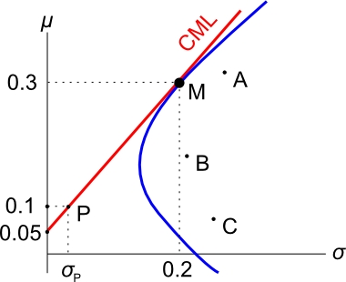
$0.1=x_{M}×0.3 +(1-x_{M})×0.05$
$$x_{M}=0.2$$
So, $x_{rf}=1-0.2=0.8$
This makes sense since the target return of 0.1 is closer to $r_{f}$ so it should have a larger weight in $r_{f}$ than M.
Since M is 1/3 in each of A, B and C, the weights in A, B and C are simply 1/3 of the weight in M:
$$x_{A}=x_{B}=x_{C}=\frac{1}{3}×x_{M}$$
$$=\frac{1}{3}×0.2=\frac{3}{15}=0.0666667$$
To find this efficient portfolio’s standard deviation, we could use the 2-stock portfolio variance equation with $r_{f}$ and M and the weights we just found, together with the fact that the covariance of $r_{M}$ with $r_{f}$is zero since $r_{f}$ is a constant:

$${σ_{P}}^{2}=x_{1}^{2} .σ_{1}^{2}+x_{2}^{2} .σ_{2}^{2}+2{{.x}_{1}.x_{2}.σ}_{1,2}$$

But another faster method is to use the CML equation instead:
$r_{P}=\left(\frac{μ_{m}-r_{f}}{σ_{m}}\right)σ_{P}+r_{f}$
Where $r_{P}$ is the return of our efficient portfolio of 0.1, and $σ_{P}$ is the variable we are trying to find.
$$0.1=\left(\frac{0.3-0.05}{0.2}\right)σ_{P}+0.05$$
$σ_{P}=0.04$

