Capital Asset Pricing Model (CAPM)
The CAPM separates total variance into two types:
Systematic variance
- Also called market or undiversifiable variance. This risk can not be avoided and affects all assets except treasury bonds.
- Caused by macro-economic events such as interest rate changes, the government’s budget, a financial boom or crisis, a natural disaster, a currency crisis, or a statistics release.
- Only systematic risk should affect an asset’s expected return or price since it cannot be diversified away.

Idiosyncratic variance
- Also called residual, firm-specific, diversifiable, non-systematic or non-market variance.
- Caused by events such as an oil company’s discovery of a new oil field, the death of a firm’s CEO, tax breaks for a specific industry, or fraud or rogue-trading losses at a bank.
- Idiosyncratic risk can be diversified away to zero by investing in a large enough portfolio of assets. Therefore it should not affect an asset’s expected return or price.

CAPM – Beta (β)
Systematic risk can be measured using beta ($β$).
$$β_{i}= \frac{σ_{i,M}}{{σ_{M}}^{2}}=\frac{cov(r_{i}, r_{M})}{var(r_{M})}=ρ_{i,M}\frac{σ_{i}}{σ_{M}}=correl\left(r_{i}, r_{M}\right).\frac{stdev\left(r_{i}\right)}{stdev\left(r_{m}\right)}$$
Where $β_{i}$ is the beta of stock i, $r_{i}$ is the return of stock i and $r_{M}$ is the return of the market portfolio. The higher the beta of a stock, the more sensitive it is to movements in the market.
Interpretation: If a stock’s beta is 2, then a sudden 1% increase in the price of the market portfolio would be expected to cause a 2% increase in the stock’s price.
$$β_{i}= \frac{σ_{i,M}}{{σ_{M}}^{2}}=\frac{cov(r_{i}, r_{M})}{var(r_{M})}$$
The beta of the market portfolio $β_{M}$ equals one.
- This makes sense since the covariance of $r_{M}$ with itself equals its variance, $\frac{cov\left(r_{M}, r_{M}\right)}{var\left(r_{M}\right)}=\frac{var\left(r_{M}\right)}{var\left(r_{M}\right)}=1$.
The beta of the risk free security is zero.
- This makes sense since the risk free rate is a constant and the covariance of a constant with any variable is zero.
Note: variance ($σ^{2}$) can also be used to measure systematic risk as well as beta ($β$). The relationship, which we’ll examine later, is: ${σ_{i syst}}^{2}={β_{i}}^{2}.{σ_{M}}^{2}$
The CAPM Equation
$$r_{i}=r_{f}+β_{i}\left(r_{M}-r_{f}\right)+ε_{i}$$
Where: $r_{i}$ is the return of stock i, it’s a variable,
$r_{f}$ is the risk-free rate, it’s a constant,
$β_{i}= \frac{σ_{i,M}}{{σ_{M}}^{2}}$, which is the systematic risk factor of stock i, it’s a constant,
$r_{M}$ is the market portfolio’s return, it is a variable and is the source of market risk.
$ε_{i}$ is the residual return of stock i. It is the unpredictable random error which averages zero. It is the source of idiosyncratic risk. It’s a variable.
The Security Market Line (SML) Equation
Taking the expectations of both sides of the CAPM equation, which is the same as taking the average,
$$μ_{i}=r_{f}+β_{i}\left(μ_{M}-r_{f}\right)$$
Where: $μ_{i}$ is the expected or average return of stock i. It can also be written as $E(r_{i})$. Note that it’s ok to just use $r$ instead of $μ$ or $E(r)$ in this course.
$μ_{M}$ is the expected return of the market. It can also be written as $E(r_{m})$.
$r_{f}$ is a constant so $E\left(r_{f}\right)=μ_{rf}=r_{f}$, so we just write $r_{f}$.
Notice that the error term $ε_{i}$, also known as the residual, drops out because its average is zero. ie, $E\left(ε_{i}\right)=0$.
SML Equation & Graph  $$μ=r_{f}+β\left(μ_{M}-r_{f}\right)$$ | CML Equation & Graph  $$μ=r_{f}+σ\left(\frac{μ_{m}-r_{f}}{σ_{m}}\right)$$
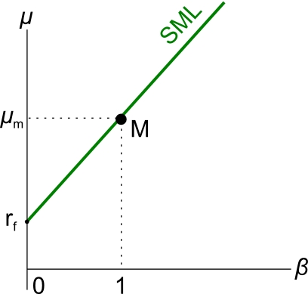 | 