Total, Systematic and Idiosyncratic Variance
The total variance of a stock can be broken up into systematic and idiosyncratic parts using the CAPM variance equation:
$${σ_{total_{i}}}^{2}={β_{i}}^{2}.{σ_{M}}^{2}+{σ_{ε_{i}}}^{2}$$
Where:
${σ_{total_{i}}}^{2}$ is the total variance of stock i,
${β_{i}}^{2}.{σ_{M}}^{2}$ is the systematic variance of stock i, and
${σ_{ε_{i}}}^{2}$ is the idiosyncratic variance of stock i. It is the variance of the residual $ε_{i}$ from the CAPM equation.

Calculation Example: Types of Variance
Question: Find stock A’s systematic and idiosyncratic standard deviations given the following:
$$β_{A}=0.75$$
$$σ_{A}=0.3$$
$$σ_{M}=0.2$$
Answer: Simply apply the CAPM variance equation using $σ_{A}$ as stock A’s total standard deviation:
$${σ_{total_{A}}}^{2}={β_{A}}^{2}.{σ_{M}}^{2}+{σ_{ε_{A}}}^{2}$$
$${0.3}^{2}={0.75}^{2}×{0.2}^{2}+{σ_{ε_{A}}}^{2}$$
So,
$${σ_{ε_{A}}}^{2}=0.0675$$
$σ_{ε_{A}}=0.2598$, which is the idiosyncratic standard deviation of stock A.
$${σ_{syst_{A}}}^{2}={β_{A}}^{2}.{σ_{M}}^{2}$$
$$={0.75}^{2}×{0.2}^{2}$$
$$=0.0225$$
$σ_{syst_{A}}=0.15$, which is the systematic standard deviation of stock A.
In conclusion, stock A has a lot of idiosyncratic risk. This could be diversified away if A was added to a large portfolio of stocks.
Comparing the β-graph and the σ-graph
The SML plots on the $β$-graph. $β$ is a measure of systematic risk. |  | The CML plots on the $σ$-graph. $σ$ is a measure of total risk.
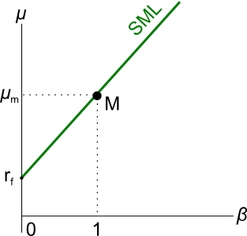 |  | 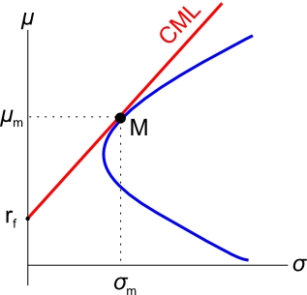

For a risky stock, say stock A, if it is fairly priced it will plot on the SML, but this does not mean it will plot on the CML. This is because stock A is likely to have idiosyncratic risk which is not apparent on the $β$-graph but can be seen on the $σ$-graph.
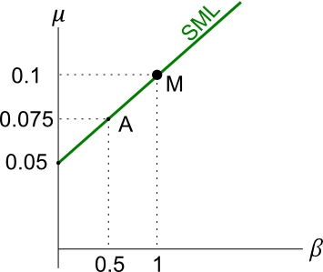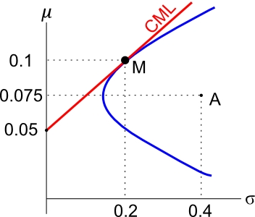
All fairly priced stocks or portfolios that plot on the CML must have zero idiosyncratic risk. They only have systematic risk.
Calculation Example: the β- and
σ-graphs
Question: Find stock A’s idiosyncratic standard deviation using the information in the below 2 graphs:

Answer:
$${σ_{total_{A}}}^{2}={β_{A}}^{2}.{σ_{M}}^{2}+{σ_{ε_{A}}}^{2}$$
$${0.4}^{2}={0.5}^{2}×{0.2}^{2}+{σ_{ε_{A}}}^{2}$$
${σ_{ε_{A}}}^{2}=$0.15
$σ_{ε_{A}}=$0.3873
So idiosyncratic variance is 0.15 units squared, and
idiosyncratic standard deviation is 0.3873 units.
Question: Find stock A’s systematic standard deviation.
Answer:
$${σ_{syst_{A}}}^{2}={β_{A}}^{2}.{σ_{M}}^{2}$$
$$={0.5}^{2}×{0.2}^{2}$$
$$=0.01$$
$$σ_{syst_{A}}=0.1$$
So systematic variance is 0.01 units squared, and
systematic standard deviation is 0.1 units.
Notice that idiosyncratic and systematic variances sum to 0.16 which is total variance, and the square root is 0.4 which is A’s total standard deviation.
Systematic plus idiosyncratic standard deviations don’t sum together to give total standard deviation since
$σ_{total_{i}}=\sqrt{{σ_{total_{i}}}^{2}}=\sqrt{{β_{i}}^{2}.{σ_{M}}^{2}+{σ_{ε_{i}}}^{2}}≠β_{i}.σ_{M}+σ_{ε_{i}}$

