Excess Returns: Jensen’s Alpha (α)
If a stock is ‘fairly priced’ then the return on the stock is commensurate with its systematic risk ($β$). This means that the stock plots on the SML: $μ_{i CAPM}=r_{f}+β_{i}\left(μ_{M}-r_{f}\right)$
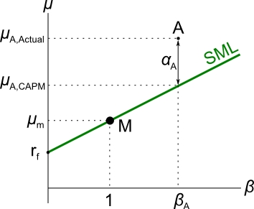
But if markets are not efficient, some stocks may return more than they should for their level of systematic risk. This is called excess return or alpha ($α$).
The return on a mis-priced stock with an alpha can be calculated using:
$$μ_{i, actual}=r_{f}+β_{i}\left(μ_{M}-r_{f}\right)+α_{i}$$
$$μ_{i, actual}=μ_{i CAPM}+α_{i}$$
On the $β$-graph below, alpha is the vertical distance of the stock above the SML.
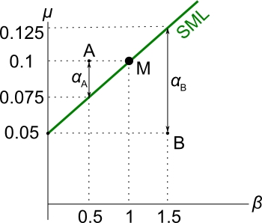
- If the alpha is positive, the stock returns more than it should and it will plot above the SML. Stock A has a positive alpha.
- If the alpha is negative, the stock returns less than it should and it will plot below the SML. Stock B has a negative alpha.
$$μ_{i CAPM}=r_{f}+β_{i}\left(μ_{M}-r_{f}\right)$$
$$μ_{i actual}=r_{f}+β_{i}\left(μ_{M}-r_{f}\right)+α_{i}$$
$$μ_{i actual}=μ_{i CAPM}+α_{i}$$
Question: Find the alphas of stock A and B ($α_{A}$ and $α_{B}$).
Answer: From the diagram, $μ_{A}=0.1$ and $β_{A}=0.5$.
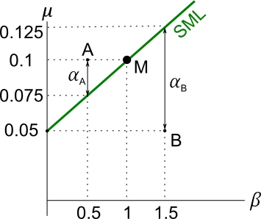
$μ_{i actual}=r_{f}+β_{i}\left(μ_{M}-r_{f}\right)+α_{i}$
$$0.1=0.05+0.5×\left(0.1-0.05\right)+α_{A}$$
$$α_{A}=0.025$$
For stock B,
$$μ_{i actual}=r_{f}+β_{i}\left(μ_{M}-r_{f}\right)+α_{i}$$
$$0.05=0.05+1.5×\left(0.1-0.05\right)+α_{B}$$
$$α_{B}=-0.075$$

Arbitrage and Equilibrium Pricing: Why Excess Returns Should Not Persist
Question:
- Stock A is expected to pay a constant dividend of $1 per share at the end of each year.
- For its level of systematic risk ($β_{A}$), it should have a return of 0.1 according to the CAPM.
- The stock is currently priced at $12.50.
- Find the alpha ($α_{A}$) of stock A now, and explain what should happen to the alpha and price ($P_{A}$) of stock A in the future.

(Long-winded) Answer:
Stock A’s required return according to the CAPM is 0.1. If it returned this much it would plot on the SML. So:
$$μ_{A CAPM}=0.1$$
But the current actual return on the stock is:
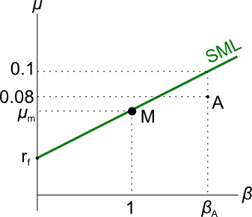
$μ_{A actual}=\frac{P_{1}-P_{0}+div_{1}}{P_{0}}$
$$=\frac{\$12.50-12.50+\$1}{\$12.50}$$
$$=0.08$$
By comparing the returns $μ_{A actual}$ and $μ_{A CAPM}$ it’s easy to see that the stock has an alpha of $-0.02$ which is ($0.08-0.1$).
For completeness:
$$μ_{A CAPM}=r_{f}+β_{A}\left(μ_{M}-r_{f}\right)$$
$$μ_{A actual}=μ_{A CAPM}+α_{A}$$
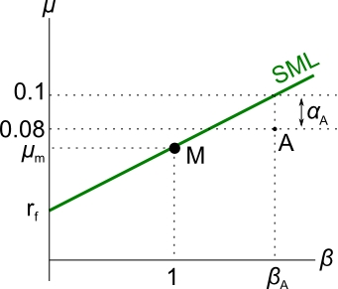
$μ_{A actual}=r_{f}+β_{A}\left(μ_{M}-r_{f}\right)+α_{A}$
$$0.08=0.1+α_{A}$$
$$α_{A}=-0.02$$
So stock A has a negative alpha, it returns less than it should. It plots below the SML. It is mis-priced.
In fact stock A is over-priced. The price should fall, which means the expected future return will increase, and the alpha will reach zero. This is why:
- Arbitrageurs will short the stock (by selling or short-selling) when they recognise the negative alpha. This is because no one wants to hold an asset that returns less than it should given its systematic risk.
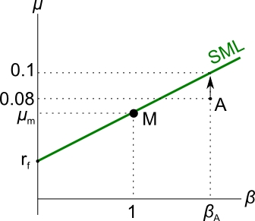
- Supply of stock A in the stock market will increase due to the heavy selling, forcing the stock price down.
- Since the price falls while the dividend remains constant, the dividend return will increase.
This can be seen from re-arranging the perpetuity formula, commonly known as the Dividend Discount Model (DDM), which says:
$P=\frac{dividend}{r}$ where the dividend is constant (g=0) so there's no expected capital growth.
Re-arranging, $r=\frac{dividend}{P}$
So as price $P$ falls, return $r$ increases.
- The actual return will continue to increase until it reaches the required rate of return according to the CAPM. So
- $μ_{A actual}=μ_{A CAPM}=0.1$

After this happens, the:
- Alpha will be zero.
- Stock price will be $10 since:
$$P_{0}=\frac{dividend}{r}=\frac{\$1}{0.1}=\$10$$
Finally, to answer the question of “Find the alpha of stock A now, and explain what should happen to the alpha and price of stock A in the future”.

The alpha of stock A right now is -0.02, so it is over-priced.
The price should fall to $10, and then the alpha will be zero.

Question: If a stock with a constant dividend (no growth) has a positive alpha now, what should happen to its price now as well as its return and alpha in the future?
Answer: Arbitrageurs would buy the stock since its returns are attractive.
The increased demand for the stock will bid the price up ($↑P$).
This causes a short term positive historical capital return ($↑r_{cap, short term},$) in the past.
The expected dividend yield will be lower since the share price has risen but the dividend remains constant
$\left(↓μ_{div}=\frac{{dividend}_{1}}{↑P_{0}}\right)$.
This leads to a fall in the expected total return
($↓μ_{total}=μ_{cap}+↓μ_{div}$).
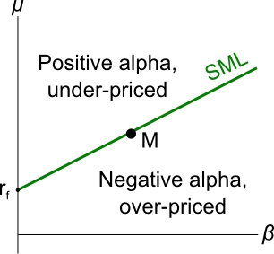
This will occur until the expected total return reaches the CAPM's theoretical return. After this happens the alpha will be zero and the stock will be fairly priced.
Vice versa for overpriced stocks. Therefore all stocks should plot on the SML by this equilibrium pricing argument.

Discussion
What’s confusing in the previous example is that the price (and capital return) rose, yet the total expected return fell. How is this possible? If prices rose, shouldn’t returns be positive?
- The price rise causes a corresonding positive capital return is in the past, which is good!
- But the lower expected total return in the future is bad. Note that the expected future total return is not negative, just lower than what it was before.
Past historical returns and future expected returns are totally different.
The inverse relationship between price and expected returns is important in the bond market also: when fixed-coupon bond prices rise, yields to maturity fall.

