***Efficient Markets Hypothesis***

* Market efficiency.
* Asset bubbles: Fama versus Shiller.
* Weak, semi-strong and strong form market efficiency.
* Charting and weak form market efficiency.
* Log graphs of long term share prices.
* Australian regulatory and industry bodies.

***Perfectly Competitive Markets - Economics***

In economics, firms operating in a [perfectly competitive market](https://en.wikipedia.org/wiki/Perfect_competition) should make zero economic profits. These markets are characterized by:

* Zero barriers to entry and exit;
* Zero transaction costs;
* Homogenous products (commodities);
* Perfect information.

A single petrol station selling fuel (a commodity) on a highway with lots of other nearby competitors would be a good example. This petrol station should make zero economic profit.

***Stock Markets***

Stock markets are highly competitive since:

* It’s easy to setup a stock trading account with a brokerage;
* The cost of holding shares is free and the cost of trading them is quite low;
* All stocks in a single company are the same;
* The cost of collecting information is negligible thanks to the internet (though analysing the information is still costly).

If stock markets are perfectly competitive then stock trading should make zero economic profit. The NPV of buying or selling any stock should be zero since their price is equal to the present value of their expected future cash flows.

***The Efficient Markets Hypothesis (EMH)***

* The EMH implies that stocks are ‘fairly’ priced. They are not over-priced or under-priced.
* If markets are efficient (so the EMH holds), then you should not be able to earn ‘abnormal’ or ‘excess’ returns above the required or deserved return.
* The return you deserve is dictated by the pricing model, such as the capital asset pricing model (CAPM). The more systematic risk you take on, the more return you deserve.
$$μ_{i}=r_{f}+β_{i}\left(μ_{M}-r_{f}\right)$$

* Efficient markets imply that investors can only earn a return commensurate with the level of systematic risk (or beta risk) they take on.
* This means that fairly priced stocks plot on the SML.
* Under-priced stocks have returns that are too high compared to their level of systematic risk (beta) and they plot above the SML. Their price should increase until their return falls and reaches the SML. Then they will be fairly priced.
* Vice-versa for over-priced stocks.

***What Makes Markets Efficient?***

There are many investors out there doing research.

As new information comes to market, buyers and sellers analyse it as quickly as possible and adjust their bids and offers accordingly.

Therefore, prices should reflect all available public information.

***Paradox: Perfect Market Efficiency***

Sanford Grossman and Joseph Stiglitz formally outlined the paradox in their [paper](https://en.wikipedia.org/wiki/Grossman-Stiglitz_Paradox)[1]:

“…because information is costly [to obtain and analyse], prices cannot perfectly reflect the information which is available, since if it did, those who spent resources to obtain it would receive no compensation.”

“We propose here a model in which there is an equilibrium degree of disequilibrium: prices reflect the information of informed individuals (arbitrageurs) but only partially, so that those who expend resources to obtain information do receive compensation.”

***Common Misperceptions about the EMH***

The EMH does not mean that you can’t make money.

If the EMH is correct, it means that:

* You should expect to earn a return appropriate for the systematic risk of the asset;
* There is no bias in prices that can be exploited to earn excess returns;
* Ignorant and uneducated buyers in liquid markets such as the stock market are protected since prices should reflect true value. If an ignorant investor buys a stock then they will pay the 'fair' price, which is good for them.

About the first point: “You should expect to earn a return appropriate for the systematic risk of the asset”

This return is calculated based on the current market price of the asset, not the past price that you originally bought it for.

**Question:** You bought a stock for $**100** with a beta of **1**.

The risk free rate is 4% and the market risk premium is 6% pa so the market and stock’s required returns are **10**% pa. The stock re-invests all free cash flow so there’s no dividends, therefore all returns are capital returns.

One year later, the stock experienced bad news and the price fell to $**20**. The stock’s required return is unchanged at 10% pa. What do you expect the price will be one year later again?

**Answer:** Based on the current share priceof $20, with medium luck the price next year is expected to be $22 (=20*(1+0.1)^1).

Note that the original $100 price is now a sunk cost, it’s a past price point that has no relevance to the future. The $20 current price is the current market value.

When you originally bought the stock for $100 you expected the price to be $110 (=100*(1+0.1)^1) the next year with medium luck. But this was not guaranteed, there was risk, and unfortunately there was bad news about the company or economy so the stock price fell to $20.

In the future, you could have good luck and see the stock price rise above $100 or $1000 if there happens to be good news.

***Asset Bubbles: Shiller vs Fama***

Eugene Fama and Robert Shiller were awarded the 2013 Nobel Prize in Economics.

“Economics is the only field in which two people can get a Nobel Prize for saying exactly the opposite thing.” ~Anonymous

Robert Shiller believes markets are prone to bubbles. He is often credited with predicting the 2001 ‘tech wreck’ and the 2007 housing bust that precipitated the Global Financial Crisis.

Eugene Fama argues markets are always efficient and there are no such things as asset bubbles.

Eugene Fama in 2010: “It’s easy to say prices went down, it must have been a bubble, after the fact. I think most bubbles are twenty-twenty hindsight. Now after the fact you always find people who said before the fact that prices are too high. People are always saying that prices are too high. When they turn out to be right, we anoint them. When they turn out to be wrong, we ignore them. They are typically right and wrong about half the time.”

-13 Jan 2010 ‘Interview with Eugene Fama’ by John Cassidy

<http://www.newyorker.com/news/john-cassidy/interview-with-eugene-fama>

***Fama’s 3 Forms of Market Efficiency***

Eugene Fama identified three forms of market efficiency in his PhD thesis in the 1960's:

* Weak form market efficiency, also known as the random walk model.
* Semi-strong form market efficiency.
* Strong form market efficiency.

***Weak-form Market Efficiency***

If the market is weak-form efficient:

* Current prices reflect all past price information. Past prices provide no guide to future prices.
* Prices are a **random walk**: they rise on good news and fall on bad news.
* Investors cannot earn abnormal returns using simple trading rules such as 'buy if the price has fallen' (contrarian strategy). Or 'buy if the price has risen' (momentum strategy).
* Technical analysis will not lead to abnormal returns.

Empirical evidence indicates that markets are generally weak-form efficient.

***Semi-strong-form Market Efficiency***

If the market is semi-strong-form efficient:

* Current prices reflect all publicly available information, including trading information, annual reports and press releases.
* Investors cannot earn abnormal returns by trading on public information, such as something searchable on Google.
* ‘Fundamental analysis’ of annual reports and publicly available news and data will not lead to abnormal returns.

***Strong-form Market Efficiency***

If the market is strong-form **efficient**:

* Current prices reflect all information, including private information that only insiders are aware of.
* Investors could **not** earn abnormal returns regardless of the information they possessed.

Most people consider markets to be strong form **in**efficient, so insider traders can make abnormal returns.

Empirical evidence indicates that markets are strong-form **in**efficient because insiders can and do earn abnormal returns.

Markets are **not** supposed to be strong form efficient because if they were, (illegal) insider-trading would be rampant.

***Questions on Market Efficiency***

<http://www.fightfinance.com/?qna=242,243,100,119,338,105,48,63,339,340,416,417,464,>

***Charting and Weak Form Efficiency***

Many investors believe that charting or 'technical analysis' works, despite the theory of weak form market efficiency. There are countless books published about charting but few of the chartists' theories actually work.

If they did work, why would they share their idea? They should be making as much money as possible for themselves and trying to prevent you from learning their money-making idea so that the gains are not competed away.

Remember that most of charting theory is irrelevant. The best guide to an asset's value is its very last traded price. Old prices and price paths are theoretically irrelevant in predicting future prices according to weak-form market efficiency.

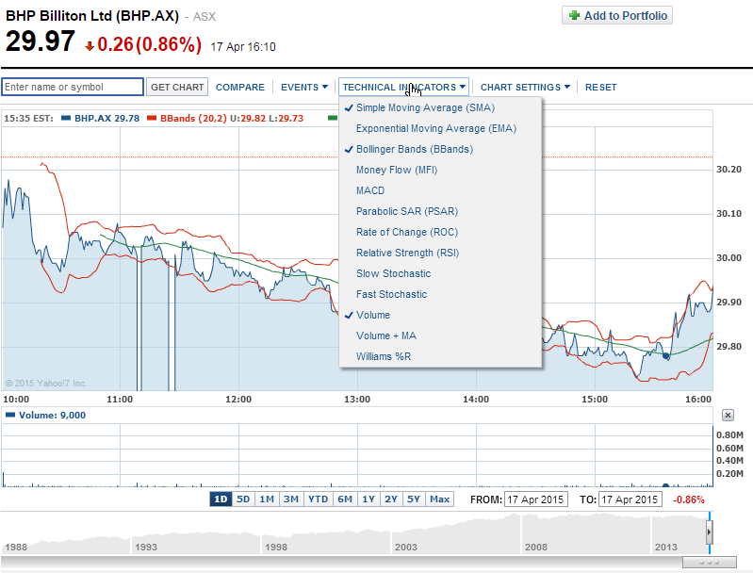

***Charting Encouraged by Brokers whose Commissions are Based on Turnover***

Stock brokers and stock exchanges are usually compensated based on turnover as measured by the number of stocks bought and sold (trading volume).

Therefore they have incentive to encourage their clients to ‘churn’ their portfolios by continually trading them. This may be one reason why brokerages and exchanges provide free training on charting and technical analysis: to encourage turnover which makes fees. Unfortunately, if markets are weak-form efficient, the client is likely to lose money by using charting strategies. This is because they’ll pay brokerage fees and waste their time analyzing charts of past prices, looking for non-existent patterns.



***Candle Stick Graphs: Open, Close, High, Low***

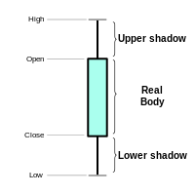 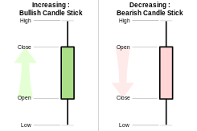

Candle stick graphs convey less information than a regular price path graph. Keep in mind that according to weak form market efficiency, the only useful price is the last observed one. Patterns in past prices do not reflect future prices.

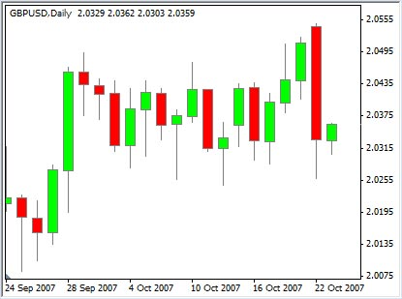

What's your best price estimate on the night of 22 Oct 2007? Closing price on the last day which is the top of the thick green bar furthest to the right

***Charting Example: Excerpt from StockCharts.com***

**Note**: Academics generally view charting as a waste of time since it doesn't work.

This example of charting is not something that you should learn, it's just a demonstration of a so-called charting pattern which probably doesn't work.

<http://stockcharts.com/school/doku.php?id=chart_school:chart_analysis:chart_patterns:double_top_reversal>

*"Double Top Reversal*

*The Double Top Reversal is a bearish reversal pattern typically found on bar charts, line charts and candlestick charts. As its name implies, the pattern is made up of two consecutive peaks that are roughly equal, with a moderate trough in-between. Note that a Double Top Reversal on a bar or line chart is completely different from Double Top Breakout on a P&F chart. Namely, Double Top Breakouts on P&F charts are bullish patterns that mark an upside resistance breakout.*

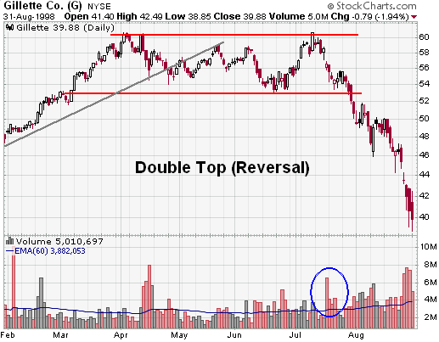

**‘Gillette Co. (G) Double Top Reversal example chart from StockCharts.com’***:*

*Although there can be variations, the classic Double Top Reversal marks at least an intermediate change, if not a long-term change, in trend from bullish to bearish. Many potential Double Top Reversals can form along the way up, but until key support is broken, a reversal cannot be confirmed."*

Notice the arbitrary nature of the theory. Most experts and academics regard charting theory as highly questionable. The actual reason for the stock price moves is more likely to be based on totally random news flow about the specific company (idiosyncratic risk) or the broader market and economy (systematic risk).

***Long Term Asset Price Growth is Exponential***

Although weak form market efficiency says that asset prices follow a random walk that depends on news, they do tend to drift higher, which reflects the capital return.

Asset price growth is exponential due to the power of compounding.

***Advantage of Log Graphs***

Many analysts prefer to see long-term stock price graphs on a log-scale. This prevents the graph from looking like an exponential curve $(y=e^{x})$. Exponential graphs can make large price changes in the past look small compared to equally large proportional price changes in the present.

Graphs with logged data series or axes have the advantage that **equal vertical falls correspond to equal percentage falls**. This fixes the 'base effect' problem.

Below is a long term stock price graph with a log scale, produced by Reserve Bank of Australia as part of their [chart pack](http://www.rba.gov.au/chart-pack/share-markets.html) which contains charts shown to the RBA board.

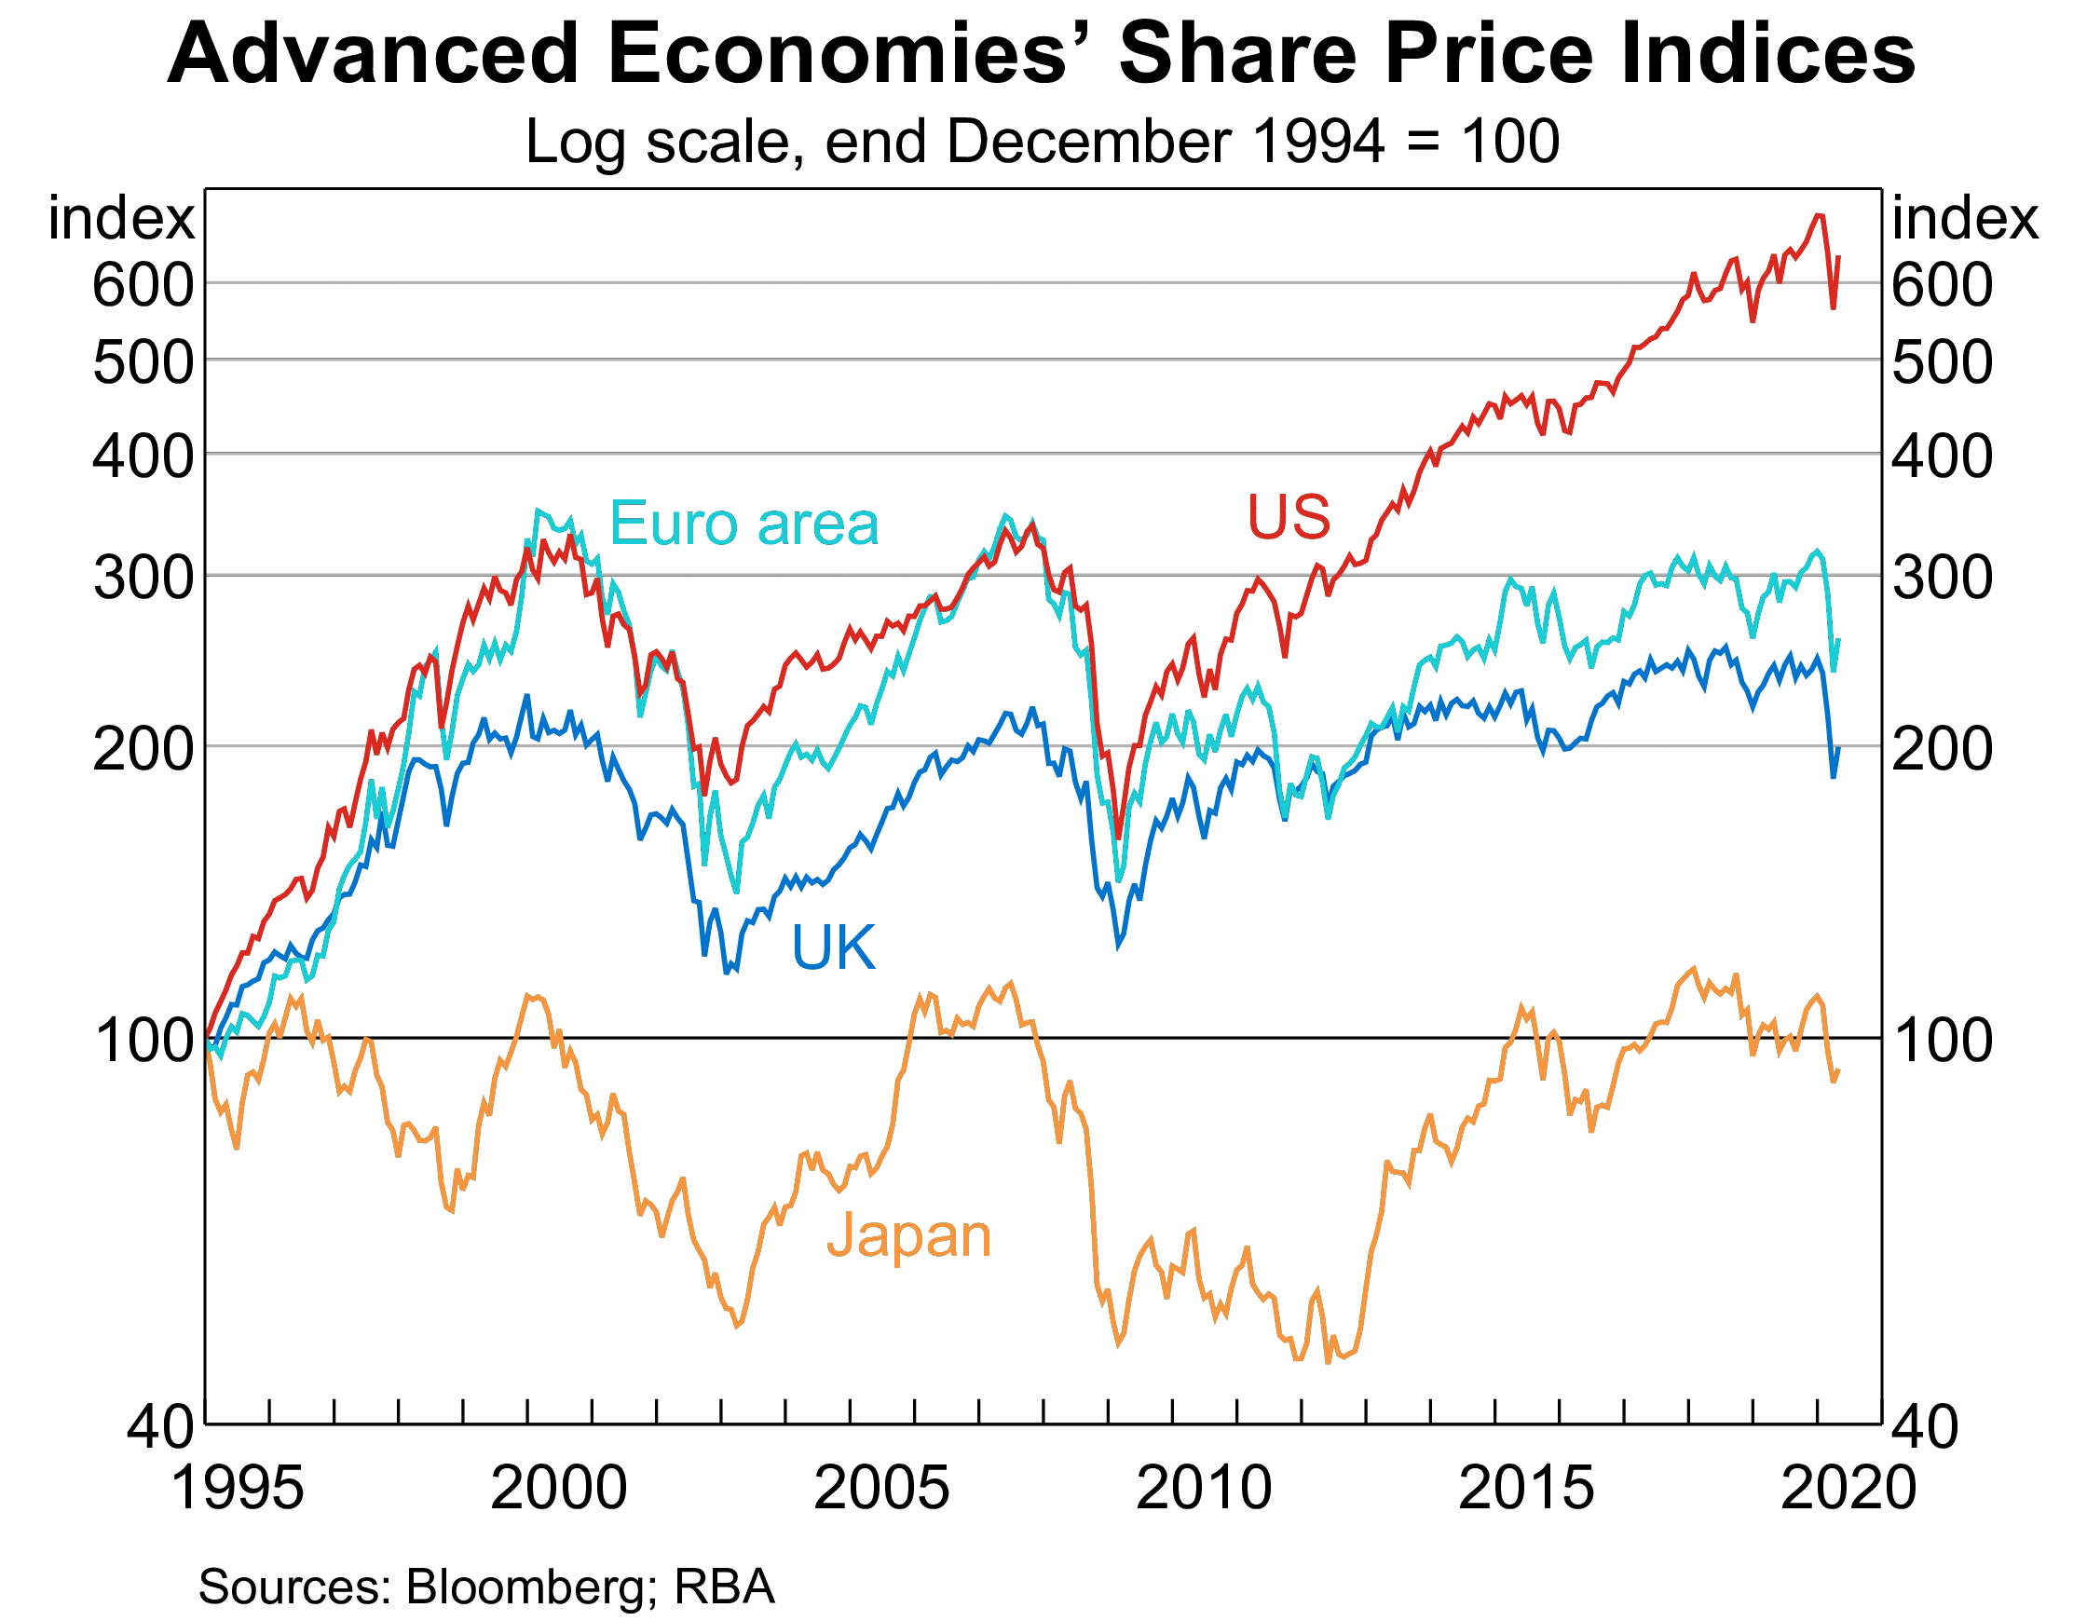

The next graph shows the US S&P500 capital index. Note that the capital index does not re-invest dividends and buybacks, unlike the accumulation index.

Let’s compare the Great Depression that began in 1929 and the Great Recession (or Global Financial Crisis or GFC) that started in 2007.

On the blue linear graph, the Great Depression looks insignificant while the GFC looks far more severe.

However, on the red logarithmic graph, the Great Depression looks more severe than the GFC, and it was. The vertical fall in the red line from peak to trough during the Great Depression was around twice as big as the fall in the GFC, therefore the percentage fall was twice as big.

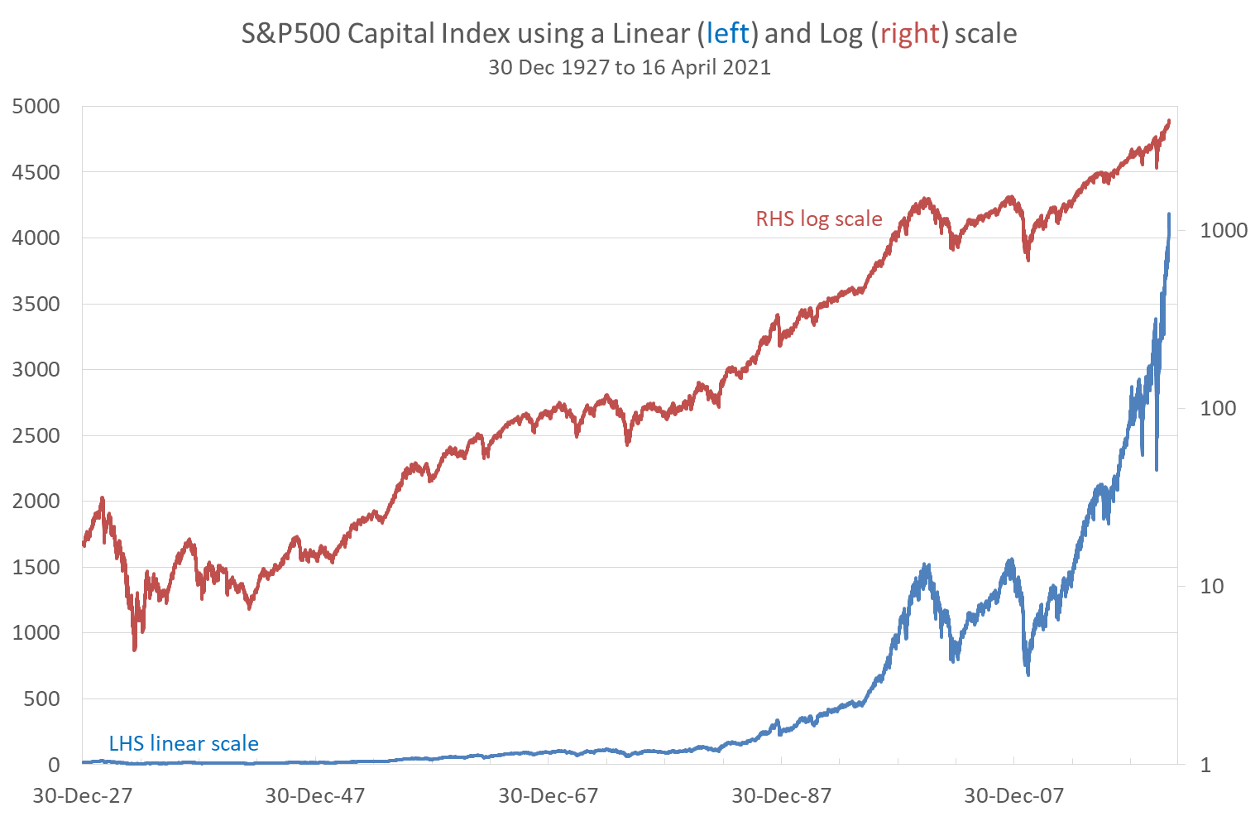

|  |  |  |  |  |  |
| --- | --- | --- | --- | --- | --- |
| **S&P500 Capital Index Performance During Two Crises** | | | | | |
|  | Great Depression | |  | Global Financial Crisis | |
|  | Peak | Trough |  | Peak | Trough |
| Date | 16-Sep-29 | 1-Jun-32 |  | 9-Oct-07 | 9-Mar-09 |
| Closing price | 31.86 | 4.4 |  | 1565.15 | 676.53 |
| Effective return = (p1-p0)/p0 |  |  |  |  |  |
| Over period | -86.19% over 989 days | |  | -56.78% over 517 days | |
| Per annum* | -39.62% pa | |  | -33.56% pa | |
| Continuously compounded  return = ln(p1/p0) |  | |  |  | |
| Over period | -197.97% over 989 days | |  | -83.88%% over 517 days | |
| Per annum* | -50.44% pa | |  | -40.88% pa | |
|  |  |  |  |  |  |
|  |  |  |  |  |  |

*Assumes 252 trading days per year. Source: Bloomberg

As you can see from the table and red logarithmic graph, the Great Depression was a far more severe crash in proportional terms compared to the GFC. But because the index was so low back in 1929 compared to 2007, the huge fall in 1929 is barely visible in the blue linear graph.

For this reason, long term stock graphs are best presented using a logarithmic scale, such as in this Vanguard graph:

<https://www.vanguardinvestments.com.au/retail/ret/campaign/indexchart2019.jsp>

***Regulatory Bodies***

**ASIC**: Australian Securities and Investments Commission. Enforces the Australian Corporations Act. <http://www.asic.gov.au>

**RBA**: Reserve Bank of Australia. Central bank whose primary function is monetary policy. Also administers the payments system and presides over financial stability. <http://www.rba.gov.au>

**APRA**: Australian Prudential Regulatory Authority. Oversees that banks are prudent by limiting their risk and having sufficient equity capital. Enforces the Basel Accord. <http://www.apra.gov.au>

**ACCC**: Australian Competition and Consumer Commission. Maintains a competitive environment by preventing monopolies and investigating illegal activities including cartels, price fixing and predatory pricing. <http://www.accc.gov.au>

***Industry Bodies***

**CFA**: Chartered Financial Analyst Institute. International organisation that administers professional qualifications. Members adhere to a code of conduct. <http://www.cfainstitute.org/learning/products/onlinelearning/Pages/60499.aspx?WPID=BrowseProducts>

**FPA:** Financial Planning Association. Australian organisation whose members adhere to a code of conduct. <http://fpa.com.au>

1. ‘Grossman, S. and Stiglitz, J. (1980), ‘On the Impossibility of Informationally Efficient Markets’, *The American Economic Review*, Vol. 70, No. 3 (Jun., 1980), pp. 393-408.