Asset Bubbles: Shiller vs Fama
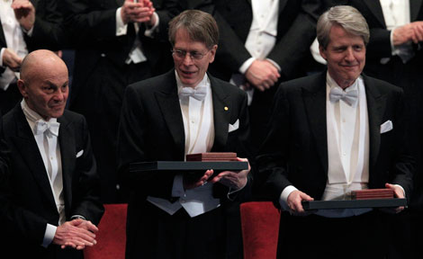
Eugene Fama and Robert Shiller were awarded the 2013 Nobel Prize in Economics.
“Economics is the only field in which two people can get a Nobel Prize for saying exactly the opposite thing.” ~Anonymous
Robert Shiller believes markets are prone to bubbles. He is often credited with predicting the 2001 ‘tech wreck’ and the 2007 housing bust that precipitated the Global Financial Crisis.
Eugene Fama argues markets are always efficient and there are no such things as asset bubbles.
Eugene Fama in 2010: “It’s easy to say prices went down, it must have been a bubble, after the fact. I think most bubbles are twenty-twenty hindsight. Now after the fact you always find people who said before the fact that prices are too high. People are always saying that prices are too high. When they turn out to be right, we anoint them. When they turn out to be wrong, we ignore them. They are typically right and wrong about half the time.”
-13 Jan 2010 ‘Interview with Eugene Fama’ by John Cassidy
http://www.newyorker.com/news/john-cassidy/interview-with-eugene-fama

