***Charting and Weak Form Efficiency***

Many investors believe that charting or 'technical analysis' works, despite the theory of weak form market efficiency. There are countless books published about charting but few of the chartists' theories actually work.

If they did work, why would they share their idea? They should be making as much money as possible for themselves and trying to prevent you from learning their money-making idea so that the gains are not competed away.

Remember that most of charting theory is irrelevant. The best guide to an asset's value is its very last traded price. Old prices and price paths are theoretically irrelevant in predicting future prices according to weak-form market efficiency.

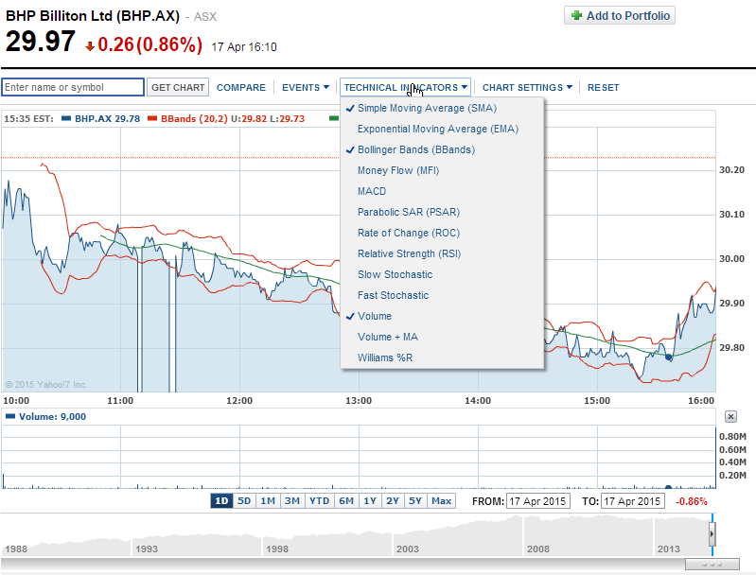

***Charting Encouraged by Brokers whose Commissions are Based on Turnover***

Stock brokers and stock exchanges are usually compensated based on turnover as measured by the number of stocks bought and sold (trading volume).

Therefore they have incentive to encourage their clients to ‘churn’ their portfolios by continually trading them. This may be one reason why brokerages and exchanges provide free training on charting and technical analysis: to encourage turnover which makes fees. Unfortunately, if markets are weak-form efficient, the client is likely to lose money by using charting strategies. This is because they’ll pay brokerage fees and waste their time analyzing charts of past prices, looking for non-existent patterns.



***Candle Stick Graphs: Open, Close, High, Low***

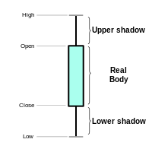 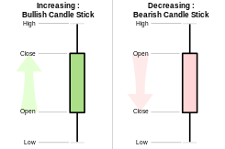

Candle stick graphs convey less information than a regular price path graph. Keep in mind that according to weak form market efficiency, the only useful price is the last observed one. Patterns in past prices do not reflect future prices.

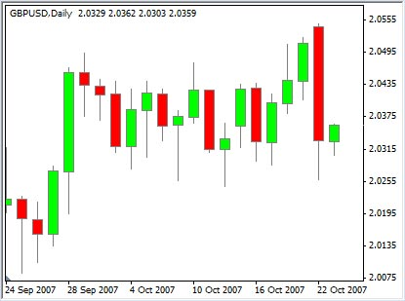

What's your best price estimate on the night of 22 Oct 2007? Closing price on the last day which is the top of the thick green bar furthest to the right

***Charting Example: Excerpt from StockCharts.com***

**Note**: Academics generally view charting as a waste of time since it doesn't work.

This example of charting is not something that you should learn, it's just a demonstration of a so-called charting pattern which probably doesn't work.

<http://stockcharts.com/school/doku.php?id=chart_school:chart_analysis:chart_patterns:double_top_reversal>

*"Double Top Reversal*

*The Double Top Reversal is a bearish reversal pattern typically found on bar charts, line charts and candlestick charts. As its name implies, the pattern is made up of two consecutive peaks that are roughly equal, with a moderate trough in-between. Note that a Double Top Reversal on a bar or line chart is completely different from Double Top Breakout on a P&F chart. Namely, Double Top Breakouts on P&F charts are bullish patterns that mark an upside resistance breakout.*

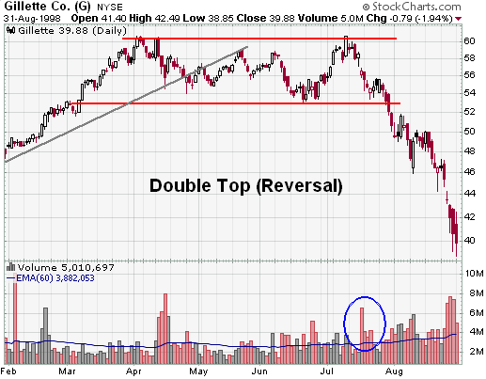

**‘Gillette Co. (G) Double Top Reversal example chart from StockCharts.com’***:*

*Although there can be variations, the classic Double Top Reversal marks at least an intermediate change, if not a long-term change, in trend from bullish to bearish. Many potential Double Top Reversals can form along the way up, but until key support is broken, a reversal cannot be confirmed."*

Notice the arbitrary nature of the theory. Most experts and academics regard charting theory as highly questionable. The actual reason for the stock price moves is more likely to be based on totally random news flow about the specific company (idiosyncratic risk) or the broader market and economy (systematic risk).