Long Term Asset Price Growth is Exponential
Although weak form market efficiency says that asset prices follow a random walk that depends on news, they do tend to drift higher, which reflects the capital return.
Asset price growth is exponential due to the power of compounding.

Advantage of Log Graphs
Many analysts prefer to see long-term stock price graphs on a log-scale. This prevents the graph from looking like an exponential curve $(y=e^{x})$. Exponential graphs can make large price changes in the past look small compared to equally large proportional price changes in the present.
Graphs with logged data series or axes have the advantage that equal vertical falls correspond to equal percentage falls. This fixes the 'base effect' problem.
Below is a long term stock price graph with a log scale, produced by Reserve Bank of Australia as part of their chart pack which contains charts shown to the RBA board.
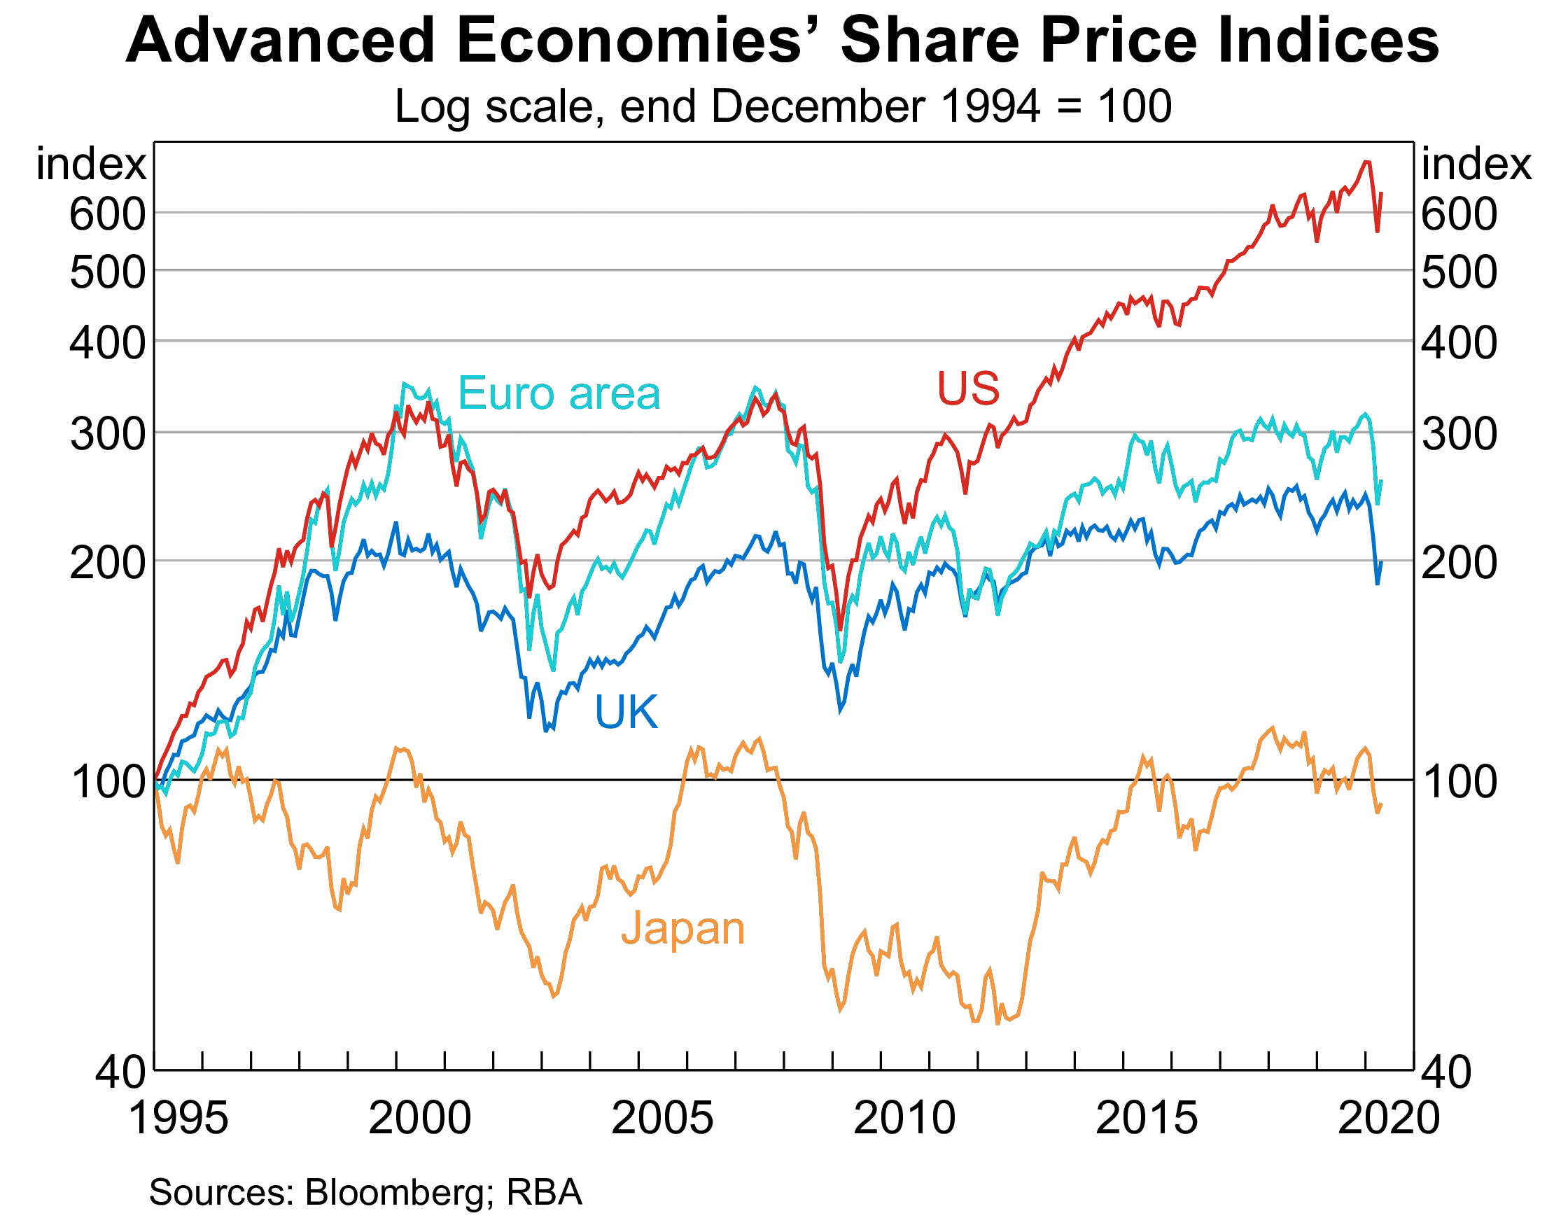
The next graph shows the US S&P500 capital index. Note that the capital index does not re-invest dividends and buybacks, unlike the accumulation index.
Let’s compare the Great Depression that began in 1929 and the Great Recession (or Global Financial Crisis or GFC) that started in 2007.
On the blue linear graph, the Great Depression looks insignificant while the GFC looks far more severe.
However, on the red logarithmic graph, the Great Depression looks more severe than the GFC, and it was. The vertical fall in the red line from peak to trough during the Great Depression was around twice as big as the fall in the GFC, therefore the percentage fall was twice as big.
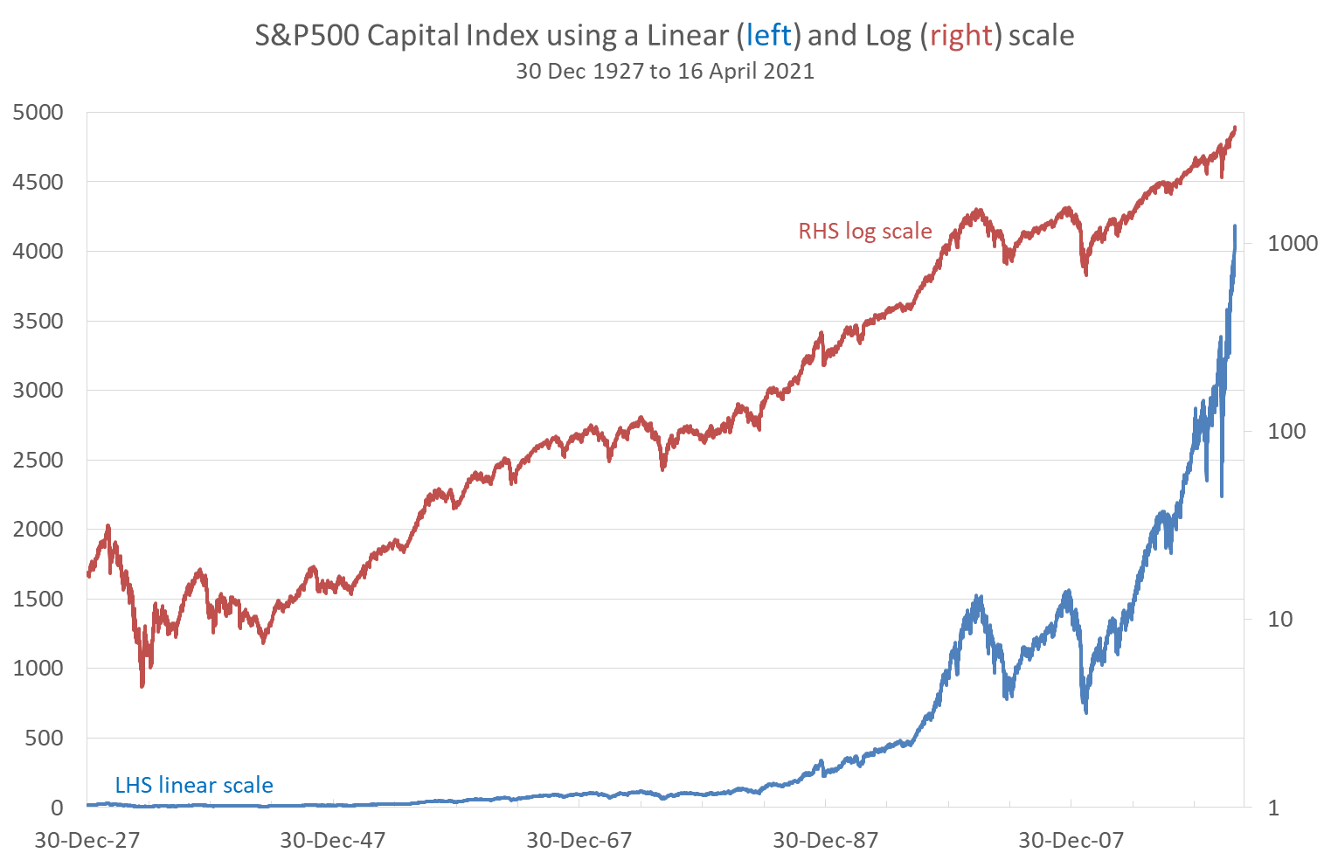
S&P500 Capital Index Performance During Two Crises
 | Great Depression |  |  | Global Financial Crisis
 | Peak | Trough |  | Peak | Trough
Date | 16-Sep-29 | 1-Jun-32 |  | 9-Oct-07 | 9-Mar-09
Closing price | 31.86 | 4.4 |  | 1565.15 | 676.53
Effective return = (p₁-p₀)/p₀
Over period | -86.19% over 989 days |  |  | -56.78% over 517 days
Per annum* | -39.62% pa |  |  | -33.56% pa
Continuously compounded
return = ln(p₁/p₀)
Over period | -197.97% over 989 days |  |  | -83.88%% over 517 days
Per annum* | -50.44% pa |  |  | -40.88% pa
*Assumes 252 trading days per year. Source: Bloomberg
As you can see from the table and red logarithmic graph, the Great Depression was a far more severe crash in proportional terms compared to the GFC. But because the index was so low back in 1929 compared to 2007, the huge fall in 1929 is barely visible in the blue linear graph.
For this reason, long term stock graphs are best presented using a logarithmic scale, such as in this Vanguard graph:
https://www.vanguardinvestments.com.au/retail/ret/campaign/indexchart2019.jsp

