Perfect Hedging using Futures
If a pig farmer is afraid of pig prices falling, he can hedge against the risk by selling lean hogs futures (short futures).
Perfect hedges are possible if:
- The farmer plans to sell his pigs at exactly the same time as the futures contract matures; and
- The farmer’s pigs are exactly the same type of pigs as the underlying pigs on the futures contract, so they’ll have the same price at maturity.
Last modified 22.3.17 KW
Portfolio $=$ LongPigs + ShortFutureOnPigs
$$V_{T portfolio}=S_{T}-f_{T LF} =S_{T}+f_{T SF}$$
$$=S_{T}-\left(S_{T}-K_{T}\right) =S_{T}+K_{T}-S_{T}$$
$$=K_{T}$$
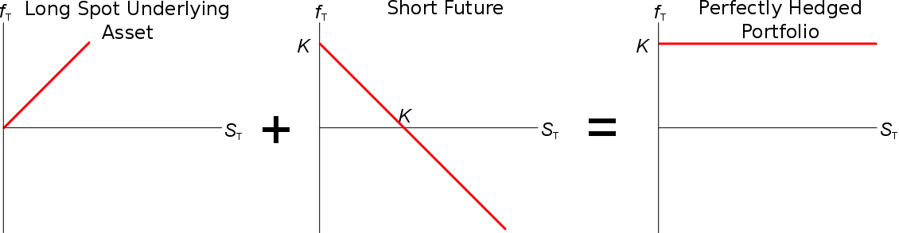
Notice that the portfolio exposure is a flat line. Regardless of the price of the pigs (S, the underlying asset price), the payoff at maturity is always K. All risk has been fully hedged away.

