Futures have Infrequent Expiry Dates
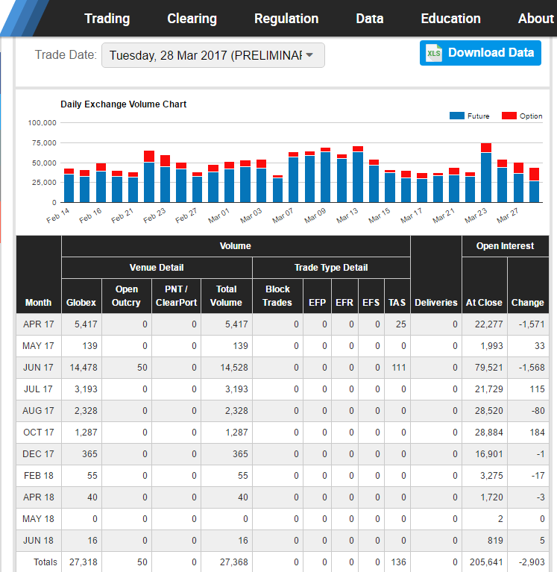
CME Futures on lean hogs mature on only 8 months of the year, and only on the 10th business day of the contract month at 12:00pm.
It would be a coincidence if the pig farmer planned to sell his pigs at exactly these times. Due to this, most hedges are imperfect.
Last modified: 4.7.17 KW
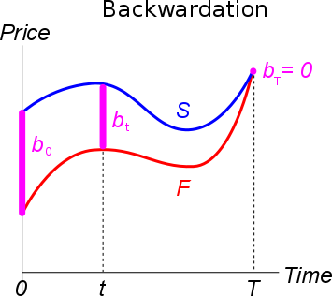
Basis Risk
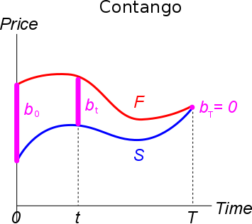
Basis risk makes hedging imperfect. It most commonly arises when futures contracts are closed out early before they mature. At the time when a futures contract is signed (time 0), there’s uncertainty about what its price quote will be later on when it’s closed out (time t). These subsequent futures price quotes are unknown.
When the new future is transacted at time t to close out the original future, the unknown price difference or ‘basis’ ($b_{t}$) equals the spot price at t ($S_{t}$) less the futures price quote at t ($F_{t,T}$) on the same future that matures at time T: $b_{t}=S_{t}-F_{t,T}$
Note that the futures price quote $F_{t,T}$ has two subscripts:
- The time that the quote is given $F_{t,T}$ (time t, which is less than time T); and
- The time that the future matures $F_{t,T}$ (time T, its expiry later on, also called the maturity).

The current basis (time 0, now) is defined as:
$$b_{0}=S_{0}-F_{0,T}$$
However, the current basis is not very concering since it’s known, it poses no risk. It’s the basis later on in time which is unknown and creates risk.

In Backwardation, the Basis is Positive
Backwardation is where the current underlying asset price ($S_{0}$) is greater than the current futures price quote ($F_{0,T}$) that matures later on at time T, so:
$$S_{0}>F_{0,T}$$
In backwardation, the current basis is positive:
$b_{0}>0$ when $S_{0}>F_{0,T}$
Since $b_{0}=S_{0}-F_{0,T}$.
The graph shows backwardation since the futures price is lower than the spot price. The basis is positive.
Remember that the futures price quote is the expected spot price grown by the time value of money (r), less any dividends (q) plus storage costs (c):
$$F_{0,T}=S_{0}.e^{\left(r-q+c\right)T}$$
Backwardation occurs due to expected price falls in the underlying asset when the dividend yield (q) is higher than storage costs (c) and the time value of money (r).
In Contango, the Basis is Negative
Contango is where the current underlying asset price ($S_{0}$) is less than the current futures price quote ($F_{0,T}$) that matures later on at time T, so:
$$S_{0}<F_{0,T}$$
In contango, the basis is negative:
$b_{0}<0$ when $S_{0}<F_{0,T}$
Since $b_{0}=S_{0}-F_{0,T}$.
The graph shows contango since the futures price is higher than the spot price. The basis is negative.
The futures price quote is:
$$F_{0,T}=S_{0}.e^{(r-q+c)T}$$
Contango occurs due to expected price gains in the underlying asset when storage costs (c) and the time value of money (r) are higher than the dividend yield (q).

At the Future’s Expiry T, the Basis is Zero
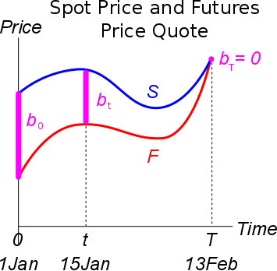
At the expiry or maturity of the futures contract (time T), the futures price quote will equal the underlying asset price, so:
$$S_{T}=F_{T,T}$$
Remember that at time 0:
$$F_{0,T}=S_{0}.e^{(r-q+c)T}$$
So at time T:
$$F_{T,T}=S_{T}.e^{\left(r-q+c\right)×0}$$
$$=S_{T}.e^{0}=S_{T}$$
You can see on the graph that the futures and spot price converge, making the basis zero. Therefore a:
- Short futures hedge to lock in a price to sell S (the pig farmer who wishes to sell hogs at time T) will be a perfect hedge if the future matures at the same time that you wish you sell the underlying asset S. The basis risk will be zero.
- Long futures hedge to lock in a price to buy S (the bacon manufacturer who wishes to buy hogs at time T) will be a perfect hedge if the future matures at the same time that you wish you buy the underlying asset S. The basis risk will be zero.
When the future matures at the same time as the underlying asset is bought or sold, the hedging future doesn’t need to be closed out prematurely. The futures price quote will have converged to the spot price at maturity. This is why the ‘perfect hedge’ is perfect: there’s no basis risk.

Basis Risk from Cross Hedging
Another source of basis risk creeps in when there are no futures on the asset to be hedged, so some similar but imperfectly correlated future must be used.
For example, an airline company might like to hedge against increases in the cost of jet fuel. Unfortunately there are no futures on jet fuel. The next best alternative may be futures on oil to hedge the jet fuel risk, since they’re positively correlated.
However, since oil futures prices ($F_{t,T}$) and jet fuel prices ($S_{t}$) are not perfectly correlated ($correl\left(S_{t},F_{t,T}\right)=ρ_{S_{T},F_{0,T}}≠1$), there will be a difference (basis) between the futures price and asset price: $b_{t}=S_{t}-F_{t,T}≠0$. Therefore cross-hedging is also an imperfect hedge.

