Example: Imperfect Short Futures Hedge
Today is 1st January. A pig farmer plans to sell 40,000 pounds of pigs on 15th January. He’s afraid of the pig price falling. Unfortunately there’s no CME hog futures expiring in January.
But he could still hedge against falls in the pig price by selling a future that expires on the tenth business day of February (13th Feb). He should short this future today (1st Jan).
On 15th January when he sells his pigs, he should then ‘close out’ the short futures by buying a lean hogs futures contract that also expires on 13th February.
By closing out his futures position, he will not be exposed to the risk of pig prices rising between 15th Jan and 13th Feb.
Last modified: 15.4.17 KW
However, there will be basis risk since the futures price quote on 15Jan is unknown when he sells the first futures contract on 1Jan.
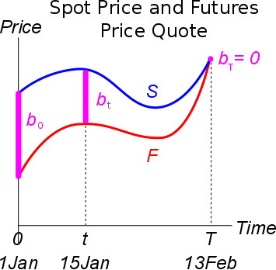
Basis Risk Price Difference
The short (sold) futures contract, entered into on 1Jan, should be closed out using a long (buy) futures contract on 15Jan.
To close out the futures contracts, both must have the same expiry (13Feb).

If the current time is 1Jan, the basis at this time is known since we can observe the futures price quote $F_{1Jan,13Feb}$ on the market:
$$b_{1Jan}=S_{1Jan}-F_{1Jan,13Feb}$$
But the basis on 15Jan is unknown now on 1Jan.
$$b_{15Jan}=S_{15Jan}-F_{15Jan,13Feb}$$
This is because on 1Jan we do not know either the
- underlying asset price ($S_{15Jan}$); or the
- futures price quote on 15Jan that matures on 13Feb ($F_{15Jan,13Feb}$).
They’re both stochastic variables. The basis on 15th January ($b_{t}$) will affect the hedge.
Gain on Closing out the Initial Short Future With a Long Future
Remember that a capital gain is the sale price less the buy price. So our futures gain is the sale price (futures price locked in on 1Jan) less the buy price (futures price on 15Jan):
FutGain1To15Jan = LockedInFutPrice1Jan - FutQuote15Jan
$=K_{1Jan,13Feb}-F_{15Jan,13Feb}$

The Basis in a Short Hedge
PortfolioValue $=$ PigSalePrice + FutGain1To15Jan
$=$ PigSalePrice + (LockedInFutPrice1Jan - FutQuote15Jan)
$$V_{t}=S_{t}+\left(K_{0,T}-F_{t,T}\right)=S_{15Jan}+(K_{1Jan,13Feb}-F_{15Jan,13Feb})$$
$$=K_{0,T}+S_{t}-F_{t,T} =K_{1Jan,13Feb}+S_{15Jan}-F_{15Jan,13Feb}$$
$$=K_{0,T}+b_{t} =K_{1Jan,13Feb}+b_{15Jan}$$
Where the basis on 15Jan is: $b_{15Jan}=S_{15Jan}-F_{15Jan,13Feb}$
When the farmer sells his pigs on 15Jan, the hedged portfolio value will be equal to the locked-in futures price that was initally entered into on 1Jan, plus the unknown basis risk on 15Jan.
On the graph, the basis is shown as being positive which would be good for the farmer. But on 1Jan, no-one knows what it will actually be.
The basis causes risk, hence why this is an ‘imperfect’ short hedge.

