Imperfect Long Futures Hedge
Today is 1st January. A bacon manufacturer plans to buy 40,000 pounds of pigs on 15th January. He’s afraid of pig prices rising. Unfortunately there are no CME futures expiring in January.
But he could still hedge against rises in the pig price by buying a future that expires on the tenth business day of February (13th Feb). He should long this future today (1st Jan).
On 15th January when he buys the pigs, he should then ‘close out’ the long futures by selling a lean hogs futures contract that also expires on 13th February.
By closing out his futures position, he will not be exposed to the risk of pig prices falling between 15th Jan and 13th Feb.
Last modified: 15.4.17 KW
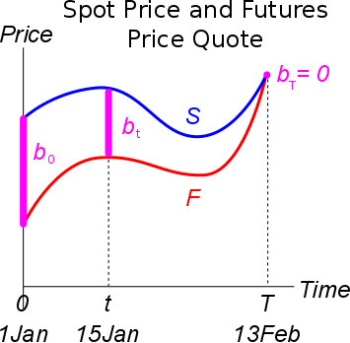
However, there will be basis risk since the futures price quote on 15Jan is unknown when he buys the first futures contract on 1Jan.
Gain on Closing out the Initial Long Future With a Short Future
Remember that a capital gain is the sale price less the buy price. So our futures gain is the sale price (futures price on 15Jan) less the buy price (locked-in futures price on 1Jan):
FutGain1To15Jan = FutQuote15Jan - LockedInFutPrice1Jan
$=F_{15Jan,13Feb}-K_{1Jan,13Feb}$

The Basis in a Long Hedge
PortfolioValue $=$ - PigBuyPrice + FutGain1To15Jan
$=$ - PigBuyPrice + (FutQuote15Jan - LockedInFutPrice1Jan)
$$V_{t}=-S_{t}+\left(F_{t,T}-K_{0,T}\right)=-S_{15Jan}+(F_{15Jan,13Feb}-K_{1Jan,13Feb})$$
$$=-K_{0,T}-S_{t}+F_{t,T} =K_{1Jan,13Feb}+S_{15Jan}-F_{15Jan,13Feb}$$
$$=-K_{0,T}-b_{t} =-K_{1Jan,13Feb}-b_{15Jan}$$
$$=-(K_{0,T}+b_{t}) =-(K_{1Jan,13Feb}+b_{15Jan})$$
Where the basis on 15Jan is: $b_{15Jan}=S_{15Jan}-F_{15Jan,13Feb}$

When the bacon manufacturer buy his pigs on 15Jan, the hedged portfolio value that he’ll have to pay will be equal to the locked-in futures price that was initally entered into on 1Jan, plus the unknown basis risk on 15Jan.
On the graph, the basis is shown as being positive which would be bad for the bacon manufacturer. But on 1Jan, no-one knows what it will actually be.
The basis causes risk, hence why this is an ‘imperfect’ long hedge.

