Calculation Example: Futures Price and Payoff at Maturity
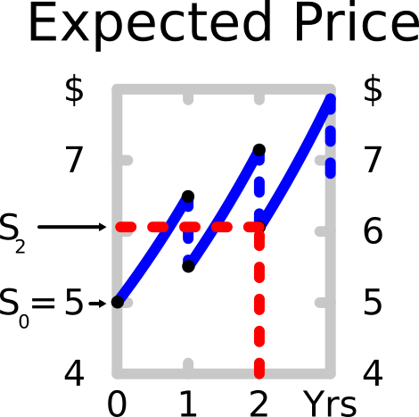
Question: Calculate the futures price of a 2 year futures contract written on the following stock. Assume that the futures contract matures just after the stock pays its dividend in year 2.
The stock has a current price of $5. Its next annual dividend of $1 will be paid in one year, and the dividend will continue to be paid annually forever and will grow at 10% pa.
The stock’s required total return is 30% pa. The perpetuity equation is suitable for valuing this share. All rates are given as effective annual returns. There are no storage costs from holding stocks.
Last modified 18.1.17 KW

Answer: The futures price will be equal to the expected stock price in 2 years since there’s no storage costs.
The dividend yield is 20%: $r_{div,eff}=\frac{C_{1}}{S_{0}}=\frac{1}{5}=0.2$
$$F_{T}=E\left[S_{T}\right]=S_{0}.{\left(1+r_{total,eff}-r_{div,eff}+r_{cost,eff}\right)}^{T}$$
$$F_{2}=E\left[S_{2}\right]=5×{\left(1+0.3-0.2+0\right)}^{2}$$
$$=5×{\left(1+0.1\right)}^{2}=6.05$$
So the futures price will be $6.05. So if you agree to buy this futures contract, you will lock in to pay $6.05 for this stock in 2 years.
Question: Will you receive the dividends at time 1 and 2 if you buy this 2 year futures contract now? Remember that the futures contract matures just after the dividend at time 2.

Answer: No, you will not receive the dividends at time 1 and 2 since the futures contract doesn’t mature until after the dividend at time 2 is paid. If the future is physically settled rather than cash settled, then from time 2 onwards you will own the stock and you will be entitled to any dividends.

Question: If the underlying stock price at maturity in two years turns out to be $5.80, what will be your payoff at maturity from the futures contract?
Answer:
$$f_{T,LF}=S_{T}-K_{T}$$
$$f_{2,LF}=5.80-6.05$$
$$=-0.25$$
Therefore you will have lost $0.25 on your long futures contract.
Your counterparty who has the short futures position will have gained $0.25.

