Long Put Option Payoff
Buying a put option (long put) gives you the right but not the obligation to sell the underlying asset (S) if you want for the exercise price (K or X) at maturity (T).
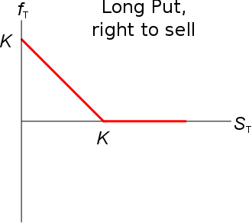
The payoff of a long put option contract at maturity is:
$p_{T, long}=max(K_{T}-S_{T}, 0)$

Short Put Option Payoff
The payoff of a short put option contract at maturity is the opposite:
$p_{T, short}=-p_{T, long}=-max(K_{T}-S_{T}, 0)$
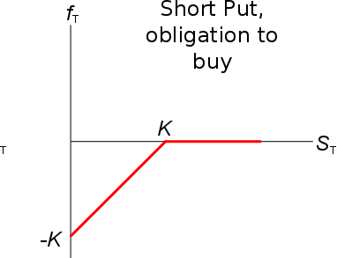
A short put option gives you the obligation to buy the underlying asset (S) from the long put trader for the exercise price (K or X) at maturity (t=T) if the long put trader chooses to exercise.
Of course the long trader will only exercise if the put is ‘in the money’ $(S_{T}<K_{T})$ which means that you’ll lose money.
If you’re short a put, you can say that you:
- Have sold the right for the long trader to sell the underlying asset to you if he wants;
- Have the obligation to buy the underlying asset from the long put trader if he wants to buy it.
Being short a put option means that you will either have a negative payoff at maturity if the put option is exercised, or you’ll lose nothing if it’s not exercised.
Either way, as a short put trader will have already gained the put option price (or premium, $p_{0}$) which you were paid at the start.
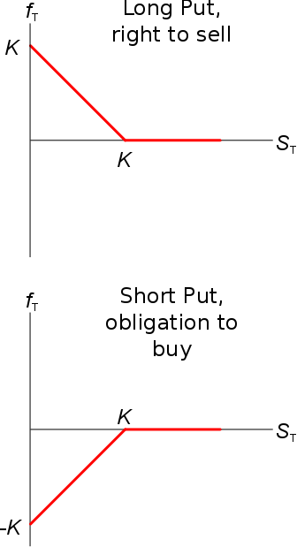
Put Option Price Now
The put premium or price now (t=0) is usually designated '$p_{0}$’ (or $f_{0LP}$).$$p_{0long}=\frac{p_{Tlong}}{e^{r.T}}$$
$$=\frac{max(K_{T}-S_{T}, 0)}{e^{r.T}}$$
Put options’ prices before maturity are always greater than zero:
$$p_{0long}>0$$
This is because there is some chance that the underlying asset price $S$ could be ‘in the money’ at maturity so $S_{T}<K_{T}$.
$S_{T}$ is unknown right now, so it’s a variable. This means that $p_{0long}$ is also a variable. So we can’t actually find the current put option price using this equation just yet.

