Call Option Profit
The profit $π$ on a long call (LC) contract subtracts the option price (or premium $c_{0}$) at the start from the option payoff at maturity ($c_{T}$).
$$π_{LC}=- cost at start+payoff at end$$
$$=-c_{0}+c_{T}$$
$$=-c_{0}+max(S_{T}-K_{T}, 0)$$
The profit on a short call (SC) is the opposite of the profit on the long call:
$$π_{SC}=-π_{LC}$$
Notice that the call (and put) profit graphs are the same as the ‘payoff at maturity’ graphs, but shifted up (short) or down (long) by the original option price or premium.
Last modified 16.1.17 KW
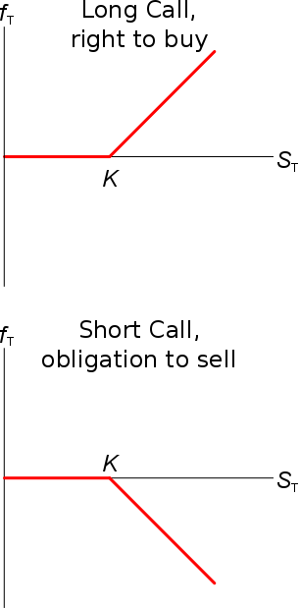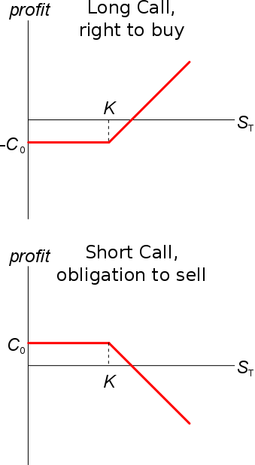
Put Option Profit
Similarly to above, the profit $π$ on a long put (LP) contract subtracts the option price (or premium $p_{0}$) at the start from the option payoff at maturity ($p_{T}$).
$$π_{LP}=- cost at start+payoff at end$$
$$=-p_{0}+p_{T}$$
$$=-p_{0}+max(K_{T}-S_{T}, 0)$$
The profit on a short put (SP) is the opposite of the profit on the long put:
$$π_{SP}=-π_{LP}$$
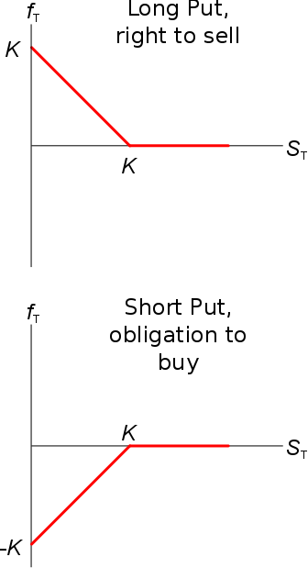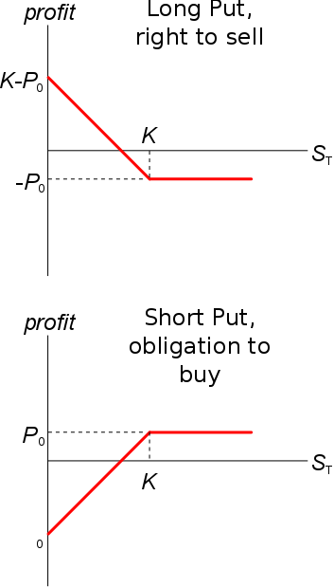
Option profit: Misleading
Be aware that call option profit is misleading for two reasons:
- The time value of money is ignored since amounts at the start and end are simply added together.
- The original call option price paid at the start $c_{0}$ is a sunk cost at maturity since the option doesn’t exist and can’t be sold after that time.
Even before maturity, the original price is irrelevant since the current price is likely to have changed.

