Exchange and OTC Trading
Listed stock, futures, options and some bonds are commonly traded on securities exchanges such as the NYSE, LSE, or ASX.
Foreign exchange (FX), short term debt (money market securities), bonds, forwards and swaps are commonly traded in the over-the-counter (OTC) markets. OTC trading is not done through a centralised exchange, it's just a trade between two parties in person or over the phone or using a computer. Usually one of the parties is a bank or other market maker.

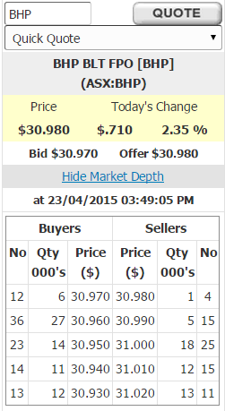
Bid and Ask Prices
Despite the 'Law of One Price', there are actually two prices quoted in the markets.
- Limit-order buyers buy at the ‘bid’ price.
- Limit-order sellers sell at the ‘ask’ or ‘offer’ price.
Since limit order traders wish to 'buy low, sell high', the bid is always lower than the ask.

Limit Order Book (LOB) and Market Depth
Limit order books (LOB) are ordered lists of the limit order bids and asks. The mining company BHP’s limit order book is shown on the right.
The limit order book shows the ‘market depth’ of liquidity.
Deep markets are characterized by large amounts of bid and ask limit orders at close together prices. This allows large buy (or sell) market orders to be transacted without losing too much money from buying at high (or selling at low) prices.
BHP is one of the biggest companies on the ASX, with deep liquidity and high trading volume.

Market Sell Order fulfilled by LOB’s Limit Buy Orders
The ‘buyers’ column shows the limit order bids. In the first row you can see that there are 12 traders waiting to buy a total of 6,000 BHP shares at a price of $30.97.
If you had 8,000 BHP shares that you wanted to quickly sell, you could make a market sell order. Your broker would instruct the exchange to sell the first 6,000 shares at $30.97, and the last 2,000 at $30.96, giving $247,740 (=6,000*30.97+2,000*30.96).
Market Buy Order fulfilled by LOB’s Limit Sell Orders
The ‘seller’ column shows the limit order offers or asks. In the first row you can see that there are 4 traders waiting to sell a total of 1,000 BHP shares at a price of $30.98.
If you wanted to quickly buy 8,000 BHP shares, you could make a market buy order. Your broker would instruct the exchange to buy the first 1,000 shares at $30.98, the next 5,000 at $30.99, and the last 2,000 shares at $31, costing $185,930 (=1,000*30.98+5,000*30.99).
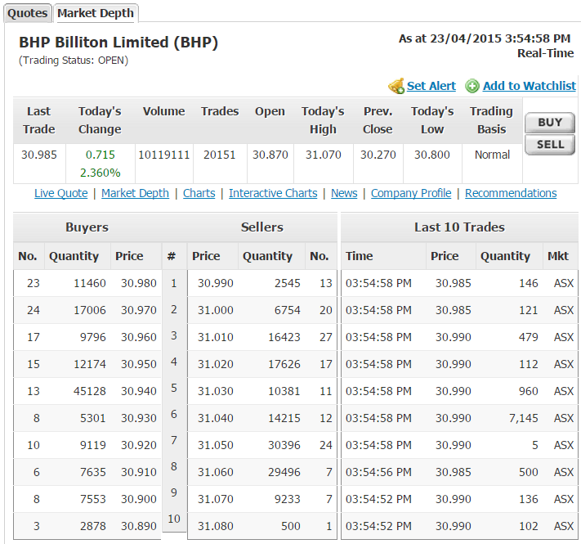
Fulfilled and Unfulfilled Limit Orders
The limit order book (LOB) shows the prices at which limit order buyers and sellers are patiently waiting to trade at.
Limit orders are queued by price and then by time.
A limit order might be:
- Fulfilled (or executed) immediately at a price equal to or better than the limit order price, or
- Wait in the limit order book until it’s fulfilled or cancelled.
It’s impossible to know whether your limit order will be fulfilled or not since the limit order book can change at any moment while you’re looking at the screen, before you press the trade button!
Limit Buy Order Fulfilled by LOB’s Limit Sell Orders
A limit buy order at $30.99 for 1,000 BHP stock is likely to be executed immediately at $39.98 which is the best ask at which 4 sellers offer 1,000 stock for sale.

Limit Buy Order Partially Fulfilled by LOB’s Limit Sell Orders, Remainder sits in LOB
A limit buy order at $30.98 for 3000 stock would be partially executed against all 1,000 stock for sale at $30.98 in the limit order book (LOB), and the other 2,000 stock remaining would sit in the limit order buy column at $30.98, being the new best bid.
The buy order will sit there until it’s executed against a market or limit sell order, or cancelled.
Limit Buy Order Unfulfilled, sits in LOB
A limit buy order at $30.97 for 1,000 stock would join the other 12 traders patiently waiting to buy 6,000 stock at that same price.
The buy order will sit there until it’s executed against a market or limit sell order, or cancelled.
That first buy row in the limit order book would change to read 13 traders willing to buy 7,000 stock at $30.97.
Limit Orders: Buy low, sell high!
Limit orders that are not fulfilled (or not executed) straight away will sit in the limit order book.
These traders with unfulfilled (or unexecuted) limit orders sitting in the limit order book tend to buy low and sell high if and when their orders eventually transact (become fulfilled or executed). They benefit from the bid-ask spread.
Note that these limit order traders with orders waiting in the limit order book actually offer liquidity to other traders. Liquidity is the benefit of being able to transact quickly and cheaply.
Limit Order Pitfalls
Traders with unfulfilled (or unexecuted) limit orders sitting in the limit order book are exposed to some potential problems:
- Their order may never be fulfilled. It may sit there forever or until it’s cancelled;
- The order could lead to a loss if there’s an adverse news release.
For example, suppose that you are one of the 12 traders with buy orders for BHP at $30.97 and it’s 2:30pm on the first Tuesday of the month.
The RBA publish their monetary policy decision to increase interest rates, which surprised you and the rest of the market who expected no change.
All share prices including BHP are likely to fall.
If you’re not quick enough to cancel your limit buy order, a quick opportunistic rival trader will sell against your $30.97 limit buy order, then buy the stock later at a lower price of say $29 once the bad news is reflected in stock prices, making $1.97 (=30.97-29) per stock at your expense.
Market Orders
Market buy (or sell) orders are executed straight away against limit sell (or buy) orders.
Traders using market orders tend to buy high and sell low. They lose from the bid-ask spread. However, unlike limit order traders, market order traders don’t have to wait for their order to be executed.
A market buy order will transact with a limit sell order.
A market sell order will transact with a limit buy order.
Market orders are not shown on the limit order book because executed market orders cancel out limit orders sitting on the limit order book.
The bid and ask are always quoted from the point of view of the limit order trader.
Market orders can only be executed while the market is open, which for the ASX is approximately 10am to 4pm Sydney time on weekdays.
On the very odd occasion that a stock’s limit order book is empty, so no limit orders exist on the buy or sell side to offer liquidity to market order traders, market orders will not be executed and will have to wait.

Market and Limit Order Inputs
Market orders specify:
- Buy or sell order type;
- The security's ticker code.
Limit orders specify:
- Buy or sell order type;
- The security's ticker code;
- Price per security, which for an order to:
  - Buy is the highest price you’re prepared to pay;
  - Sell is the lowest price you’ll accept to sell the stock.
- How long the order should last for or is 'good for', usually ‘good for the day’ or ‘until cancelled’.
Summary Comparison by Broker CommSec
 | Limit | At Market
The condition you're setting | Buys – setting the highest price you’re willing to pay  Sells – setting the lowest price you’re willing to sell at | Buys – willing to pay the going market price  Sells – willing to sell at the going market price
Price entered | Your limit price in dollars and cents | Not applicable
Accepted | All the time (we’ll queue your order when the market isn’t accepting orders; the market may subsequently reject your order depending on the market state) | During market hours only, generally 10am-4pm Sydney time
Can be amended | Yes  (unless the order’s fulfilled or if the market state doesn’t accept amendments at that time) | Not online  (and rarely over the phone because it’s often fulfilled quickly)
Can be cancelled | Yes  (unless the order’s fulfilled) | Not online  (and rarely over the phone because it’s often fulfilled quickly)

Source: https://www.commsec.com.au/support/help-centre/About-the-sharemarket/limit-and-at-market-orders-when-to-use-them-and-how-they-differ.html
Bid, Ask and Midpoint Prices
Many stock investors believe that the ‘true’ or ‘fair’ market price of a stock is somewhere between the bid and ask prices. It’s often assumed to be the average or mid-point.
$$MidPointPrice=\frac{ask + bid}{2}$$
Therefore every time a market order trader trades with a limit order trader, the market order trader loses half the bid-ask spread. This is called an implicit cost of trading, as opposed to an explicit cost such as brokerage fees.
$$HalfBidAskSpread=\frac{ask- bid}{2}$$
While the market order trader loses half the bid-ask spread, the limit order trader gains it. The market order trader pays this cost to access the liquidity provided by the limit order trader.
Here are some screen shots from the interface of the online discount stock brokerage ETrade. They show the limit order book, the market and limit order types, and the buy order confirmation screen for buying Commonwealth Bank Shares (ticker: CBA).
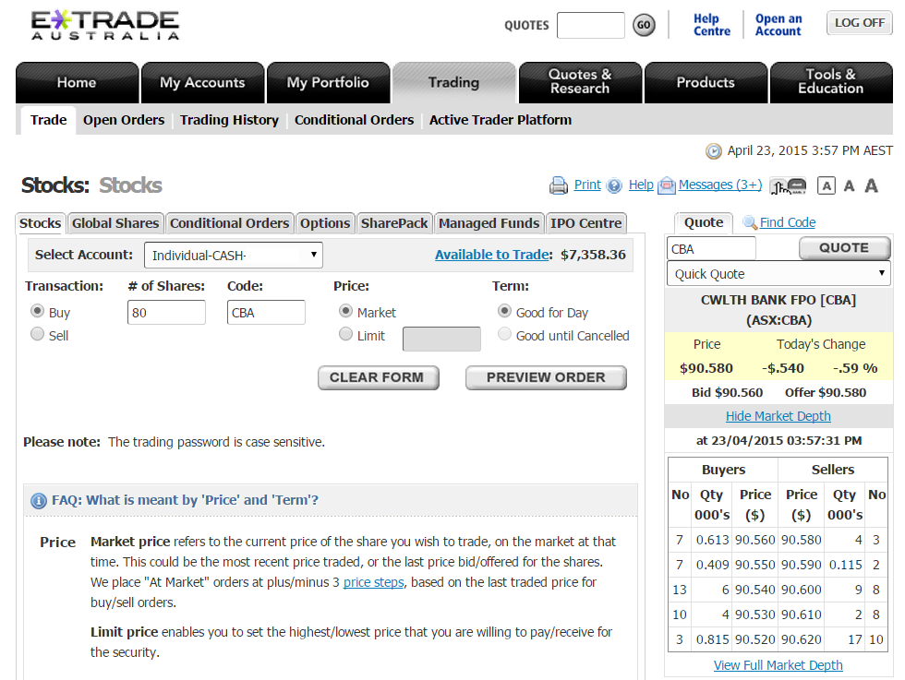
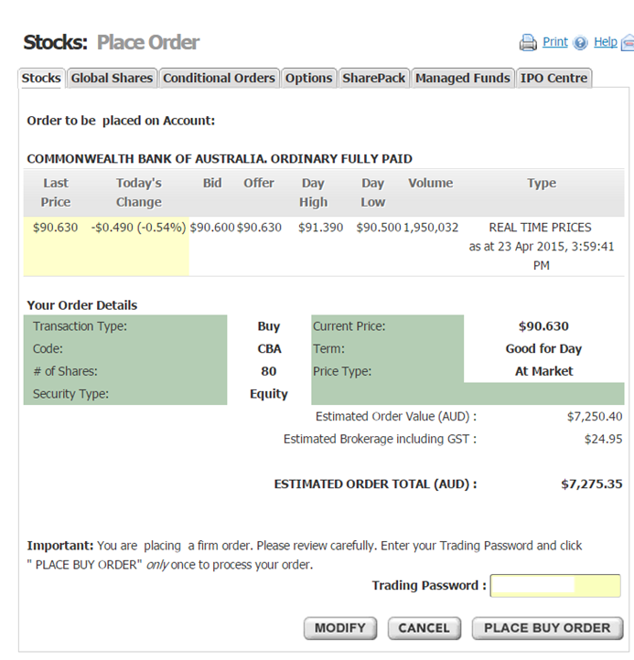
Here are some screen shots from the interface of other online discount stock brokerages CMC, CommSec and Futu Securities. They show the limit order book, the market and limit order types, and the buy order confirmation screen for buying Energy Resources Australia (ticker: ERA).

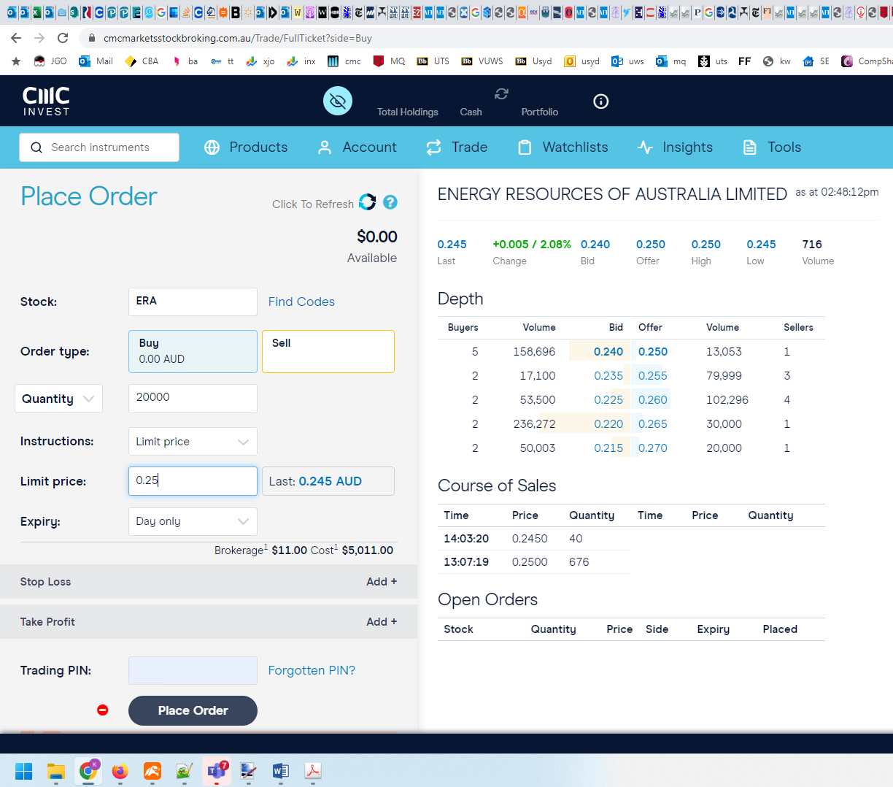Broker 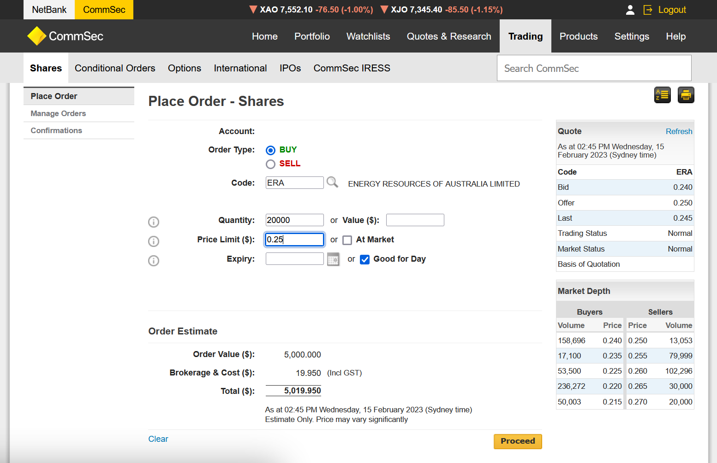

Moomoo, Futu Securities
