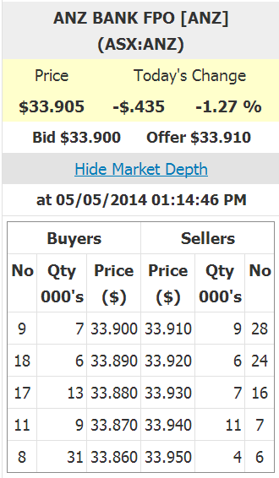
Bid-Ask Spread Example 1
Question 1: On the right is a screenshot which shows the market depth for ANZ bank shares.
Question 1a: What is the bid-ask spread on these shares?
Answer: bid-ask spread = ask - bid
= 33.91 - 33.9
= $0.01
Last modified 3.5.17 KW

Question 1b: What is your best estimate of the 'true price' of these shares?
Answer: midpoint = (ask + bid)/2
= (33.91 + 33.9)/2 = 33.905
Question 1c: What is the best price that you could buy one share when placing a market order?
Answer: We execute our market buy order against the limit sell orders shown in the limit order book. The lowest price that we can buy from these sellers is at $33.91, which is the best ‘ask’ or ‘offer’.
Question 1d: How much money could you sell 10,000 shares for, using a market order? (Note that in this question you are selling, in the previous question, you are buying).
Answer: We can only sell to the buyers, and they are prepared to sell 7,000 shares at $33.9, and then we’ll have to sell the remaining 3,000 shares at the slightly worse price of $33.89. So altogether that’s:
Sales = 7,000*33.9+3,000*33.89
=$338,970

Question 1e: What is the implicit cost of selling these 10,000 shares, given your 'true price' answered above?
Answer: The actual sale price less the ‘true’ midpoint price summed across all stocks will give the total implicit cost.
ImplicitCost = 7,000*(33.9-33.905)+
3,000*(33.89-33.905)
= 80

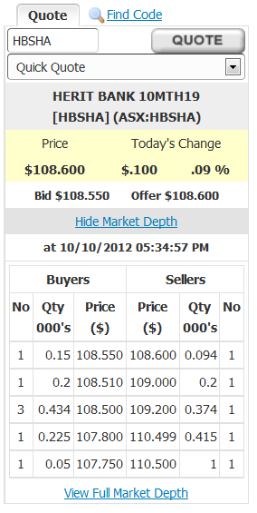
Bid-Ask Spread Example 2
Question 2: On the right is a screenshot from a brokerage which shows the market depth for Heritage Bank Notes (ticker: HBSHA).
Question 2a: What is the bid-ask spread on these notes?
Answer: $0.05
Question 2b: What is your best estimate of the 'true price' of these notes?
Answer: $108.575
Question 2c: What is the best price that you could buy one Heritage Note when placing a market order?
Answer: $108.6

Question 2d: How much would it cost to buy 200 notes using a market buy order, excluding explicit transaction costs?
Answer: Expense = 94*108.6 + 106*109
= $21,762.4

