Exchange traded Stock, Option and Bond
Limit and Market Order Questions
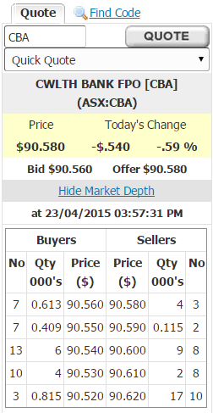
Question 1 (total of 21 marks): Below is a screenshot from E-Trade which shows details of CBA bank shares.
Question 1a (3 marks): What is the bid-ask spread on these shares?

Question 1b (3 marks): What is your best estimate of the 'true price' of these shares?

Question 1c (3 marks): What is the best price that you could buy one share when placing a market order?

Question 1d (3 marks): For how much money could you sell 5,000 shares when submitting a market order? (Note that in this question you are selling, in the previous question, you were buying).

Question 1e (3 marks): What would be the implicit cost of selling these 5,000 shares using a market order, given your 'true price' answered above?

Question 1f (3 marks): List one advantage of a placing a limit order rather than a market order.

Question 1g (3 marks): List two disadvantages of a placing a limit order rather than a market order.

Question 1 (total of 24 marks): Below is a screenshot from E-Trade which shows details of a call option on CBA bank shares. Note that the strike price is $77.

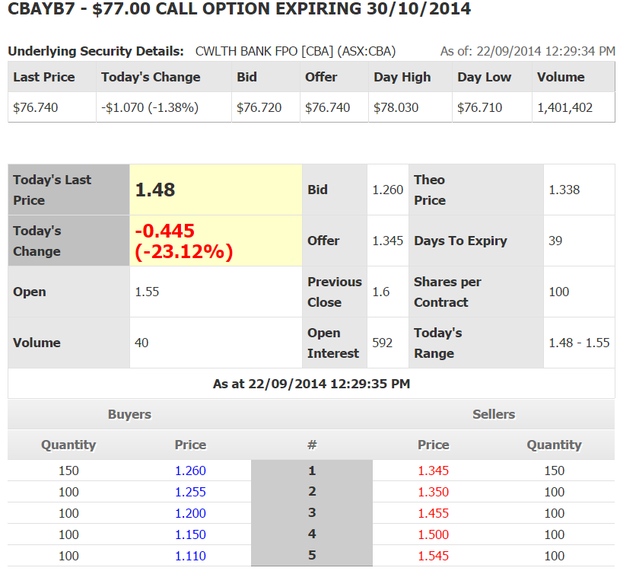
Question 1a (3 marks): What is the bid-ask spread on these options?

Question 1b (3 marks): What is your best estimate of the 'true price' of these call options?

Question 1c (3 marks): What is the best price that you could buy one call option contract when placing a market order? Be aware that one call option contract is on 100 shares and prices are listed on a per-share basis rather than a per contract basis.

Question 1d (3 marks): How much money could you sell 200 call options for? (Note that in this question you are selling, in the previous question, you are buying).

Question 1e (3 marks): What would be the implicit cost of selling these 200 call options, given your 'true price' answered above?

Question 1f (3 marks): Is this call option 'in-the-money' or 'out-of-the-money'?

Question 1g (3 marks): The quantity demanded by the top 5 buyers equals the quantity supplied by the top 5 sellers. Will this always be the case?

Question 1h (3 marks): The CBA share price $1.07 from the previous day, but the call option fell by $0.445. Would you usually expect the value of the share to change by more than the value of the call option? Explain why or why not.

Question 1 (total of 15 marks): Below is a screenshot from E-Trade which shows details of BHP shares.
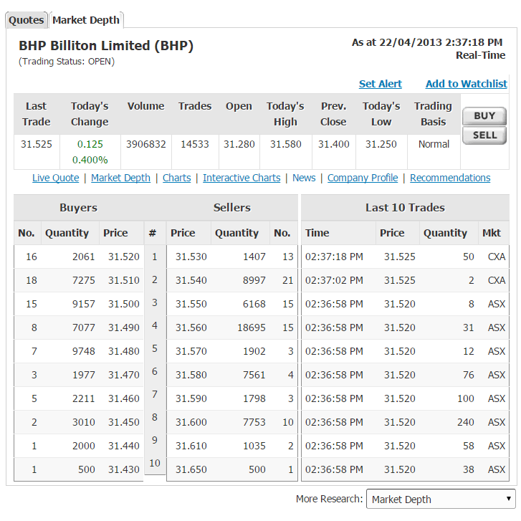
Question 1a (3 marks): What is the bid-ask spread on these shares?

Question 1b (3 marks): What is your best estimate of the 'true price' of these

Question 1c (3 marks): What is the best price that you could buy one share when placing a market order?

Question 1d (3 marks): How much money could you sell 5,000 shares for? (Note that in this question you are selling, in the previous question, you were buying).

Question 1e (3 marks): What would be the implicit cost of selling these 5,000 shares using a market order, given your 'true price' answered above?

Question 1 (total of 20 marks):
The next few questions relate to the data below which is a screenshot from the broking platform ETRADE showing the market depth for BHP call options. (8 marks)

BHPUJ8 - $35.00 CALL OPTION EXPIRING 25/07/2013  Underlying Security Details: BHP BLT FPO [BHP] (ASX:BHP) | As of: 22/04/2013 2:34:16 PM

Last Price | Today's Change | Bid | Offer | Day High | Day Low | Volume
$31.530 | $0.130 (.41%) | $31.520 | $31.530 | $31.580 | $31.250 | 3,891,894

Today's Last Price | 0.75 | Bid | 0.390 | Theoretical  Price | 0.439
Today's  Change | 0.34 (82.93%) | Offer | 0.430 | Days To Expiry | 95
Open | 0 | Previous  Close | 0 | Shares per Contract | 100
Volume | 0 | Open  Interest | 474 | Today's  Range | 0 - 0
As at 22/04/2013 2:34:16 PM
Buyers |  |  | Sellers
Quantity | Price | # | Price | Quantity
30 | 0.390 | 1 | 0.430 | 30
20 | 0.0380 | 2 | 0.450 | 10
0 | 0.000 | 3 | 0.000 | 0
0 | 0.000 | 4 | 0.000 | 0
0 | 0.000 | 5 | 0.000 | 0

Question 1a (2 marks): Of the 3 choices below, where each is in bold, circle the correct answer:
The call option is in the money, at the money, or out of the money.
Question 1b (4 marks): ETRADE calculates the theoretical option price to be $0.439. In their FAQ they state that the theoretical option price is only a guide, but that it is calculated using the Black-Scholes option pricing equation. In one sentence, explain whether the estimated theoretical option price looks reasonable.

Question 1c (4 marks): What is the intrinsic value of this call option?

Question 1d (4 marks): What is the breakeven price of this call option?

Question 1e (6 marks): A trader is planning to buy 35 of the above call options by submitting a market order. Ignoring broking fees, what will be the total cost of her purchase?
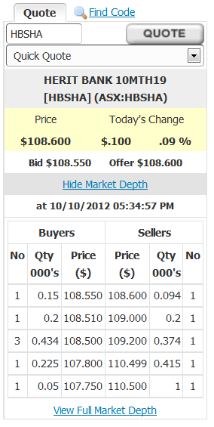
Question 1 (total of 12 marks): On the right is a screenshot from E-Trade which shows the market depth for Heritage Notes (ticker: HBSHA).
Question 1a (3 marks): What is the bid-ask spread on these notes?

Question 1b (3 marks): What is your best estimate of the 'true price' of these notes?

Question 1c (3 marks): What is the best price that you could buy one Heritage Note when placing a market order?

Question 1d (3 marks): How much would it cost to buy 200 notes, excluding transaction costs?

