Exchange traded Stock, Option and Bond
Limit and Market Order Questions
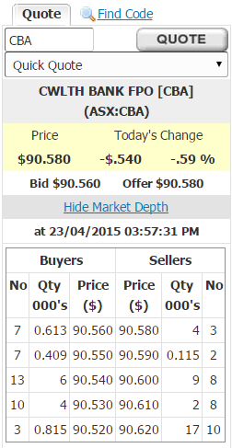
Question 1 (total of 21 marks): Below is a screenshot from E-Trade which shows details of CBA bank shares.
Question 1a (3 marks): What is the bid-ask spread on these shares?
*$0.02 (=90.58 - 90.56)

Question 1b (3 marks): What is your best estimate of the 'true price' of these shares?
*$90.57 (=(90.58 + 90.56)/2)

Question 1c (3 marks): What is the best price that you could buy one share when placing a market order?
*$90.58.

Question 1d (3 marks): How much money could you sell 5,000 shares for? (Note that in this question you are selling, in the previous question, you were buying).
*$452,716.35 (=613*$90.56 + 409*$90.55 + 3,978*90.54)

Question 1e (3 marks): What would be the implicit cost of selling these 5,000 shares using a market order, given your 'true price' answered above?
*$133.65 (=613*(90.57 - 90.56) + 409*(90.57 - 90.55) + 3,978*(90.57 - 90.54))

Question 1f (3 marks): List one advantage of a placing a limit order rather than a market order.
*Earn half the bid-ask spread.

Question 1g (3 marks): List two disadvantages of a placing a limit order rather than a market order.
*The limit order may not be executed.
*News may arrive that makes your buy limit order too high, and you fail to withdraw the order before it is executed with an opportunistic seller. So you'll lose money.

Question 1 (total of 24 marks): Below is a screenshot from E-Trade which shows details of a call option on CBA bank shares. Note that the strike price is $77.

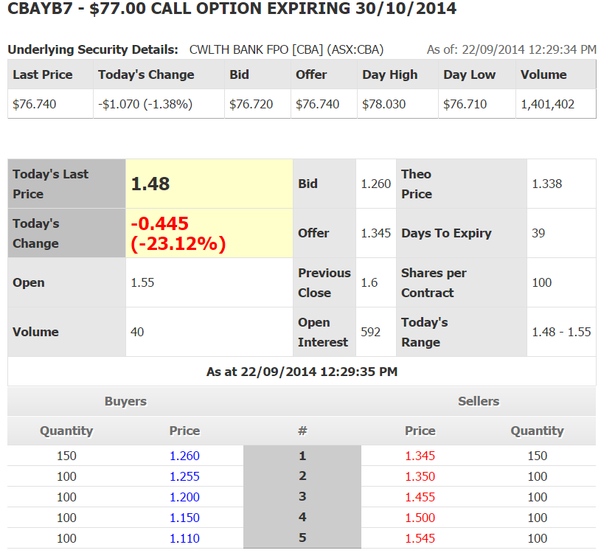
Question 1a (3 marks): What is the bid-ask spread on these options?
*$0.085 (=1.345 - 1.26)

Question 1b (3 marks): What is your best estimate of the 'true price' of these call options?
*$1.3025 (=(1.345 + 1.26)/2)

Question 1c (3 marks): What is the best price that you could buy one call option contract when placing a market order? Be aware that one call option contract is on 100 shares and prices are listed on a per-share basis rather than a per contract basis.
*$1.345 on a per share basis or $134.50 since one call option contract is on 100 shares.

Question 1d (3 marks): How much money could you sell 200 call options for? (Note that in this question you are selling, in the previous question, you are buying).
*$25,175.00 (=(150*$1.26 + 50*$1.255)*100)

Question 1e (3 marks): What would be the implicit cost of selling these 200 call options, given your 'true price' answered above?
*$875 (=[150*(1.3025 - 1.26) + 50*($1.3025 - $1.255)]*100)

Question 1f (3 marks): Is this call option 'in-the-money' or 'out-of-the-money'?
*Out of the money.
Question 1g (3 marks): The quantity demanded by the top 5 buyers equals the quantity supplied by the top 5 sellers. Will this always be the case?
*No, it's a coincidence.
Question 1h (3 marks): The CBA share price $1.07 from the previous day, but the call option fell by $0.445. Would you usually expect the value of the share to change by more than the value of the call option? Explain why or why not.
*Yes, since the delta of the call option (change in option price divided by change in stock price) is always between zero and one.

Question 1 (total of 15 marks): Below is a screenshot from E-Trade which shows details of BHP shares.
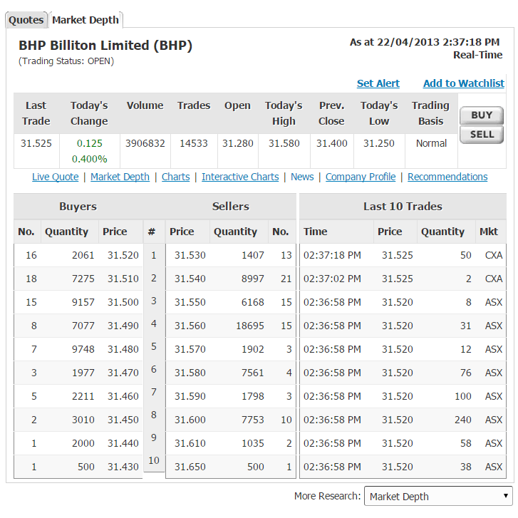
Question 1a (3 marks): What is the bid-ask spread on these shares?
*$0.01 (=31.53 - 31.52)

Question 1b (3 marks): What is your best estimate of the 'true price' of these shares?
*$31.525 (=(31.53 - 31.52)/2)

Question 1c (3 marks): What is the best price that you could buy one share when placing a market order?
*$31.53.

Question 1d (3 marks): How much money could you sell 5,000 shares for? (Note that in this question you are selling, in the previous question, you were buying).
*$157,570.61 (=2061*$31.52 + (5000-2061)* $31.51)

Question 1e (3 marks): What would be the implicit cost of selling these 5,000 shares using a market order, given your 'true price' answered above?
*$54.39 (=2061*(31.525 - 31.52) + (5000-2061)*(31.525 - 31.51))

Question 1 (total of 20 marks):
The next few questions relate to the data below which is a screenshot from the broking platform ETRADE showing the market depth for BHP call options. (8 marks)

BHPUJ8 - $35.00 CALL OPTION EXPIRING 25/07/2013  Underlying Security Details: BHP BLT FPO [BHP] (ASX:BHP) | As of: 22/04/2013 2:34:16 PM

Last Price | Today's Change | Bid | Offer | Day High | Day Low | Volume
$31.530 | $0.130 (.41%) | $31.520 | $31.530 | $31.580 | $31.250 | 3,891,894

Today's Last Price | 0.75 | Bid | 0.390 | Theoretical  Price | 0.439
Today's  Change | 0.34 (82.93%) | Offer | 0.430 | Days To Expiry | 95
Open | 0 | Previous  Close | 0 | Shares per Contract | 100
Volume | 0 | Open  Interest | 474 | Today's  Range | 0 - 0
As at 22/04/2013 2:34:16 PM
Buyers |  |  | Sellers
Quantity | Price | # | Price | Quantity
30 | 0.390 | 1 | 0.430 | 30
20 | 0.0380 | 2 | 0.450 | 10
0 | 0.000 | 3 | 0.000 | 0
0 | 0.000 | 4 | 0.000 | 0
0 | 0.000 | 5 | 0.000 | 0

Question 1a (2 marks): Of the 3 choices below, where each is in bold, circle the correct answer:
The call option is in the money, at the money, or *out of the money.
Question 1b (4 marks): ETRADE calculates the theoretical option price to be $0.439. In their FAQ they state that the theoretical option price is only a guide, but that it is calculated using the Black-Scholes option pricing equation. In one sentence, explain whether the estimated theoretical option price looks reasonable.
Answer: No, it is not between the bid and ask prices of $0.39 and $0.43 respectively. Either the theoretical price is wrong, or the sellers who are willing to sell at a price less than the theoretical price are idiots.
Question 1c (4 marks): What is the intrinsic value of this call option?
Answer: This option is out of the money so its intrinsic value is zero.

Question 1d (4 marks): What is the breakeven price of this call option?
Answer: The break-even price of a call option the strike price plus the option price. The option price is the mid-point of the bid-ask prices which is (0.39+0.43)/2 = $0.41. So the break-even price is $35.00 + $0.41 = $35.41.

Question 1e (6 marks): A trader is planning to buy 35 of the above call options by submitting a market order. Ignoring broking fees, what will be the total cost of her purchase?
Answer: Note that we buy from the sellers.
Also, note that each option contract is on 100 shares (Shares per contract = 100), but the option price is given as if it is on 1 share. So we must multiply the option cost by 100.
Total cost = 100 * (30 * 0.43 + 5 * 0.45) = $1515.00

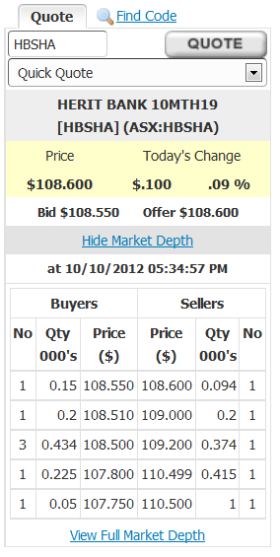
Question 1 (total of 12 marks): On the right is a screenshot from E-Trade which shows the market depth for Heritage Notes (ticker: HBSHA).
Question 1a (3 marks): What is the bid-ask spread on these notes?
*$0.05 (=108.6-108.55)

Question 1b (3 marks): What is your best estimate of the 'true price' of these notes?
*108.575 (=(108.6+108.55)/2)

Question 1c (3 marks): What is the best price that you could buy one Heritage Note when placing a market order?

*108.60

Question 1d (3 marks): How much would it cost to buy 200 notes, excluding transaction costs?

*21762.4 (=94*108.6 + 106*109)

