Diagrams: Payoff at Maturity $\left(f_{T}\right)$
‘Payoff at maturity’ shows the security’s cash flow at the end time, which is at the expiry of an option or future or at the time of sale for a bond or stock.
Payoff at maturity ignores cash flows at the start and middle. It only includes cash flows at the end (maturity). In particular, the price paid for the security at the start is ignored, such as the option price or premium or the stock price.
Last modified 20.4.17 KW
Last modified 20.4.17 KW
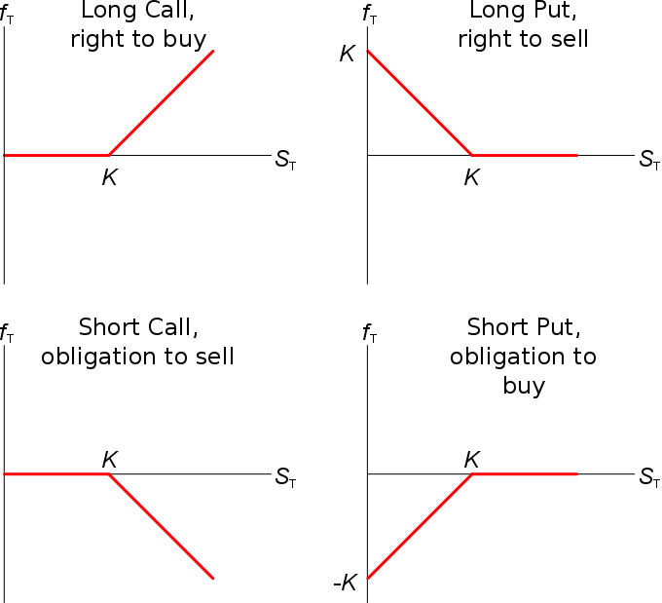
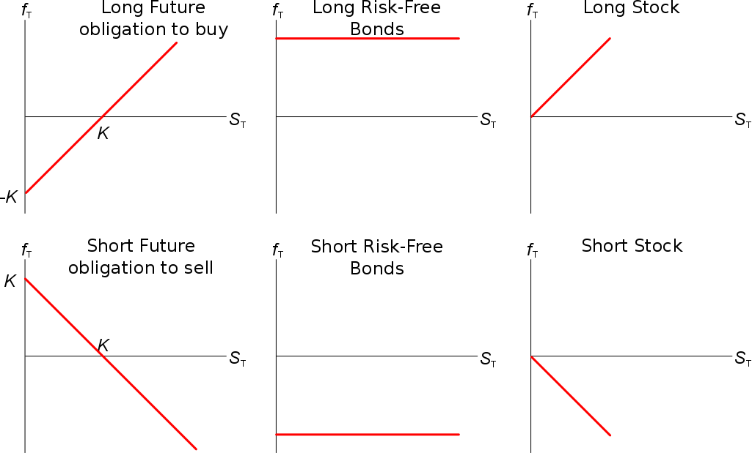

Diagrams: Profit $\left(π\right)$
The profit sums all cash flows from the start to the end but unfortunately, just like accounting profit, it ignores the time value of money and can include sunk costs.
For example, profit subtracts the stock price paid at the start and adds the price sold at the end, mixing up payments at different times. That’s why you can’t say when the profit occurs, it’s a mess.
For options, profit subtracts the option price (also called the premium) at the start, which is a sunk cost when contemplating profit at maturity. This is because the premium can’t be refunded and the option can’t be sold after maturity. Such costs should be ignored when making decisions about the option at or after maturity, they should not be subtracted.
