European Option Put-Call Parity
Buying a stock and buying a put option is equivalent to buying a call option and buying government bonds, where both European-style options are written on the same underlying stock, with the same strike price and maturity, and the government bond investment equals the present value of the options’ strike price:
LongStock + LongPut = LongCall + LongGovtBonds
$$S_{0} +{ p}_{0} = { c}_{0 }+ { K}_{T}.e^{-r.T}$$
The above equation shows asset prices at time zero (now).
This relationship should always hold before and at maturity. At any time t:
Last modified 20.4.17 KW
Last modified 20.4.17 KW
Last modified 20.4.17 KW
$$S_{t}+p_{t}=c_{t}+K_{T}.e^{-r.(T-t)}$$
At maturity (T):
$$S_{T }+ p_{T} = c_{T} + K_{T}$$
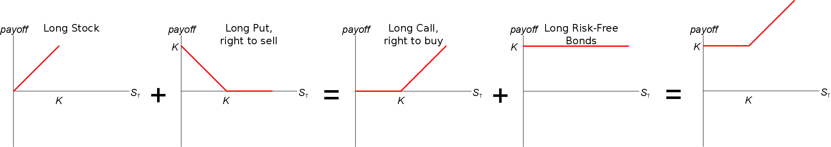
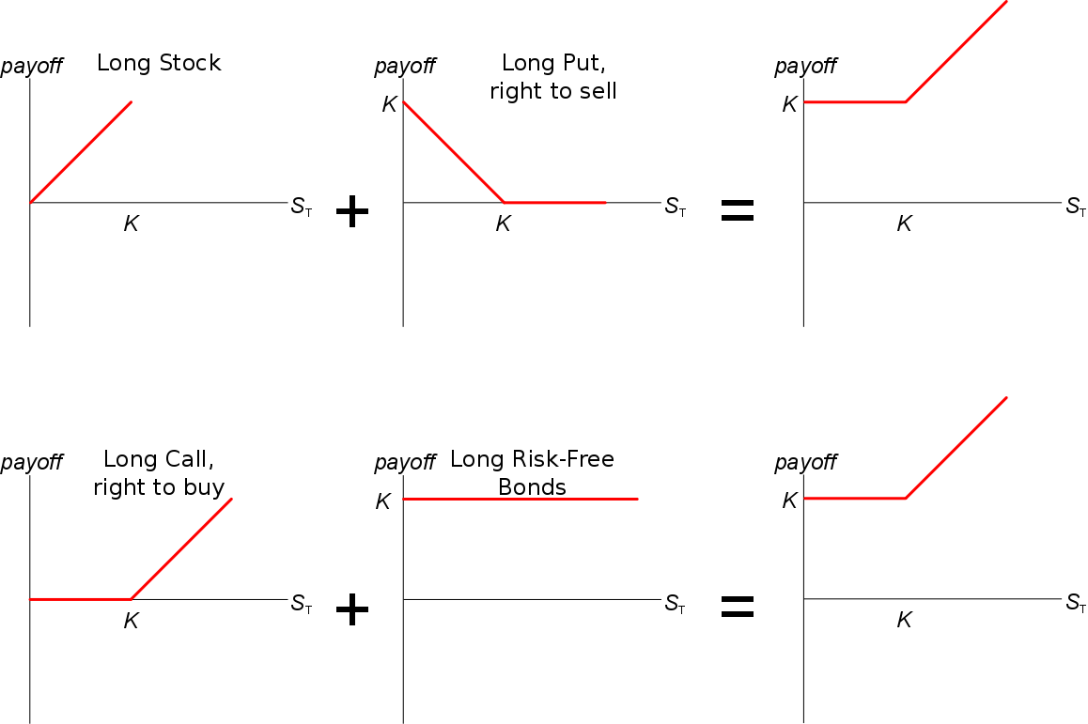
Investments versus Cash Flows
A positive investment is a negative cash flow, so put-call parity expressed as an investment now (t=0) uses the familiar equation:
$$S_{0}+p_{0}=c_{0}+K_{T}.e^{-r.T}$$
But put-call parity expressed as cash flows now (t=0) is:
$$-S_{0}-p_{0}=-c_{0}-K_{T}.e^{-r.T}$$
This is because investing in, say, a stock, means paying money now which is a negative cash flow now, hence the switch in the signs (+ to -). So:
Buying stock = Long stock = Investing in stock = Spending cash on stock = Negative cash flow on stock purchase

Adjustment for Dividends
Dividends can be included by simply replacing all instances of $S_{0}$ with:
- $S_{0}-D_{0}$ where $D_{0}$ is the present value of the discrete dividend paid at time t, so $D_{0}=D_{t}.e^{-r.t}$ and r is the continuously compounded risk free rate:
$$(S_{0}-D_{0})+p_{0}=c_{0}+K_{T}.e^{-r.T}$$

- $S_{0}.e^{-q.t}$ where $q$ is the continuously compounded annual dividend yield, say when $S$ is a stock index such as the S&P500:
$$(S_{0}.e^{-q.t})+p_{0}=c_{0}+K_{T}.e^{-r.T}$$

