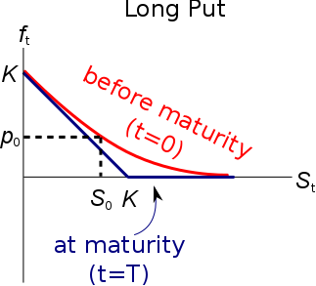
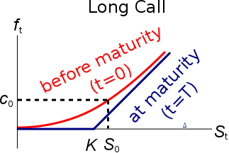
European Option Valuation Without Dividends
$c_{0}= S_{0}.N[d_{1}] -K_{T}.e^{-rT}.N[d_{2}]$
$$p_{0}=-S_{0}.N[-d_{1}]+K_{T}.e^{-rT}.N[-d_{2}]$$
$$d_{1}=\frac{\ln{[S_{0}/K_{T}]}+\left(r+\frac{σ^{2}}{2}\right).T}{σ.\sqrt{T}}$$
$d_{2}=\frac{\ln{[S_{0}/K_{T}]}+\left(r-\frac{σ^{2}}{2}\right).T}{σ.\sqrt{T}}=d_{1}-σ.\sqrt{T}$

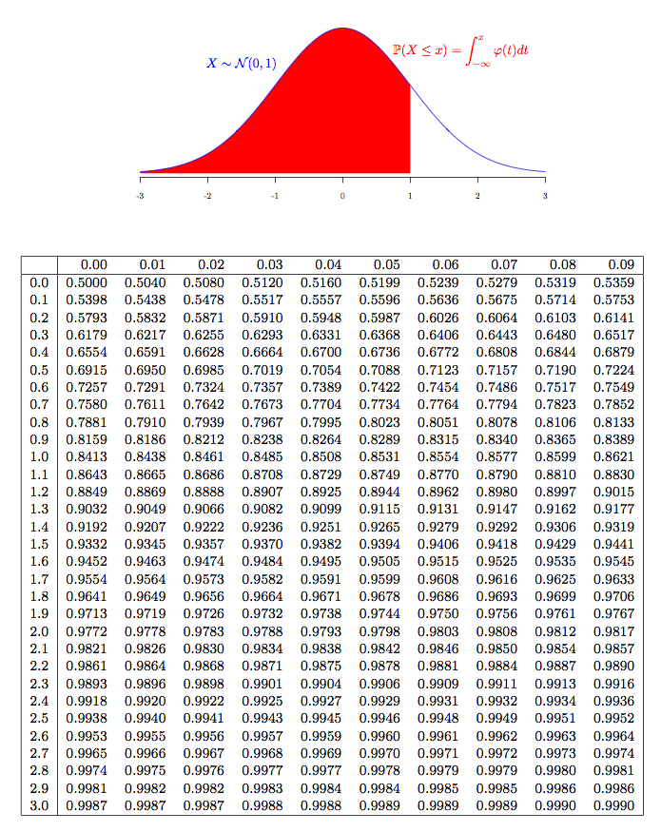
$N[Z]$
$N\left[Z\right]$ gives the probability that the standardised normally distributed random variable $x$ with mean 0 and variance 1 is less than $Z$:
$$N\left[Z\right]=Pr⁡(x<Z)$$
It’s normally looked up on the standard normal Z table. It can also be calculated in MS Excel using the ‘=normsdist()’ function.
$N[d_{2}]$ Probability
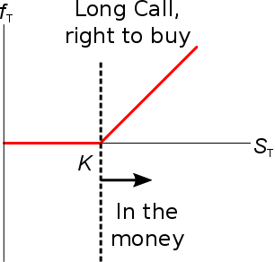
$N\left[d_{2}\right]=\operatorname{Pr}\left(S_{T}>K_{T}\right)$ for a European call option, which is the probability that the call option ends up being in the money at maturity in a risk-neutral world where all assets earn the risk free rate r.
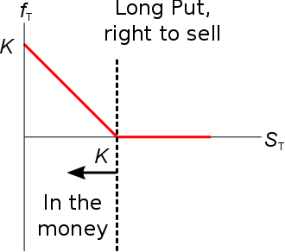
$N\left[-d_{2}\right]=\operatorname{Pr}\left(S_{T}<K_{T}\right)$ for a European put option, which is the probability that the put option ends up being in the money at maturity in a risk-neutral world.

To get the risk-averse probability in the real world, replace r in $N\left[d_{2}\right]$ with the underlying asset’s forecast natural logarithm of arithmetic average gross discrete returns (LAAGDR):
$$L{AAGDR}_{ 0→T}=\ln\left(\frac{1}{T}.\sum_{t=1}^{T}{\left(\frac{p_{t}}{p_{t-1}}\right)}\right)$$

See the lecture on return distributions for more detail.

$N[d_{1}]$ Option Delta Δ
$N\left[d_{1}\right]=Δ$, the European call option Delta at the current underlying asset price $S_{0}$ which has $T$ time until maturity.
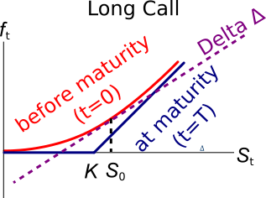
The Delta is a tangential gradient, it’s the increase (rise) in option price $f_{t}$ divided by the increase (run) of the underlying asset price $S_{t}$.
For every 1 cent increase in the underlying asset price, the option price will increase by Delta cents.
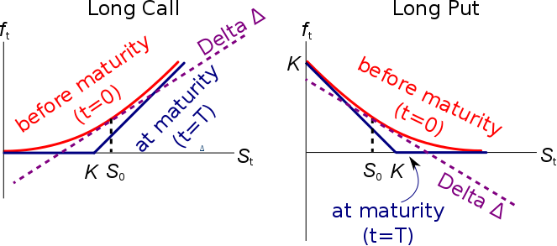

Portfolio Delta $Δ_{p}$
If a portfolio’s Delta is zero then a small change in the underlying asset price will lead to no change in the value of the portfolio, so it’s hedged. The Delta of a portfolio is simply the sum of the assets’ Deltas. Let $n_{1}$ be the number of asset 1’s, and let m be the total number of assets. Then the portfolio Delta ($Δ_{p}$) is:
$$Δ_{p}=Δ_{1}.n_{1}+Δ_{2}.n_{2}+…+Δ_{m}.n_{m}$$

Relationship to the No-arbitrage Binominal Option pricing Delta
This Black-Scholes-Merton Delta $(Δ=N\left[d_{1}\right])$ is the same Delta as the No-arbitrage Binominal Option pricing formula’s delta:
$$V_{0}=-f_{0}+Δ.S_{0}$$

