Calculation Example: European Option Valuation Without Dividends
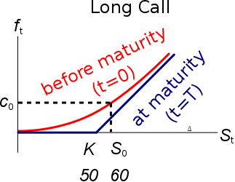
Question: Find the price of a 6 month European call option with a strike price of $50, written on a non-dividend paying stock currently trading at $60. The risk-free interest rate is 10% pa continuously compounded and the standard deviation of the stock’s returns is 20% pa.
Last modified 21.2.17 KW

Answer:
$$d_{1}=\frac{\ln{[S_{0}/K_{T}]}+\left(r+\frac{σ^{2}}{2}\right).T}{σ.\sqrt{T}}$$
$$d_{1}=\frac{ln⁡[60/50]+\left(0.1+\frac{{0.2}^{2}}{2}\right)×0.5}{0.2×\sqrt{0.5}}$$
$$=1.71347$$
$$d_{2}=d_{1}-σ.\sqrt{T}$$
$$d_{2}=1.71347-0.2×\sqrt{0.5}$$
$$=1.57205$$

$$c_{0}=S_{0}.N[d_{1}]-K_{T}.e^{-rT}.N[d_{2}]$$
$$=60×N[1.71347]-50×e^{-0.1×0.5}×N[1.57205]$$
$$=60×0.9567-50×e^{-0.1×0.5}×0.9420$$
$$=57.4012-44.8044$$
$$=\$12.60$$
