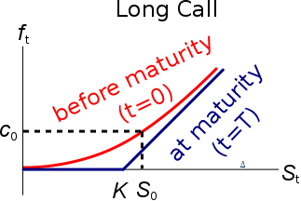
Valuation of European Options with Continuous Dividends
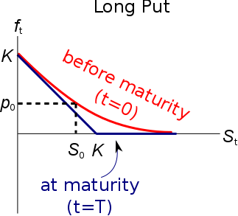
To value an option written on an equity index that pays a continuously compounded dividend yield $q$, simply replace all instances of $S_{0}$ with $S_{0}.e^{-q.T}$:
Last modified 9.11.19 KW

$$c_{0}= S_{0}.e^{-q.T}.N[d_{1}] -K.e^{-r.T}.N[d_{2}]$$
$$p_{0}=-S_{0}.e^{-q.T}.N[-d_{1}]+K.e^{-r.T}.N[-d_{2}]$$
$$d_{1}=\frac{\ln{[S_{0}.e^{-q.T}/K_{T}] }+\left(r+\frac{σ^{2}}{2}\right).T}{σ.\sqrt{T}}$$
$$d_{2}=\frac{\ln{[S_{0}.e^{-q.T}/K_{T}] }+\left(r-\frac{σ^{2}}{2}\right).T}{σ.\sqrt{T}}=d_{1}-σ.\sqrt{T}$$
Calculation Example: Valuation of European Index Options with Continuous Dividends
Question: A stock index stands at 4500 points and has a 40% pa standard deviation of returns. The index pays a constant dividend yield of 4% pa and the risk free rate is 10% pa, both with continuous compounding. Value a 3 month European put option on the index with a strike of 5000 points.

Answer:
$$d_{1}=\frac{\ln{[S_{0}.e^{-q.T}/K_{T}] }+\left(r+\frac{σ^{2}}{2}\right).T}{σ.\sqrt{T}}$$
$$d_{1}=\frac{\ln{[4500×e^{-0.04×0.25}/5000] }+\left(0.1+\frac{{0.4}^{2}}{2}\right)×0.25}{0.4×\sqrt{0.25}}$$
$$d_{1}=-0.351802578$$

$$d_{2}=d_{1}-σ.\sqrt{T}$$
$$d_{2}=-0.351802578-0.4×\sqrt{0.25}$$
$$=-0.551802578$$
$$p_{0}=-S_{0}.e^{-q.T}.N\left[-d_{1}\right]$$
$$+K.e^{-r.T}.N[-d_{2}]$$
$$p_{0}=-4500.e^{-0.04×0.25}.N[--0.351802578]+$$
$$+5000×e^{-0.1×0.25}.N[--0.551802578]$$
$$=- 2840.235923$$
$$+3459.708022$$
$$=619.4720993$$

