***Prices are Log-Normally Distributed***

Since security prices (p) cannot fall below zero due to limited liability, they're normally assumed to be log-normally distributed with a left-most value of zero.

$$p_{t} \sim lnN\left(mean, variance\right)$$

$$0≤p_{t}<∞$$

Of course, in reality this assumption of log-normal prices (and normal continuously compounded returns) is broken, but keeping it makes the mathematics tractable.

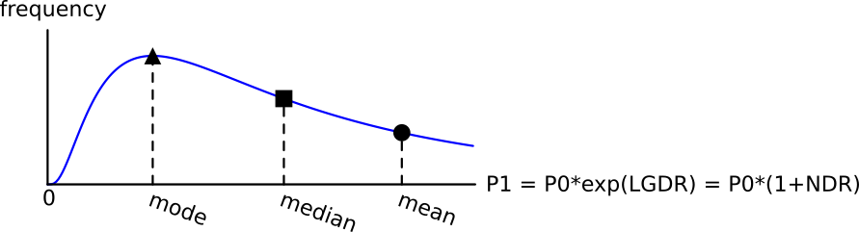

***GDR's are Log-Normally distributed***

Since gross discrete returns (GDR's) are linear functions of the price, they are also log-normally distributed.

GDR's have a left-most point of zero, same as prices.

$$GDR \sim lnN\left(mean, variance\right)$$

$$0≤{GDR}_{t→t+1}<∞$$

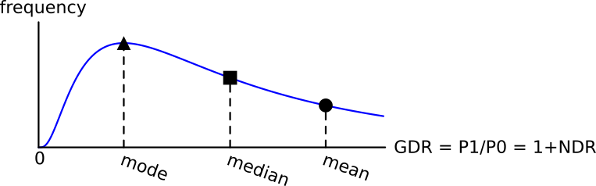

***NDR's are Log-Normally distributed***

Net discrete returns (NDR's, also known as effective returns) are equal to GDR’s minus 1, so they’re shifted to the left by one.

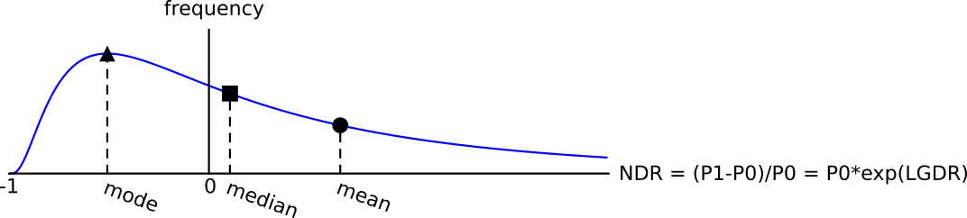NDR’s have a left-most point of negative one.

$$NDR \sim lnN\left(mean, variance\right)$$

$$-1≤{NDR}_{t→t+1}<∞$$

***LGDR's are Normally distributed***

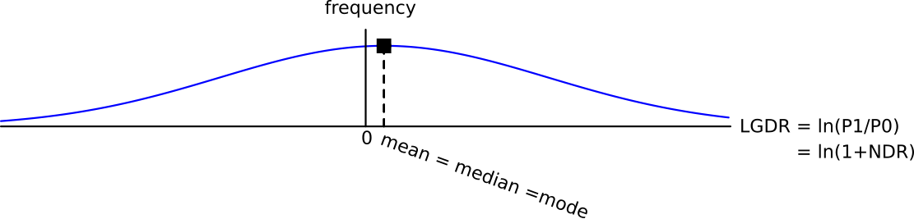Log gross discrete returns $\left(LGDR=\ln\left(\frac{p_{t}}{p_{0}}\right)\right)$ are normally distributed and they are unbounded in the positive and negative directions.

$$LGDR \sim N\left(mean, variance\right)$$

$$-∞≤{LGDR}_{t→t+1}<∞$$

***AAGDR = Mean GDR***

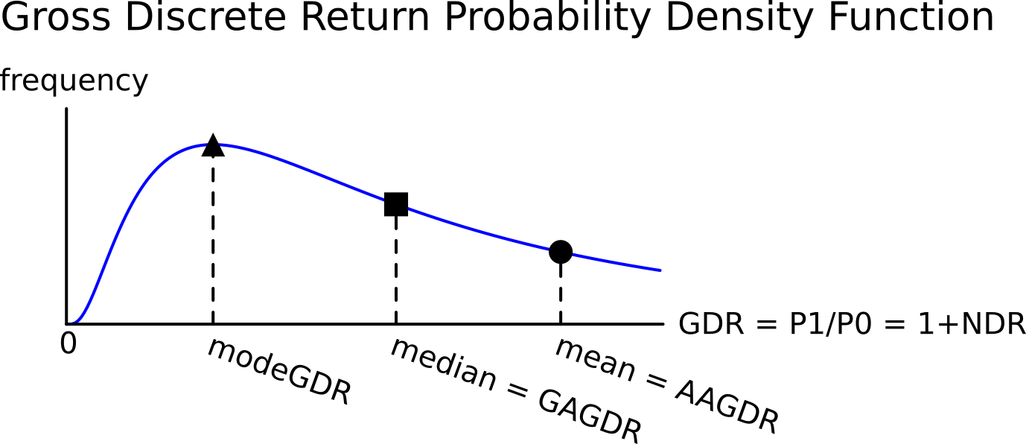Arithmetic average of the gross discrete returns (AAGDR) is the mean:

$${AAGDR}_{ 0→T}=\frac{1}{T}.\sum_{t=1}^{T}{\left(\frac{p_{t}}{p_{t-1}}\right)}$$

$$=\frac{\frac{p_{1}}{p_{0}}+\frac{p_{2}}{p_{1}}+…+\frac{p_{T}}{p_{T-1}}}{T}$$

$$=\frac{{GDR}_{0→1}+{GDR}_{1→2}+…+{GDR}_{T-1→T}}{T}$$

***GAGDR = Median GDR***

Geometric average of the gross discrete returns (GAGDR):

$$GAGDR_{0→T}={\left(\prod_{t=1}^{T}{\left(\frac{p_{t}}{p_{t-1}}\right)}\right)}^{\frac{1}{T}}$$

$$={\left({GDR}_{0→1}×{GDR}_{1→2}×…×{GDR}_{T-1→T}\right)}^{\frac{1}{T}}$$

$$={\left(\frac{p_{1}}{p_{0}}×\frac{p_{2}}{p_{1}}×\frac{p_{3}}{p_{2}}×…×\frac{p_{T}}{p_{T-1}}\right)}^{\frac{1}{T}}$$

$$={\left(\frac{p_{T}}{p_{0}}\right)}^{\frac{1}{T}}={\left(GDR_{0→T}\right) }^{\frac{1}{T}}$$

***LGAGDR = AALGDR = Mean, Median and Mode LGDR***

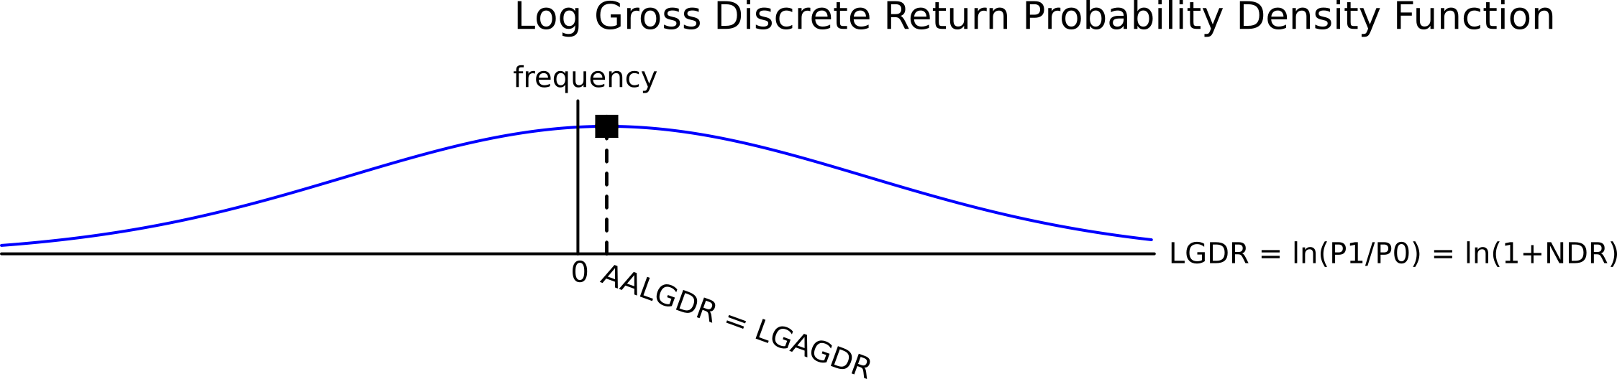The log of the geometric average of the gross discrete returns (LGAGDR) is:

$$LGAGDR_{0→T}=\ln\left({\left(\prod_{t=1}^{T}{\left(\frac{p_{t}}{p_{t-1}}\right)}\right)}^{\frac{1}{T}}\right)$$

$$=\frac{1}{T}.\ln\left(\frac{p_{T}}{p_{0}}\right)=\frac{1}{T}.\ln\left(GDR_{0→T}\right)$$

The log of the geometric average of the gross discrete returns (LGAGDR) equals the arithmetic average of the log gross discrete returns (AALGDR):

$$LGAGDR_{0→T}=\ln\left({\left(\prod_{t=1}^{T}{\left(\frac{p_{t}}{p_{t-1}}\right)}\right)}^{\frac{1}{T}}\right)$$

$$=\frac{1}{T}.ln\left(\frac{p_{1}}{p_{0}}×\frac{p_{2}}{p_{1}}×\frac{p_{3}}{p_{2}}×…×\frac{p_{T}}{p_{T-1}}\right)$$

$$=\frac{1}{T}.\left(\ln\left(\frac{p_{1}}{p_{0}}\right)+\ln\left(\frac{p_{2}}{p_{1}}\right)+\ln\left(\frac{p_{3}}{p_{2}}\right)+…+\ln\left(\frac{p_{T}}{p_{T-1}}\right)\right)$$

$$=\frac{1}{T}.\sum_{t=1}^{T}{\left(\ln\left(\frac{p_{t}}{p_{t-1}}\right)\right)} =AALGDR_{0→T}$$

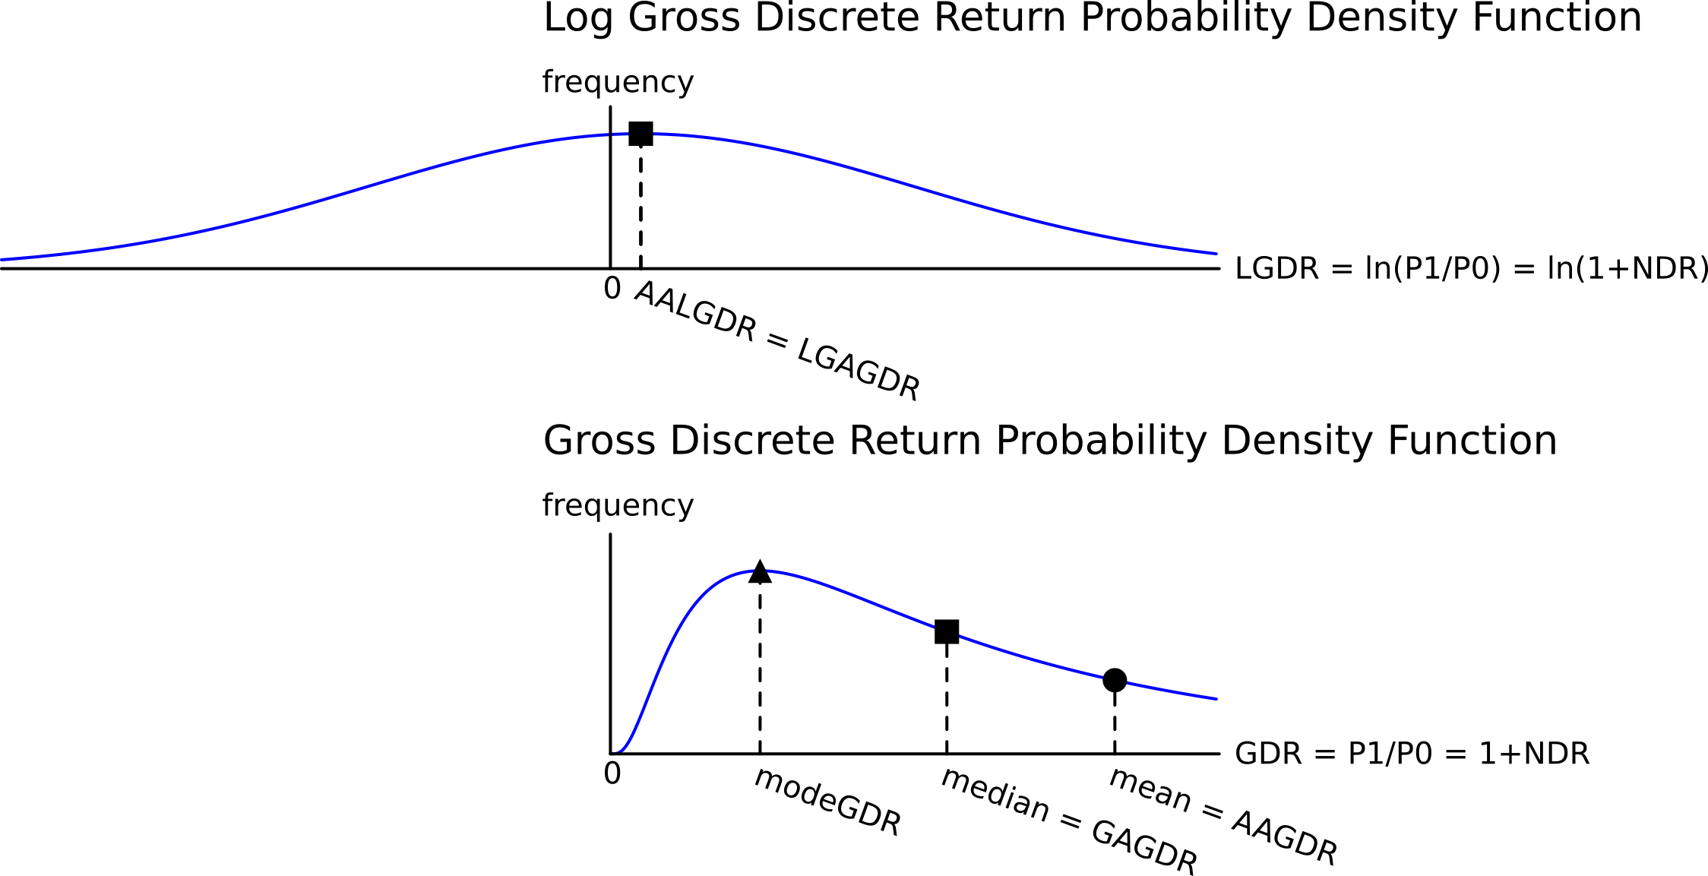

***SDLGDR***

The ***arithmetic*** standard deviation of the log gross discrete returns (SDLGDR) is defined as:

$$SDLGDR=σ=\sqrt{\frac{1}{T}.\sum_{t=1}^{T}{\left({\left(\ln\left(\frac{p_{t}}{p_{t-1}}\right)-AALGDR_{0→T}\right)}^{2}\right)}}$$

Since $AALGDR_{0→T}=LGAGDR_{0→T}=ln\left(GAGDR_{0→T}\right)$, then:

$$SDLGDR=\sqrt{\frac{1}{T}.\sum_{t=1}^{T}{\left({\left(\ln\left(\frac{GDR_{t-1→t}}{GAGDR_{0→T}}\right)\right)}^{2}\right)}}$$

The ***geometric*** standard deviation of the gross discrete returns is defined as the exponential of the ***arithmetic*** standard deviation of the ***log*** gross discrete returns (SDLGDR).

$$GeometricSDGDR=\exp\left(SDLGDR\right)$$

$=\exp\left(\sqrt{\frac{1}{T}.\sum_{t=1}^{T}{\left({\left(\ln\left(\frac{GDR_{t-1→t}}{GAGDR_{0→T}}\right)\right)}^{2}\right)}}\right)$

***AAGDR = exp(AALGDR + SDLGDR2/2)***

Another interesting relationship between the arithmetic average gross discrete return (AAGDR) and the arithmetic average of the log gross discrete return (AALGDR or continuously compounded return).

$$AAGDR=e^{AALGDR+\frac{SDLGDR^{2}}{2}}$$

$$=\exp\left(LGAGDR\right)×\exp\left(\frac{SDLGDR^{2}}{2}\right)$$

$$=GAGDR×\exp\left(\frac{SDLGDR^{2}}{2}\right)$$

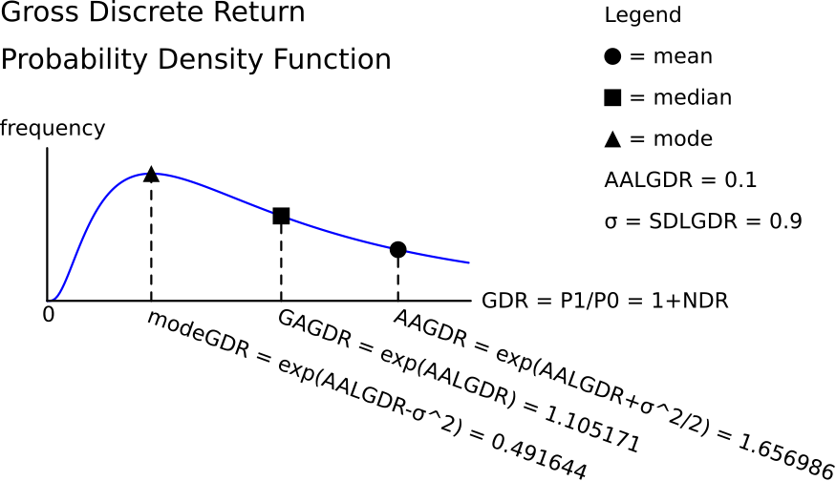

Some people prefer to write the expression without the exponential function by taking the logarithm of both sides:

$$AAGDR=e^{AALGDR+\frac{SDLGDR^{2}}{2}}$$

$$LAAGDR=AALGDR+\frac{SDLGDR^{2}}{2}$$

There is a difference between how the LAAGDR and AALGDR are calculated from prices:

$$LAAGDR=ln\left(\frac{1}{T}.\sum_{t=1}^{T}{\left(\frac{p_{t}}{p_{t-1}}\right)}\right)$$

$$AALGDR=\frac{1}{T}.\sum_{t=1}^{T}{\left(ln\left(\frac{p_{t}}{p_{t-1}}\right)\right)}=LGAGDR$$

Necessary assumptions:

* LGDR's (also called continuously compounded returns) must be normally distributed and therefore the GDR’s are log-normally distributed.
* If the returns (LGDR's) are of a portfolio, this equation only holds if the weights are continuously rebalanced.

***Mean GDR ≥ Median GDR***

$$AAGDR=GAGDR×\exp\left(\frac{SDLGDR^{2}}{2}\right)$$

This is equivalent to:

$$Mean GDR = Median GDR×exp\left(\frac{{SDLGDR}^{2}}{2}\right)$$

So the Mean GDR (or AAGDR) is always greater than or equal to the Median GDR (or GAGDR) because $exp\left(\frac{{SDLGDR}^{2}}{2}\right)$ is always greater than or equal to one.

$Mean GDR≥ Median GDR$ or $AAGDR≥ GAGDR$

This can be shown intuitively using a graph.

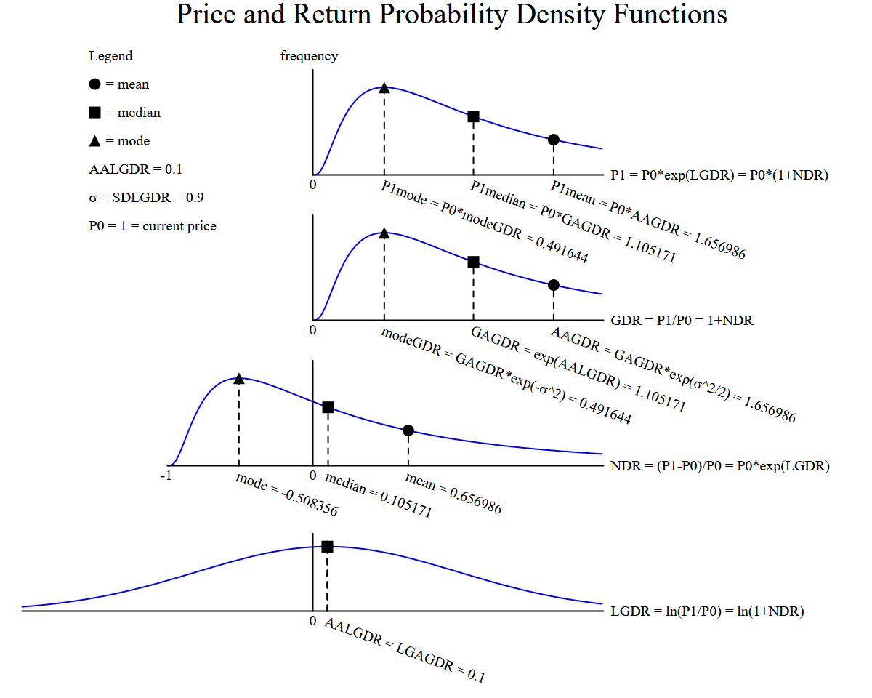



Image author: Olivier de La Grandville, from his book ‘Bond Pricing and Portfolio Analysis’, 2001.

***Why is this interesting?***

If future prices are log-normally distributed, the mean and median future prices will be different!



$$MeanP_{t}=P_{0}.e^{\left(AALGDR+\frac{{SDLGDR}^{2}}{2}\right).t}=P_{0}.AAGDR^{t}==P_{0}.{\left(1+AANDR\right)}^{t}$$

$$MedianP_{t}=P_{0}.e^{AALGDR.t}=P_{0}.AAGDR^{t}.e^{-\frac{SDLGDR^{2}}{2}.t}=P_{0}.{\left(1+AANDR\right)}^{t}/\exp\left(\frac{SDLGDR^{2}.t}{2}\right)$$

***Mean versus Median of a Log-normally distributed variable***

Due to the long right tail in the log-normal distribution, there are some very high values which increase the mean but have less effect on the median.

**The chance of achieving a GDR, NDR or price above the mean is less than 50%.**

The chance of achieving a return above the median is exactly 50% since the median is the 50th percentile.

***Time Weighted Average = GAGDR = Median GDR***

The ‘time-weighted average’ GDR or NDR is synonymous with the geometric average GDR or NDR.

Over time, the chance of achieving or exceeding the median price, GDR or NDR will always be 50%.

***Ensemble Average = AAGDR = Mean GDR***

Over time, the chance of achieving or exceeding the **mean** price, GDR or NDR will get smaller and smaller. As time approaches infinity, the chance will approach zero.

This makes sense because there are a small number of shares that will do exceptionally well. Think of Berkshire Hathaway, Google or Amazon which have had incredibly high returns. There is no limit to how high prices, GDR’s or NDR’s can go.

However, the lowest that prices and GDR’s can go is zero and NDR’s can’t get below minus 1 which is losing 100%.

The arithmetic average is pulled up by the small number of very high returns, while the median or geometric average, the ‘middle value’, is not affected as much.