FINAL EXAM – SPRING/2H SESSION 2016
School of Business

Complete your details in this section when instructed by the Exam Supervisor at the start of the exam.
You should also complete your details on any answer booklets provided.
STUDENT SURNAME:
STUDENT FIRST NAME:
STUDENT ID:

EXAM INSTRUCTIONS
Read all the information below and follow any instructions carefully before proceeding.
This exam is printed on both sides of the paper – ensure you answer all the questions.
You may begin writing when instructed by the Exam Supervisor at the start of the exam.
Clearly indicate which question you are answering on any Examination Answer Booklets used.
UNIT NAME: | Derivatives
UNIT NUMBER: | 200079
NUMBER OF QUESTIONS: | Part A has 5 questions, Part B has 5 questions.
VALUE OF QUESTIONS: | Part A questions are worth 2 marks each. Part B questions are worth 8 marks each. This totals to 50 marks.
ANSWERING QUESTIONS: | Part A: Answer multiple choice questions on the scan sheet provided.  Part B: Answer all other questions on the exam paper itself.
LECTURER/UNIT COORDINATOR: | Keith Woodward and Maria Varua
TIME ALLOWED: | 2 hours | TOTAL PAGES: | 15

RESOURCES ALLOWED
Only the resources listed below are allowed in this exam.
Any calculator which has the primary function of a calculator is allowed. For example, calculators on mobile phones or similar electronic devices are not allowed.

DO NOT TAKE THIS PAPER FROM THE EXAM ROOM

DO NOT TAKE THIS PAPER FROM THE EXAM ROOM

This page intentionally left blank

Part A
Note that the next 3 questions have the same answer options, but different questions.
Question 1: Which of the following derivative instruments has a zero value when it’s first agreed to?
*(a) Long futures contract.
(b) Out-of-the money European-style long call option.
(c) At-the-money European-style long call option.
(d) In-the-money European-style long call option.
(e) At-the-money American-style long put option.

Question 2: Which of the following derivative instrument positions require an initial deposit into a margin account?
*(a) Long futures contract.
(b) Out-of-the money European-style long call option.
(c) At-the-money European-style long call option.
(d) In-the-money European-style long call option.
(e) At-the-money American-style long put option.

Question 3: Which of the following derivative instrument positions could you exercise before maturity?
(a) Long futures contract.
(b) Out-of-the money European-style long call option.
(c) At-the-money European-style long call option.
(d) In-the-money European-style long call option.
*(e) At-the-money American-style long put option.

Question 4: Which of the following types of call or put options CANNOT be exactly priced using the Black-Scholes equation?
(a) European-style call or put options on non-dividend-paying paying stocks.
(b) European-style call or put options on dividend-paying paying stocks.
(c) American-style call or put options on non-dividend-paying paying stocks.
*(d) American-style call or put options on dividend-paying paying stocks.
(e) The Black-Scholes equation gives an exact price for all of the above types of options.

Question 5: Alice, Bob, Chris and Delta are traders in the futures market. The following trades occur over a single day in a newly-opened equity index future that matures in one year which the exchange just made available.
1. Alice buys 2 futures from Bob.
2. Chris buys 3 futures from Delta.
3. Bob buys 4 futures from Chris.
These were the only trades made in this equity index future. What is the open interest?
(a) 1 contracts.
(b) 2 contracts.
(c) 3 contracts.
*(d) 4 contracts.
(e) 5 contracts.

Part B
Question 1 (total of 8 marks): A stock index is expected to pay a continuously compounded dividend yield 4% pa for the foreseeable future. The index is currently at 5,000 points, the continuously compounded total required return is 9% p.a and its standard deviation of returns is 30% p.a.. An investor has just taken a long position in an 8-month call option contract on the index with a strike price of 5,100. Compute the call option price in index points using the Black-Scholes model.
Question 1a (3 marks): Calculate $d_{1}$.
*d1= 0.177713363

Question 1b (1 mark): Calculate $d_{2}$.
*d2= -0.067235611

Question 1c (1 mark): Calculate $N\left(d_{1}\right)$ using the tables in the back of this exam paper.
*N(d1)= 0.570525955

Question 1d (1 mark): Calculate $N\left(d_{2}\right)$ using the tables in the back of this exam paper.

*N(d2)= 0.473197068

Question 1e (2 marks): Calculate the call option price in index points.
*c0= 504.799859
Question 2 (8 marks): The below table summarises the borrowing costs confronting two companies.
Suppose Firm A wants to borrow at a floating rate and Firm B wishes to borrow fixed.
Design an intermediated swap that provides a bank with a spread of 30 basis points p.a., and gives the remaining swap benefits to firm A only.
Use a clearly labelled diagram to summarise the terms of the arrangement.

*Firm A has an absolute advantage in both the fixed and floating rate markets.
Firm A has a comparative advantage in the fixed rate market since it beats firm B by 1% compared to 0.1%.
Firm A should issue a fixed rate bond.
Firm B has a comparative advantage in the floating rate market because it’s less worse here.
Firm B should issue a floating rate bond.
The total benefit available to all 3 parties including the bank is the absolute value of the difference of differences which is:
TotalBenefitToABAndBank = |4-5 - (0.6-0.7)|% = |-1 - -0.1|% = |-0.9|% = 0.9%
Subtract the bank's spread to find the benefit to the banks:
TotalBenefitToAandB = 0.9% - 0.3% = 0.6%. Firm A gets all of this benefit.

A receives 4-0.6+0.6=4% B pays 5-0.7+0 =4.3%
A pays 4% Firm A Bank Firm B B pays L+0.7%
A pays LIB B receives LIB

Question 3 (total of 8 marks): Consider the below screen shot of the details of a European call option on Westpac Bank (WBC).

WESTPAC FPO [WBC] (ASX:WBC) | As of: 14/09/2016 3:54:46 PM
Last Price | Today's Change | Bid | Ask | Day High | Day Low | Volume
$29.140 | $0.440 (1.53%) | $29.130 | $29.140 | $29.280 | $28.560 | 6,395,293

WBCFG9 - $29.00 CALL OPTION EXPIRING 24/11/2016
Today's Last Price | Bid | Ask | Day High | Day Low | Volume | OI | ASXC Valuation | Theoretical Value
1.070 | 1.030 | 1.105 | 1.070 | 0.940 | 482 | 133 | 0.850 | 1.163

Buyers Sellers  Quantity Price # Price Quantity  450 1.030 1 1.105 150  150 1.000 2 1.155 150  150 0.990 3 1.180 300  150 0.925 4 1.215 300  150 0.920 5 1.225 150 | Last 5 Trades  Price Quantity Time  1.070 82 15:54:28  0.945 16 10:19:23  0.945 84 10:19:23  0.940 1 10:19:17  0.940 299 10:19:17

Question 3a (1 marks): What is the bid-ask spread on these options (not the underlying stock)?
*$0.075 (=(=1.105 – 1.03))

Question 3b (1 marks): What is your best estimate of the 'true price' of these call options?
*$1.0675 (=(1.105 + 1.03)/2)

Question 3c (1 marks): What is the best price that you could buy one call option contract when placing a market order? Be aware that one call option contract is on 100 shares and prices are listed on a per-share basis rather than a per contract basis.
*$1.105 on a per share basis or $110.50 since one call option contract is on 100 shares.

Question 3d (1 marks): How much money could you sell 600 call options for? (Note that in this question you are selling, in the previous question, you are buying).
*$61,350 (=((450*1.03)+(150*1))*100)

Question 3e (1 marks): What would be the implicit cost of selling these 600 call options, given your 'true price' answered above?
*$2,700 (=((450*(1.03-1.0675)) + 150*(1-1.0675))*100)

Question 3f (1 marks): Is this call option 'in-the-money' or 'out-of-the-money'?
*In the money.

Question 3g (1 marks): What’s more liquid, the stock or the option? Explain your answer.
*The stock is more liquid based on trading volume and bid-ask spread.

Question 3h (1 marks): If the CBA stock price were to suddenly rise, would you expect the call option price to rise, fall, or stay the same?
*Rise
Question 4 (total of 8 marks): Consider a 6 month European call option with a strike price of $5, written on a dividend paying stock currently trading at $5.50. The dividend is paid annually and the next dividend is expected to be $0.30, paid in 3 months. The risk-free interest rate is 5% p.a. continuously compounded and the standard deviation of the stock’s returns is 40% p.a..
Calculate the option price now (t=0) using either the no-arbitrage approach or the risk-neutral approach with a two-step binomial tree with 3 months per step. Remember that the option is European so it cannot be exercised before maturity. There are formulas on the formula sheet to help. You may wish to use the binomial tree below to work out the answer.

European |  |  | Stock
Call (1) or put (-1) | 1 |  | t=0 | t=3mths before div | t=3mths after div | t=6mths | t=6mths option payoff at maturity
T | 0.5 |  |  |  |  | 7.838615 | 2.838615
sd pa | 0.4 |  |  | 6.717715 | 6.417715
t | 0.25 |  |  |  |  | 5.254381 | 0.254381
Dt, one off paid at t only and not at end | 0.3 |  | 5.5
K | 5 |  |  |  |  | 5.133579 | 0.133579
r | 0.05 |  |  | 4.503019 | 4.203019
u | 1.221403 |  |  |  |  | 3.441141 | 0
d | 0.818731
prob | 0.481403 |  | Option
 |  |  | t=0 |  | t=3mths after div |  | t=6mths option payoff at maturity
 | 0.282843 |  |  |  |  |  | 2.838615
 | 0.012578 |  |  |  | 1.479826
 |  |  |  |  |  |  | 0.254381
 |  |  | 0.736069
 |  |  |  |  |  |  | 0.133579
 |  |  |  |  | 0.063507
 |  |  |  |  |  |  | 0

Question 5 (total of 8 marks): Suppose a stock currently trades at $100. The stock’s semi-annual dividend is expected to be $6, paid in 3 months from now. Assume a 10% continuously compounded risk-free rate.
Question 5a (3 marks): Calculate the futures price of a 6-month futures contract on this stock, as implied by the above information.

F_0.5 = (S_0*exp(r*3/12) - D_0.25)*exp(r*3/12)
=(100*exp(0.1*3/12) - 6)*exp(0.1*3/12)
=98.97521891

Question 5b (5 marks): If the fair futures price that you calculated above suddenly changed to $105 but all else was unchanged and there was no news about the company, then explain how you could conduct a risk-free arbitrage. Assume that the future is mis-priced. You're best able to show the steps using an arbitrage table.
Hint: Construct the arbitrage table by having some position in the physical mispriced future above and an offsetting position in a synthetic future. The synthetic future can be constructed using stocks and bonds.

*Short the physical future since it's overpriced. Long the synthetic future (=long stock, and short bond (borrow)) to balance out the risk.
Viewing the below amounts as investments (not cash flows) at time zero, then all positive investments are payments by us now which are buy (long) transactions and all negative investments are receipts to us now which are sell (short) transactions:
$$V_{0 LF synthetic}=S_{0}-\frac{K_{T}}{e^{r.T}}$$
LongSyntheticFuture = LongStock + ShortBond
To find the amounts of these assets that we need to long and short to make a risk free zero capital arbitrage, we'll use an arbitrage table. Note that this arbitrage table shows cash flows, not investments:

Action | t=0 | t=3mth | t=6mth
Short physical future | 0 |  | -(ST-105)
Long stock | -100 | 6 | ST
Short bond to cover dividend (borrow now) | 5.8519 (=6/exp(3/12*0.1))  (Step 4) | -6 (Step 3)
Short bond to bo(borrow now) | 99.87908957 (=105/exp(6/12*0.1)) (Step 5) |  | -105 (Step 2)
Total | 5.730949045  (Step 6) | 0 (Step 1) | 0 (Step 1)

Formulas
$$r_{continuously compounded}=ln⁡(1+r_{discrete})$$
$$P_{0}=\frac{P_{t}}{e^{{t.r}_{continuously compounded}}}$$
$$P_{0}=\frac{P_{t}}{{\left(1+r_{discrete}\right)}^{t}}$$
$$r_{discrete}=e^{r_{continuously compounded}}-1$$
$$h^{*}=ρ_{S,F}.\frac{σ_{S}}{σ_{F}}$$
$$N_{no tailing}^{*}=h^{*}.\frac{Q_{S}}{Q_{F}}$$
$$N_{tailing}^{*}=h^{*}.\frac{V_{S}}{V_{F}}$$
$$F=S_{0}.e^{r.T}$$
$$f_{0,long}=S_{0}-K.e^{-r.T}$$
$$f_{long}=-f_{short}$$
$$p=\frac{e^{rt}-d}{u-d}$$
$$u=e^{σ\sqrt{t}}$$
$$d=\frac{1}{u}=e^{-σ\sqrt{t}}$$
$$c_{0}+K.e^{-r.T}=p_{0}+S_{0}$$
$$c_{0}=S_{0}.N\left(d_{1}\right)-K.e^{-r.T}.N\left(d_{2}\right)$$
$$p_{0}=-S_{0}.N\left({-d}_{1}\right)+K.e^{-r.T}.N\left({-d}_{2}\right)$$
$$d_{1}=\frac{\ln\left(\frac{S_{0}}{K}\right)+\left(r+\frac{σ^{2}}{2}\right).T}{σ.T^{0.5}}$$
$$d_{2}=d_{1}-σ.T^{0.5}=\frac{\ln\left(\frac{S_{0}}{K}\right)+\left(r-\frac{σ^{2}}{2}\right).T}{σ.T^{0.5}}$$
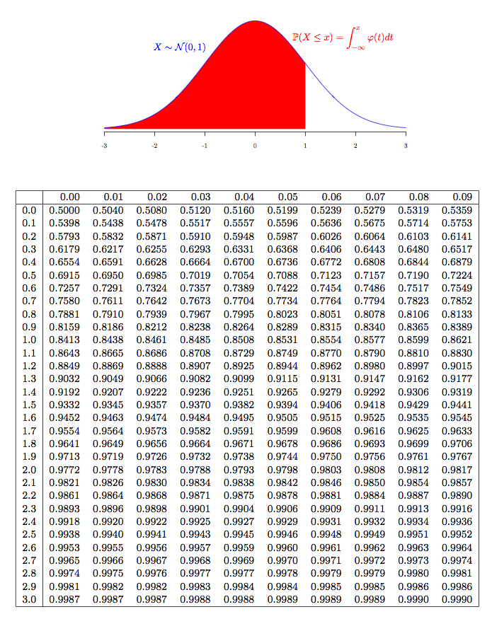

END OF EXAM PAPER

