FINAL EXAM – SPRING/2H SESSION 2017
School of Business

Complete your details in this section when instructed by the Exam Supervisor at the start of the exam.
You should also complete your details on any answer booklets provided.
STUDENT SURNAME:
STUDENT FIRST NAME:
STUDENT ID:

EXAM INSTRUCTIONS
Read all the information below and follow any instructions carefully before proceeding.
This exam is printed on both sides of the paper – ensure you answer all the questions.
You may begin writing when instructed by the Exam Supervisor at the start of the exam.
Clearly indicate which question you are answering on any Examination Answer Booklets used.
UNIT NAME: | Derivatives
UNIT NUMBER: | 200079
NUMBER OF QUESTIONS: | Part A has 5 questions, Part B has 5 questions.
VALUE OF QUESTIONS: | Part A questions are worth 2 marks each. Part B questions are worth 8 marks each. This totals to 50 marks.
ANSWERING QUESTIONS: | Part A: Answer multiple choice questions on the scan sheet provided.  Part B: Answer all other questions on the exam paper itself.
LECTURER/UNIT COORDINATOR: | Keith Woodward
TIME ALLOWED: | 2 hours | TOTAL PAGES: | 16

RESOURCES ALLOWED
Only the resources listed below are allowed in this exam.
Any calculator which has the primary function of a calculator is allowed. For example, calculators on mobile phones or similar electronic devices are not allowed.

DO NOT TAKE THIS PAPER FROM THE EXAM ROOM

This page intentionally left blank

Part A
Question 1: Which of the following instruments has a zero value (present value of future cash flows) when it’s first agreed to?
*(a) Futures contract.
(b) Call option contract
(c) Put option contract
(d) Stock contract

Question 2: Alice, Bob, Chris and Delta are traders in the futures market. The following trades occur over a single day in a newly-opened equity index future that matures in one year which the exchange just made available.
1. Alice buys 1 future from Bob.
2. Chris buys 2 futures from Delta.
3. Bob buys 3 futures from Chris.
These were the only trades made in this equity index future. What is the open interest?
(a) 1 contracts.
(b) 2 contracts.
*(c) 3 contracts.
(d) 4 contracts.
(e) 5 contracts.

Question 3: Calculate the appropriate hedge ratio for using oil futures to hedge against changes in the spot oil price. Over the last 3 years, the standard deviation of monthly changes in the spot and futures oil prices are $0.90 and $0.80 per barrel respectively. The correlation and covariance between the futures and the spot prices are 0.8125 and 0.585 respectively.
(a) 0.52
(b) 0.658125
(c) 0.722222
(d) 0.8125
*(e) 0.914063

Question 4: A spam meat manufacturer in the US is worried about the price of lean hogs rising and wants to lock in a price now. In one year the spam factory company intends to buy 2,000,000 pounds of hogs. CME futures on lean hogs that expire in one year have a notional principal of 40,000 pounds (about 18 metric tons) and currently trade at a price of 75.11 cents per pound. The underlying lean hogs spot price is 69.30 cents per pound. The correlation of the futures price and the underlying hogs price is 0.95 and the standard deviation of changes in the spot price and futures price is $0.41 and $0.42 per pound respectively. Ignore hedge tailing. The initial margin is USD1,500 and the maintenance margin is USD1,200 per futures contract. Which of the below statements is NOT correct?
(a) The meat manufacturer should buy futures to hedge against the danger of rising hog prices.
(b) The hedge ratio is 0.927380952, which means that if the futures price rises by 1 cent then the spot price would be expected to rise by 0.927380952 cents.
(c) The meat manufacturer should take the above position in 46 lean hogs futures contracts.
*(d) The meat manufacturer can only withdraw funds from her margin account if the futures price rises by more than 0.0075 cents per pound.
(e) The meat manufacturer will only receive a margin call from her broker if the futures price falls by more than 0.0075 cents per pound.

Question 5: Refer to the below table of Government bonds.
Which of the below statements about the zero rates and forward rates based on those zero rates is NOT correct?
(a) The 0.5 year zero coupon spot yield to maturity per annum compounding semi-annually is -0.01 pa.
*(b) The 1 year zero coupon spot yield to maturity per annum compounding semi-annually is 0.010211 pa.
(c) The 1.5 year zero coupon spot yield to maturity per annum compounding semi-annually is 0.010051 pa.
(d) The 0.5 to 1 year zero coupon forward rate per annum compounding semi-annually is 0.011884 pa.
(e) The 1 to 1.5 year zero coupon forward rate per annum compounding semi-annually is 0.028455 pa.

Part B
Question 1 (total of 8 marks): A stock index is expected to pay a continuously compounded dividend yield 5% pa for the foreseeable future. The index is currently at 5,800 points, the continuously compounded total required return is 8% p.a and its standard deviation of returns is 20% p.a.. An investor has just taken a long position in a one year futures contract on the index. Compute the futures price in index points.
Question 1a (4 marks):

*FT = S0*exp((r-q)*T)
F1=5800*exp((0.08-0.05)*1)
=5976.636297

Question 1b (4 marks): 7 months later, the stock index is 6100 points. Calculate the value of the long futures contract.

*V7mth = (S7*exp((r-q)*(12-7)/12) - K12)/exp(r*(12-7)/12)
= (6100*exp((0.08-0.05)*(12-7)/12) - 5976.636297)/exp(0.08*(12-7)/12)
=193.5324529
Question 2 (total of 8 marks): The below table summarises the borrowing costs confronting two companies.
Question 2a (6 marks): Suppose Firm A wants to borrow at a fixed rate and Firm B wishes to borrow floating.
Design a non-intermediated swap (so there’s no bank in the middle) that gives the swap benefits to Firm B only.
Use a clearly labelled diagram to summarise the terms of the arrangement.

*Firm B has an absolute advantage in the fixed rate market, while firm A has an absolute advantage in the floating rate market. Comparative advantages are the same in this case.
So Firm B should issue a fixed rate bond. Firm A should issue a fixed rate bond.
The total benefit available to both parties is the difference of differences which is:
TotalBenefitToAAndB = |(4-3) - (L+0.2-(L+0.5))| = |1 - - 0.3| = 1.3%
Firm B gets all of this benefit.

A pays 4-0.2+0=3.8% B receives 3-0.5+1.3=3.8%
A pays L+0.2% Firm A Firm B B pays 3%
A receives L B pays L

Question 2b (2 marks): If the LIBOR rate unexpectedly falls after Firm A and B sign the swap contract, who will gain from the swap contract (not from the physical bonds)? Firm A or B? Circle the correct answer:

Firm A, *Firm B, both or neither.
Question 3 (total of 8 marks): Consider the below screen shot of the details of a put option on NAB.

NABTB8 - $30.00 PUT OPTION EXPIRING 23/11/2017
Underlying Security Details: NAT. BANK FPO [NAB] (ASX:NAB) | As of: 15/09/2017 2:56:39PM

Last Price | Today's Change | Bid | Offer | Day High | Day Low | Volume
$30.860 | -$0.080 (-.26%) | $30.850 | $30.860 | $30.920 | $30.660 | 2,045,717

Today's Last Price | 1.25 | Bid | 0.880 | Theo  Price | 0.901
Today's  Change | 0.35 (38.89%) | Offer | 0.965 | Days To Expiry | 70
Open | 0 | Previous  Close | 0 | Shares per Contract | 100
Volume | 0 | Open  Interest | 203 | Today's  Range | 0 - 0
As at 15/09/2017 2:56:39 PM
Buyers |  |  | Sellers
Quantity | Price | # | Price | Quantity
700 | 0.880 | 1 | 0.965 | 250
200 | 0.850 | 2 | 1.030 | 200
400 | 0.775 | 3 | 1.045 | 200
0 | 0.000 | 4 | 1.075 | 400
0 | 0.000 | 5 | 0.000 | 0

Question 3a (1 marks): What is the bid-ask spread on these options (not the underlying stock)?
*$0.085 (=0.965 – 0.88)
Question 3b (1 marks): What is your best estimate of the 'true price' of these options?
*$0.9225 (=(0.965 + 0.88)/2)
Question 3c (1 marks): What is the best price that you could sell one option contract when placing a market order? Be aware that one call option contract is on 100 shares and prices are listed on a per-share basis rather than a per contract basis.
*$0.88 on a per share basis or $88.00 since one put option contract is on 100 shares.

Question 3d (1 marks): How much money could you buy 400 options for? (Note that in this question you are buying, while in the previous question you were selling).
*$39575 (=((250*0.965)+(150*1.03))*100)
Question 3e (1 marks): What would be the implicit cost of buying these 400 options, given your 'true price' answered above?
*$2675 (=((250*(0.965-0.9225)) + 150*(1.03-0.9225))*100)
Question 3f (1 marks): Is this put option 'in-the-money' or 'out-of-the-money'?
*Out of the money since S > K, 30.86 < 30.00.
Question 3g (1 marks): Calculate the bid-ask spread as a proportion of the mid-point price for both the option and the stock. Why is one much lower than the other?
*Option = 9.214% = 0.092140921 (=(0.965 - 0.88)/((0.965 + 0.88)/2))
Stock = 0.032% = 0.000324097 (=(30.86 - 30.85)/(30.86 + 30.85)/2))
Compared to the option, the stock is much more liquid. The bid-ask spread is much smaller so it’s cheaper to trade.
Question 3h (1 marks): If NAB were to go bankrupt, so the stock price were to fall to zero, would you expect the put option price to rise, fall, or stay the same?
*Rise.

Question 4 (total of 8 marks): Find the price of a 12 month American-style put option with a strike price of $95, written on a dividend paying stock currently trading at $100.
The dividend is paid annually and the next dividend is expected to be $4.5, paid in 6 months. The risk-free interest rate is 5% p.a. continuously compounded and the standard deviation of the stock’s returns is 20% p.a..
Calculate the option price now (t=0) using either the no-arbitrage approach or the risk-neutral approach with a two-step binomial tree with 6 months per step. Remember that the option is American-style so it can be exercised before maturity. You may wish to use the binomial tree below to work out the answer. Use up and down moves as given by these formulas where $t$ is 0.5 year time step:
$$u=e^{σ\sqrt{t}}$$
$$d=\frac{1}{u}$$

*Answer:
Question 5 (total of 8 marks): A 12 month European-style put option with a strike price of $95 is written on a dividend paying stock currently trading at $100.
The dividend is paid annually and the next dividend is expected to be $4.5, paid in 6 months. The risk-free interest rate is 5% p.a. continuously compounded and the standard deviation of the stock’s returns is 20% p.a..
Question 5a (3 marks): If a European call option with the same characteristics is currently trading at a price of $10.32, calculate the price of the put option now.

*Using put-call parity:
$$c_{0}+K_{T}.e^{-r.T}=p_{0}+\left(S_{0}-D_{0}\right)$$
$$p_{0}=c_{0}-\left(S_{0}-D_{0}\right)+K_{T}.e^{-r.T}$$
$$=c_{0}-\left(S_{0}-D_{0.5}.e^{-r×0.5}\right)+K_{T}.e^{-r×1}$$
=10.32 - (100-4.5*exp(-0.05*0.5)) + 95*exp(-0.05*1)
=5.076580766

Question 5b (5 marks): If the put option price in the market was actually $4, then explain how you could conduct a risk-free arbitrage. Assume that the put option is mis-priced. You're best able to show the steps using an arbitrage table.
Hint: Construct the arbitrage table by having some position in the physical mispriced put above and an offsetting position in a synthetic put. The synthetic put can be constructed using calls, stocks and bonds.

*Buy the physical put since it's underpriced. Short the synthetic put to balance out the risk.
Viewing the below amounts as investments (not cash flows) at time zero, then all positive investments are payments by us now which are buy (long) transactions and all negative investments are receipts to us now which are sell (short) transactions:
$$V_{0SP synthetic}=-p_{0}=-c_{0}+\left(S_{0}-D_{0}\right)-K_{T}.e^{-r.T}$$
ShortSyntheticPut = -LongCall + LongStock - LongBond
= ShortCall + LongStock + ShortBond
To find the amounts of these assets that we need to long and short to make a risk free zero capital arbitrage, we'll use an arbitrage table. Note that this arbitrage table shows cash flows, not investments:

Action | t=0 | t=0.5yr | t=1yr  S<K  S<95 | t=1yr  S>K  S>95
Long physical put | -4 |  | 95-S1 | 0
Short call | 10.32 |  | 0 | -(S1-95)
Long stock | -100 | 4.5 | S1 | S1
Short 1yr bond (borrow now) | 90.36679533 (=95/exp(0.05*1)) (Step 4) |  | (Step 2)  -95 | (Step 2)  -95
Short 0.5yr bond (borrow now) | 4.388894604 (=4.5/exp(0.05*0.5)) (Step 5) | (Step 3)  -4.5
Total | 1.075689932 (Step 7) | 0 (Step 1) | 0 (Step 1) | 0 (Step 1)

Formulas
$$r_{continuouslycompounded}=ln⁡\left(1+r_{discrete}\right)$$
$$P_{0}=\frac{P_{t}}{e^{{t.r}_{continuouslycompounded}}}$$
$$P_{0}=\frac{P_{t}}{{\left(1+r_{discrete}\right)}^{t}}$$
$$r_{discrete}=e^{r_{continuouslycompounded}}-1$$
$$h^{}=ρ_{S,F}.\frac{σ_{S}}{σ_{F}}$$
$$N_{notailing}^{}=h^{}.\frac{Q_{S}}{Q_{F}}$$
$$N_{tailing}^{}=h^{}.\frac{V_{S}}{V_{F}}$$
$$F=S_{0}.e^{r.T}$$
$$f_{0,long}=S_{0}-K.e^{-r.T}$$
$$f_{long}=-f_{short}$$
$$p=\frac{e^{rt}-d}{u-d}$$
$$u=e^{σ\sqrt{t}}$$
$$d=\frac{1}{u}=e^{-σ\sqrt{t}}$$
$$c_{0}+K.e^{-r.T}=p_{0}+S_{0}$$
$$c_{0}=S_{0}.N\left(d_{1}\right)-K.e^{-r.T}.N\left(d_{2}\right)$$
$$p_{0}=-S_{0}.N\left({-d}_{1}\right)+K.e^{-r.T}.N\left({-d}_{2}\right)$$
$$d_{1}=\frac{ln\left(\frac{S_{0}}{K}\right)+\left(r+\frac{σ^{2}}{2}\right).T}{σ.T^{0.5}}$$
$$d_{2}=d_{1}-σ.T^{0.5}=\frac{ln\left(\frac{S_{0}}{K}\right)+\left(r-\frac{σ^{2}}{2}\right).T}{σ.T^{0.5}}$$
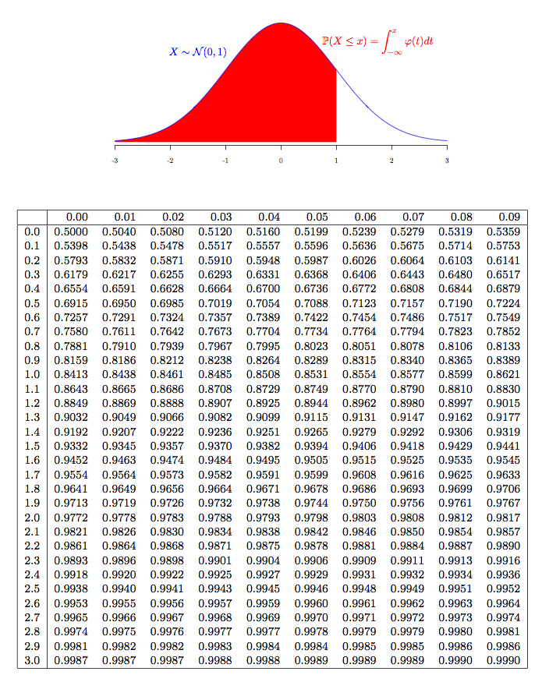

END OF EXAM PAPER

