***Present Value Formula Toolkit***

* Present values of:
  + Single cash flows.
  + Annuities.
  + Perpetuities.
* DDM.
* Multi stage growth model.
* Multiples valuation.
* Fungible assets.
* Equivalent annual cost (EAC).

***Present Value Formulas***





$$PV[single cash flow]=V_{0}=\frac{C_{t}}{{\left(1+r_{eff}\right)}^{t}}$$

$PV[annuity]=V_{0}=\frac{C_{1}}{r_{eff}}\left(1-\frac{1}{{\left(1+r_{eff}\right)}^{T}}\right)$

$$PV[perpetuity]=V_{0}=\frac{C_{1}}{r_{eff}-g_{eff}}$$

***Present Value of a Single Cash Flow***

$$PV[ single cash flow ]=V_{0}=\frac{C_{t}}{{\left(1+r\right)}^{t}}$$

Where:

$C_{t}=$ cash flow at time t.

$t=$ time periods.

$r=$ the effective rate over a single period.



***Calculation Example: Present Value of a Single Cash Flow***

**Question**: What is the present value of $100 received in 5 years when interest rates are 8% pa?

**Answer**:

$$V_{0}=\frac{C_{t}}{{\left(1+r\right)}^{t}}$$

$$=\frac{100}{{\left(1+0.08\right)}^{5}}$$

$$=68.0583$$

***Future Value of a Single Cash Flow***

$$FV[ single cash flow ]=V_{t}=C_{0}{\left(1+r\right)}^{t}$$

Where:

$C_{0}=$ cash flow now.

$t=$ time periods into the future.

$r=$ the effective rate over a single period.



***Calculation Example: Future Value of a Single Cash Flow***

**Question**: You have $100 in the bank. Interest rates are 8% pa. How much will you have in the bank after 5 years?

**Answer**:

$$V_{t}=C_{0}{\left(1+r\right)}^{t}$$

$$=100×{\left(1+0.08\right)}^{5}$$

$$=146.9328$$

***Calculation Example: Present and Future Values***

**Question**: If you pay this year's university fees of $5,000 now, the government will give you a 25% discount. Otherwise the government will lend you the $5,000, but will capitalise interest charges (add interest charges to the principal) at the rate of inflation which is expected to be 2.5% pa, compounding annually. When you start work, the government will demand repayment of your debt. You expect to start work and have to pay off all of your debt in a single payment in 6 years.

You can borrow and lend at 8% pa from and to the bank.

Should you pay your fees now or in 6 years?

**Answer**:

**Option 1**: Pay your uni fees now.

If you pay your fees now and receive the 25% discount, they will cost:

$$V_{0}=5,000×(1-0.25)$$

$$=3,750$$

**Option 2**: Pay your university fees in 6 years.

The future value of the uni fees in 6 years, growing at the inflation rate of 2.5% pa will be:

$$V_{t}=C_{0}{\left(1+r\right)}^{t}$$

$$V_{6}=5,000×{\left(1+0.025\right)}^{6}=5,798.4671$$

This is the amount that the government will demand for repayment. A naive person would compare this to the $3,750 and conclude that paying immediately is better, but that is wrong. The two amounts can't be compared since they are at different times. Values can only be compared at the same point in time.

The present value of $5,798.47 can be calculated and compared to the cost of paying the fees now.

$$V_{0}{\left(1+r\right)}^{t}=V_{6}$$

$$V_{0}{\left(1+0.08\right)}^{6}=5,798.4671$$

$$V_{0}=\frac{5,798.4671}{{\left(1+0.08\right)}^{6}}=3,654.0178$$

Therefore you should pay your fees in 6 years since it has a lower present value of costs.

***Present Value of an Annuity***

$$PV[annuity]=V_{0}=\frac{C_{1}}{r}\left(1-\frac{1}{{\left(1+r\right)}^{T}}\right)$$

Where:

$C_{1}=$ the cash flow received at $t=1$ and every period after until the last cash flow at $t=T$. All cash flows are equal to $C_{1}$, they don't grow.

$T=$ the number of cash flows. Some people prefer to use ‘n’ rather than ‘T’.

 $r=$ the effective rate over a single period.

$$PV[annuity]=V_{0}=\frac{C_{1}}{r}\left(1-\frac{1}{{\left(1+r\right)}^{T}}\right)$$

Note that $C_{1}$ is used instead of $C$ to remind you that the first cash flow is 1 period ahead of the present value $V_{0}$. The annuity formula does not include a cash flow at $t=0$.



***Calculation Example: Present Value of an Annuity***

**Question**: What is the value of receiving $10 for the next 5 years with the first payment one year from now? The interest rate is 10% pa.

**Answer**:

$$V_{0}=\frac{C_{1}}{r}\left(1-\frac{1}{{\left(1+r\right)}^{T}}\right)$$

$$=\frac{10}{0.1}\left(1-\frac{1}{{\left(1+0.1\right)}^{5}}\right)$$

$$=37.9079$$

***Questions: Annuities***

<http://www.fightfinance.com/?q=2,288,481,137,356,58,499,>

***Present Value of a Perpetuity***

The 'perpetuity with growth' formula finds the present value of periodic cash flows that continue forever.

This formula is also called the 'Gordon Growth Model' or the 'Dividend Discount Model' (DDM).

$$PV[perpetuity with growth]=P_{0}=\frac{C_{1}}{r-g}$$

$C_{1}=$**** dividend cash flow received at $t=1$. The dividend cash flows go on forever, but grow by $g$ every period.

$g=$ effective growth rate of the dividend over a single period.

$r=$ effective discount rate over a single period, also called the required return on equity.

Note that $C_{1}$ is used instead of $C$ to remind you that the first cash flow is 1 period ahead of the present value $V_{0}$. The perpetuity formula does not include a cash flow at $t=0$.

The cash flows grow by g forever:

$$C_{2}=C_{1}(1+g)$$

$$C_{3}=C_{1}{\left(1+g\right)}^{2}$$

$C_{4}=C_{1}{\left(1+g\right)}^{3}$ and so on.

Perpetuities with no growth are called level perpetuities. In this case, $g=0$ and $C_{1}=C_{2}=C_{3}$ and so on.

***Calculation Example: Present Value of a Perpetuity (with no growth)***

**Question**: Your friend promises to pay you $50 at the end of every year forever, if you lend him $400 now. Today is new year's day so the next payment will be in one year. Interest rates are 10% pa. Is this a good deal for you?

**Answer**: Your friend is offering you a perpetuity with no growth.

$$V_{0}=\frac{C_{1}}{r-g}$$

$$=\frac{50}{0.1-0}=500$$

$500 is more than $400 so it's a good deal.

But this is assuming that your friend actually does pay you forever even after he becomes old and senile. Assuming he stops paying you in 40 years, then the $50 will be an annuity:

$$V_{0}=\frac{C_{1}}{r}\left(1-\frac{1}{{\left(1+r\right)}^{T}}\right)$$

$$=\frac{50}{0.1}\left(1-\frac{1}{{\left(1+0.1\right)}^{40}}\right)$$

$$=488.9525$$

This is more than $400, so it's still a good deal.

***Calculation Example: Perpetuity***

**Question 1:** A start-up company is forecast to pay its first dividend of $1 per share in 5 years. From then on, this annual dividend will grow by 2% pa. The required return on the stock is 10% pa. All rates are given as effective annual rates. What is the value of the stock?

**Answer:** This question is slightly trickier than simply applying the DDM since the first cash flow is not 1 year away, it is 5 years away.

What we will do is value the stock using the DDM which will give a value at t=4, one year before the first dividend at t=5, then discount that price back to the present (t=0).

$$V_{0}=\frac{C_{1}}{r_{eff}-g_{eff}}$$

$$V_{4}=\frac{C_{5}}{r_{eff}-g_{eff}}$$

$$=\frac{1}{0.1-0.02}=12.50$$

But this is a value at t=4. To find the current price at t=0,

$$V_{0}=\frac{V_{4}}{{\left(1+r_{eff}\right)}^{4}}$$

$$=\frac{12.50}{{\left(1+0.1\right)}^{4}}=8.537668192$$

So the stock price should be $8.54 right now

***Dividend Discount Model (DDM)***

$$P_{t-1}=\frac{C_{t}}{r-g}$$

Some important assumptions that you need to be aware of:

* The price given by the formula will be one period before the first cash flow.
* The returns must be effective rates that have a period matching the frequency of the cash flows. So if the cash flow ($C_{t}$) is **annual**, then $r$ and $g$ must be effective **annual** rates.
* The constant dividend growth rate 'g' must occur in perpetuity (forever).
* $r$ is the total required return of the stock ($r_{total}$).

***Dividend Discount Model and Returns***

Re-arranging the DDM,

$$P_{0}=\frac{C_{1}}{r-g}$$

$$r = \frac{C_{1}}{P_{0}} + g$$

$$r_{total}=r_{income}+r_{capital}$$

This illustrates the surprising fact that the long term capital return of a stock should be equal to its dividend growth rate: $r_{capital}=g$.

Note that in the short term, $g$ is the stock's expected capital return as measured from just after a dividend payment to just after the next dividend payment (from trough to trough).

Similarly the expected capital return is $g$ as measured from just *before* a dividend payment to just *before* the next dividend payment (from peak to peak).

However, in between two consecutive dividend payments (from trough to peak), the expected capital return is $r$, not $g$. This stock must grow by the higher total required return $r$ to accumulate enough cash to pay its dividend, fall in price and still have grown by $g$ overall.

The dividend yield (or income return) is $\frac{C_{1}}{P_{0}}$**.*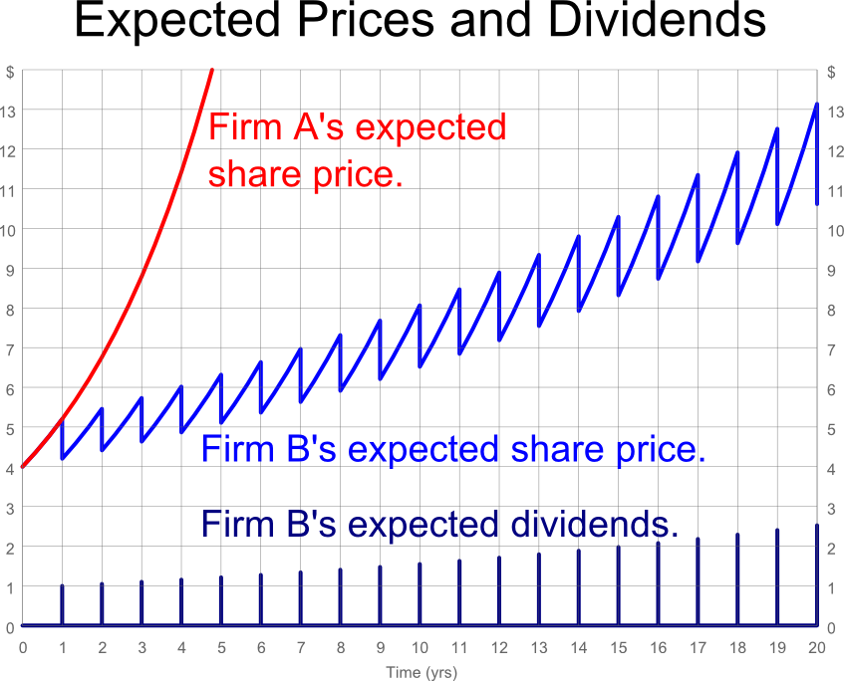***

***Expected Share Prices and Dividends***

Expected share prices and dividends of firms A and B are shown in the graph above. Both firms have a total expected return of 30% pa and a current (t=0) share price of $4.

Firm A pays no dividends, for at least the next 5 years. All of its free cash flows are reinvested to expand and grow its business which means that its capital return is 30% pa, equal to its total return.

Firm B has a dividend return of 25% pa, so the capital return is 5% pa. The growth rate of the dividend is also 5% pa. Firm B pays most of its cash flows out as dividends, and every time it pays a dividend its price falls.

Firm A and B’s share price and dividend graphs are not linear, they are curves that get steeper and steeper. We say that they grow exponentially. Albert Einstein is quoted as saying: “The strongest force in the universe is Compound Interest.”

Note that the share prices shown in the graph are expectations. The realization of the share prices will be different as investors’ expectations of future dividends and total returns change through time as news about the firm and the economy becomes available.

The realized share prices will be highly volatile, but they will still depict the familiar ‘exponential’ price growth graph.

***Dividend and Stock Price Growth Rates***

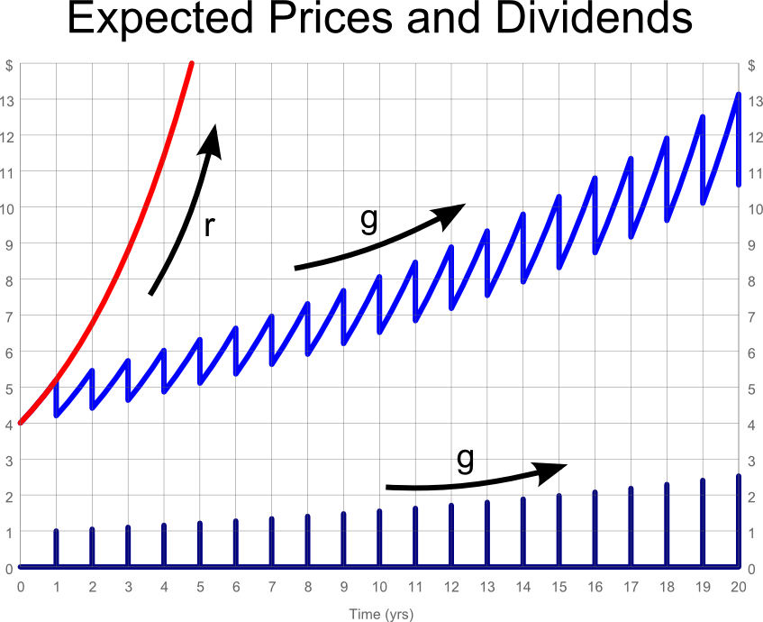The growth rate (g) of the stock price and the dividend should be equal in perpetuity if the assumptions of the DDM hold.

Of course, if the dividends are re-invested back into the stock, the growth rate will be the total return (r).

***Dividend Discount Model in Practice***

A common mistake when applying the DDM is to use a growth rate that is too high. Remember that the DDM’s dividend growth rate is **perpetual**, so it goes forever. Also, the dividend growth rate is the capital return (proportional price increase).

Say there is a stock, 'Growth Corp', that has a high average historical dividend growth rate of 7% pa. An inexperienced analyst forecasts that dividends will continue to grow at this high rate forever.

Since the average stock in the economy grows by approximately the level of GDP growth, which is around 5% pa, then Growth Corp will outgrow the average stock. But since this occurs in perpetuity, Growth Corp will take over the world since it is always getting bigger than the average firm forever.

So there is an upper limit on the **nominal** dividend growth rate. This limit is **nominal** GDP growth. Similarly for real growth rates.

***Calculation Examples: DDM***

**Question:** The Telstra (TLS) stock price is $**6**. Its next annual dividend of $**0.30** will be paid in exactly one year from now. Dividends are expected to grow by **2**% pa forever.

What is the stock's required return on equity, given as an effective annual rate?

**Answer:**

$$P_{0}=\frac{C_{1}}{r_{total}-g}$$

$$6=\frac{0.30}{r_{total}-0.02}$$

$$r_{total}=\frac{0.3}{6}+0.02$$

$$=0.07=7\% pa$$

**Question:** Estimate the future stock price in 2 years and 6 months (2.5 years).

**Answer:** We can use a number of methods to find the price. All are best visualised by following the path of the ‘saw tooth’ diagram of price versus time.

*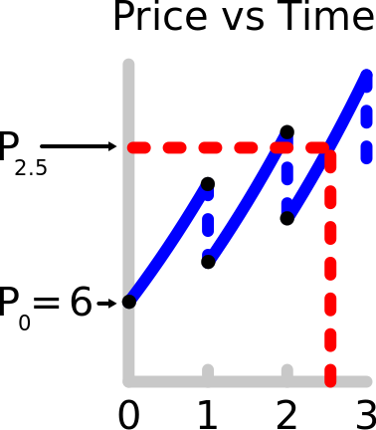Method 1:* Grow the current price by g from trough to trough for two periods, then by r for half a period from trough to peak.

$$P_{2.5}=P_{0}{\left(1+g\right)}^{2}{\left(1+r\right)}^{0.5}$$

$$=6{\left(1+0.02\right)}^{2}{\left(1+0.07\right)}^{0.5}$$

$$=6.457188769$$

*Method 2:* Grow the current price by r from trough to peak, then subtract the dividend, and repeat for another one and a half periods. Note that $C_{2}=C_{1}{\left(1+g\right)}^{1}$.

$$P_{2.5}=\left(\left(P_{0}{\left(1+r\right)}^{1}-C_{1}\right){\left(1+r\right)}^{1}-C_{2}\right){\left(1+r\right)}^{0.5}$$

$$=\left(\left(P_{0}{\left(1+r\right)}^{1}-C_{1}\right){\left(1+r\right)}^{1}-C_{1}{\left(1+g\right)}^{1}\right){\left(1+r\right)}^{0.5}$$

$$=\left(\left(6{\left(1+0.07\right)}^{1}-0.30\right){\left(1+0.07\right)}^{1}-0.30{\left(1+0.02\right)}^{1}\right){\left(1+0.07\right)}^{0.5}$$

$$=6.457188769$$

*Method 3:* The price in 2.5 periods will be the price in 2 periods, grown forward from trough to peak by r for half a period.

$$P_{2.5}=P_{2}{\left(1+r\right)}^{0.5}$$

$$=\frac{C_{3}}{r-g}{\left(1+r\right)}^{0.5}$$

$$=\frac{C_{1}{\left(1+g\right)}^{2}}{r-g}{\left(1+r\right)}^{0.5}$$

$$=\frac{0.30{\left(1+0.02\right)}^{2}}{0.07-0.02}{\left(1+0.07\right)}^{0.5}$$

$$=6.457188769$$

***Questions: Dividend Discount Model***

<http://www.fightfinance.com/?q=479,3,4,451,7,28,201,216,497,217,264,289,352,31,161,36,39,40,41,148,158,441,51,50,270,488,465,>

***Multi-Stage Growth Model***

To value a growing business's equity, practitioners often use a 'two-stage growth model'. For example,

**Question:** A dividend of $10 was just paid. Dividends are forecast to increase at a high rate of 7% pa for the first 3 years (t=0 to 3) and then revert to a lower rate of 2% (inflation) forever after that (t=3 to infinity). The required return on equity is 10% pa. What should be the share price?

**Answer:** The basic idea is to discount the high growth years individually, then discount the 'terminal value' at the end. In the finance industry, the terminal value might be calculated using the DDM as we did here, or it might be calculated using a multiples approach such as using PE ratios (see the addendum slides), or even an average of the two. Note that the $10 dividend just paid is excluded since it's in the past.

$$P_{0}=\frac{C_{1}}{{\left(1+r\right)}^{1}}+\frac{C_{2}}{{\left(1+r\right)}^{2}}+\frac{\left(\frac{C_{3}}{r-g_{low}}\right)}{{\left(1+r\right)}^{2}}$$

$$=\frac{C_{0}{\left(1+g_{high}\right)}^{1}}{{\left(1+r\right)}^{1}}+\frac{C_{0}{\left(1+g_{high}\right)}^{2}}{{\left(1+r\right)}^{2}}+\frac{\left(\frac{C_{0}{\left(1+g_{high}\right)}^{3}}{r-g_{low}}\right)}{{\left(1+r\right)}^{2}}$$

$$=\frac{10{\left(1+0.07\right)}^{1}}{{\left(1+0.1\right)}^{1}}+\frac{10{\left(1+0.07\right)}^{2}}{{\left(1+0.1\right)}^{2}}+\frac{\left(\frac{10{\left(1+0.07\right)}^{3}}{0.1-0.02}\right)}{{\left(1+0.1\right)}^{2}}$$

$$=145.7432851$$

Note that the second line above:

$$P_{0}=\frac{C_{0}{\left(1+g_{high}\right)}^{1}}{{\left(1+r\right)}^{1}}+\frac{C_{0}{\left(1+g_{high}\right)}^{2}}{{\left(1+r\right)}^{2}}+\frac{\left(\frac{C_{0}{\left(1+g_{high}\right)}^{3}}{r-g_{low}}\right)}{{\left(1+r\right)}^{2}}$$

is equivalent to this:

$$P_{0}=\frac{C_{0}{\left(1+g_{high}\right)}^{1}}{{\left(1+r\right)}^{1}}+\frac{C_{0}{\left(1+g_{high}\right)}^{2}}{{\left(1+r\right)}^{2}}+\frac{C_{0}{\left(1+g_{high}\right)}^{3}}{{\left(1+r\right)}^{3}}+\frac{\left(\frac{C_{0}{\left(1+g_{high}\right)}^{3}{\left(1+g_{low}\right)}^{1}}{r-g_{low}}\right)}{{\left(1+r\right)}^{3}}$$

and both will give the same answer.

***Questions: Multi-stage growth model***

<http://www.fightfinance.com/?q=217,498,>

***Multiples Valuation***

Multiples valuation is the preferred method to value stocks amongst practitioners in the finance industry. There are many different multiples that are used, some of the most common are:

* Share Price/Earnings (PE) ratio,
* Enterprise Value/EBITDA (EV/EBITDA) ratio
* Book value of equity/Market value of equity (Book to market) ratio
* Share Price/ Sales (Price to sales) ratio
* (Share Price/Earnings)/Earnings growth (PEG) ratio

We'll focus on the 'Price to Earnings' or PE ratio.

***Earnings Per Share (EPS) Calculation***

Earnings per share is reported in companies’ financial reports. It is the total earnings of the firm divided by the total number of shares.

$$EPS=\frac{Total earnings}{number of shares}=\frac{NI}{n_{shares}}$$

Note that earnings are an American term for Net Income (NI) or Net Profit After Tax (NPAT).

***PE Ratio Calculation***

The PE ratio can be calculated in two different ways which give the same answer:

$$PE ratio=\frac{share price}{EPS}=\frac{P_{share}}{EPS}$$

If we multiply the top and bottom of the fraction by the total number of shares, then the denominator will be total earnings, and the numerator will be the market capitalisation of equity (E, as in V=D+E) which is the price of buying all shares ($E=n_{shares}.P_{share}$).

$$PE ratio=\frac{market capitalisation of equity}{total earnings}=\frac{E}{NI}$$

***Price-Earnings Ratio Valuation***

How to calculate stock XYZ's market capitalisation of equity using the price-earnings multiple (or PE ratio) approach:

* Make a list of similar firms from the same industry as XYZ with the same levels of risk and leverage (ratio of debt to assets).
* Calculate each similar firm's PE ratio by dividing its current share price by its earnings per share last year (historical EPS). Calculate the average of all of the similar firms' PE ratios. If any firms had negative EPS or EPS close to zero, then their PE ratios will be negative or extremely large so they should be excluded from the average.
* Multiply XYZ's EPS last year by the average PE ratio of similar firms. This will give the share price of XYZ now. Multiplying by the number of shares gives XYZ’s market capitalisation of equity.

***Backward versus Forward Looking PE Ratios***

In the above steps we valued our firm using 'backward looking' PE ratios since we used last year’s EPS, also known as ‘historical’ EPS. This gives PE ratios which are accurate but stale since they reflect the past, not the future which is what we're interested in.

Another way of doing PE ratio valuation is to use 'forward-looking' PE ratios by using next year's expected EPS which are more useful, but less accurate because. They are less accurate because next year's EPS is unknown so they are usually based on analysts' forecasts which can vary widely.

***Calculation Example: Multiples Valuation***

**Question:** Estimate Westpac Bank's (WBC) **share price** using the comparable firms in the table.

|  |  |  |  |  |
| --- | --- | --- | --- | --- |
| Australian Banks' Financial Details as at 28/2/14 | | | | |
|  | ANZ | CBA | NAB | WBC |
| Share price ($) | 32.14 | 74.66 | 34.74 | ? |
| Historical EPS ($) | 2.24 | 4.94 | 2.26 | 2.15 |
| Number of shares (billion) | 2.72 | 1.61 | 2.29 | 3.10 |
| Market cap of equity ($ billion) | 87.42 | 120.20 | 79.55 | ? |
| Historical net income ($ billion) | 6.09 | 7.95 | 5.18 | ? |
| PE ratio, backward looking | 14.35 | 15.11 | 15.37 | ? |
| *Source: Google Finance.* |  |  |  |  |
|  |  |  |  |  |

**Answer:** The other major Australian banks are comparable to Westpac so a PE ratio approach will work. Westpac's estimated share price equals the average of the comparable firms' PE ratios, all multiplied by Westpac's earnings per share:

$$P_{WBC}=Average of comparable {firms}^{'} PE ratios×{EPS}_{WBC}$$

$$=\frac{14.35+15.11+15.37}{3}×\$2.15$$

$$=14.9433×\$2.15=\$32.13$$

This is very close to Westpac's actual share price on 28/2/14 of $**33.47**. In this case the PE multiple approach to valuation has done a good job, probably because the 4 major Australian banks are so similar.

***Reconciling DCF and PE-Ratio Valuation***

Discounted Cash Flow (DCF) valuation and Price/Earnings (PE) ratio valuation can be seen as two sides of the same coin.

Assume that a firm pays out all of its earnings as dividends. In this case, there will be no ***real*** growth in earnings, dividends or stock price since there is no re-investment back into the firm to buy new assets and make higher earnings. Note that ***nominal*** growth will be equal to inflation.

Applying the Dividend Discount Model (DDM) and assuming that cash flows and discount rates are ***nominal***:

$$P_{0}=\frac{C_{1}}{r-g}$$

Because the dividend cash flow ($C_{1}$) equals earnings (earnings per share, ${EPS}_{1}$),

$$P_{0}=\frac{{EPS}_{1}}{r-g}$$

Re-arranging,

$$\frac{P_{0}}{{EPS}_{1}}=\frac{1}{r-g}$$

The left hand side of this equation is actually the forward-looking PE ratio formula, it's the ratio the current share price (at t=0) to next year's earnings (at t=1).

So the forward-looking PE ratio can be seen as 1/(r-g), the inverse of the nominal dividend yield which (since g is inflation) is also the real total required return on equity.

If earnings equal dividends ($EPS=C$), then the **multiples** approach:

$$P_{0}={EPS}_{1}×(Average of comparable {firms}^{'} PE ratios)$$

Is equivalent to the **dividend discount model** approach:

$$P_{0}={EPS}_{1}×\left(\frac{1}{r-g}\right)$$

In the listed stock market, PE ratios are generally around **15.** This makes sense because judging by history, the market portfolio's nominal total required return is around 10%, inflation 3%, so the real total required return is expected to be around 7% and (1/0.07) is approximately **15**.

The historical Price-Earnings graph on the next slide was used by Robert Shiller in his famous book 'Irrational Exuberance', published in the same month as the dot-com bust in March 2000. Shiller argued that there was a stock market bubble because PE ratios were too high. 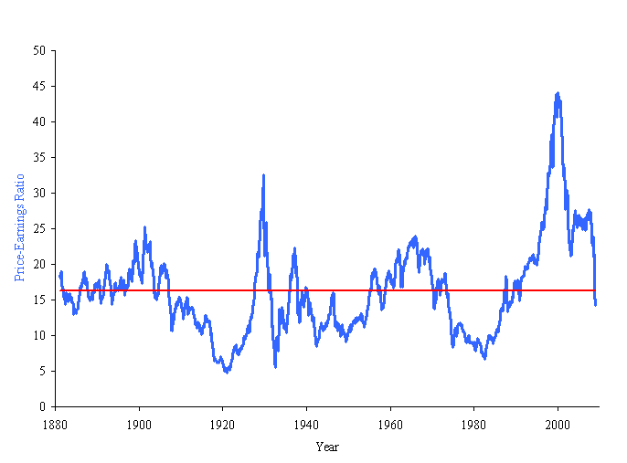

***Why Firms Have Different PE ratios***

There are many reasons why PE ratios vary between firms:

* Growth stocks tend to have **high** PE ratios. This is because their earnings are low now but are expected to grow significantly in the future. Therefore the current share price is high (since it's the PV of future high earnings) and next year's expected earnings are low.
* Stocks with high systematic risk tend to have **low** PE ratios. This is because their required return is high so the present value of their cash flows (price) is low.
* Illiquid stocks tend to have **low** PE ratios. This is because the stocks take a long time to sell or have high transaction costs such as brokerage or taxes. Potential buyers know that if they want to sell later on then they will suffer these significant costs. So they are only willing to buy at a low price now to make up for those costs later on.

***Questions: Multiples Valuation***

<http://www.fightfinance.com/?q=348,358,341,347,354,357,364,457,463,>

***Fungible Asset Classes***

Shares in a publically listed firm are all the same, so we say that the shares are fungible. Fungible assets all have the same price and they are interchangeable.

Shares, bonds, bills and standardised derivatives like options and futures are all fungible asset classes.

For example, BHP's common shares are fungible. An investor does not care which BHP share he owns since each BHP share will receive the same dividends, have the same voting rights, and in the event of insolvency will receive an equal residual value of the firm's assets once all debts are paid.

Fungible assets tend to

* be exchange-traded since they are a standardised product.
* be more liquid, which means that they are easier to sell in terms of cost and time required.
* have a more certain (or at least easily observed) price since they trade frequently.

***Non-fungible Asset Classes***

Individual assets are unique if they belong to a non-fungible asset class. No two assets are the same and therefore trade at different prices.

Property such as real estate is not fungible. Each piece of land is different in terms of location, size, government zoning, access, view, noise levels, aspect, rainfall, smell, and so on and each will have a different price.

Loans are not fungible since each has a different borrower, face value, coupon rate, price, yield, seniority, collateral, maturity, and so on.

Non-fungible assets tend to be:

* Traded Over-The-Counter (OTC), which means that buyers and sellers negotiate literally over a counter at a bank, or more likely by phone, email or in person at an auction;
* Less liquid in terms of cost and time. For example, selling a house is usually done through a real estate agent who takes around 3% of the sale price and might take a few months to sell;
* Cheaper and have higher required returns since they are less liquid compared to an equivalent fungible exchange-traded asset. You will notice that small private companies sometimes sell at price-to-earnings ratios (PE ratios) as low as 2, compared to listed stocks’ 15. However, this comparison ignores their different risks.

***Valuation***

Valuation is an important and interesting part of this course.

There are 3 ways to think about valuation. They are:

* Discounted Cash Flow (DCF) valuation,
* Multiples or Comparables valuation,
* Option valuation.

All assets including debt, equity and real estate can be valued using these techniques.

Note that an asset has just one price but many valuations by all of the different buyers and sellers. The price is actually the intersection of the supply and demand curves for the asset. The demand and supply curves are constructed using the buyers' and sellers' valuations respectively.

DCF is also called 'net present value' or 'discounted expected value'. Arguably DCF is the most important and multiples and option valuation are just variations of the same theme.

DCF has 3 main parts: the formulas, the cash flows and the required returns.

***DCF Valuation Overview***

* Same as Net Present Value (NPV) of cash flows.
* Preferred when future cash flows are predictable and the required return can be easily calculated.
* Debt securities, real estate with stable rental income and stable low-growth stocks are suitable for DCF valuation.
* More of an absolute or intrinsic valuation technique, as opposed to a relative valuation technique.
* Solid mathematical foundation and theory, favoured by academics.

***Multiples Valuation Overview***

* Relative valuation technique. Prices assets using the prices of other, similar assets.
* Many different types of multiples can be used.
* Simple, intuitive, based on real-world prices.
* Preferred when future cash flows are unpredictable, and when there are many similar assets that are frequently traded at observable prices, such as stocks trading on a stock exchange.
* Real estate and stocks are suitable for multiples valuation.

***NPV and Projects with Different Lives***

How do we choose between mutually exclusive projects when one ends before the other? For example, there are two machines that do the same job and the expensive machine lasts for longer than the cheap one. Which do you choose?

**Wrong method 1:** Choose the machine with the lowest present value of costs. Wrong because obviously the cheap machine will always appear better even though it lasts for less time.

**Wrong method 2:** Divide each machine's present value of costs by the number of years it lasts for. Wrong because it ignores the time value of money, it is an accounting way of thinking. It is spreading the present value of costs, which is an amount now, across years in the future which should actually be grown to account for the time value of money.

***Equivalent Annual Cost (EAC)***

**Correct method:** Find the present value of each machine's costs. Then calculate the Equivalent Annual Cost (EAC) using the annuity formula which spreads the costs into equal payments over the life of each machine, taking timing into account. Choose the machine with the lowest EAC.

This method implicitly assumes that whichever machine the firm chooses, it will keep buying identical machines to replace the previous one forever. This is known as ‘constant chain of replacement’.

$$PV[annuity]=V_{0}=\frac{C_{1}}{r}\left(1-\frac{1}{{\left(1+r\right)}^{T}}\right)$$

$$V_{0}=C_{1}×\frac{1}{r}\left(1-\frac{1}{{\left(1+r\right)}^{T}}\right)$$

$$V_{0}=C_{1}×AnnuityFactor[r,T]$$

So $V_{0}$ will be the NPV of all future costs, $C_{1}$ will be the equivalent annual cost, and the annuity factor which depends on the effective discount rate per period *r* and the number of periods T.

$$NPV[all costs] =EAC×AnnuityFactor[r,T]$$

$$EAC=\frac{NPV[all costs]}{AnnuityFactor[r,T]}=\frac{V_{0}}{\frac{1}{r}\left(1-\frac{1}{{\left(1+r\right)}^{T}}\right)}$$

***Calculation Example: EAC***

**Question 7:** You estimate the following cash flows from buying, maintaining and selling two different old cars. Which one is the better choice if the discount rate is 10%? Ignore taxes and assume 'constant chain of replacement'.

|  |  |  |
| --- | --- | --- |
|  | Cash Flows ($) | |
| Time | Toyota Camry | Holden Commodore |
| 0 | -1800 | -3500 |
| 1 | -500 | -400 |
| 2 | -500 | -400 |
| 3 | -500 | -400 |
| 4 | -500 | -400 |
| 5 | +50 | -400 |
| 6 |  | -400 |
| 7 |  | +1500 |

**Answer:**

First find the total NPV of each car's costs:

$$V_{0, toyota}= -1800 - \frac{500}{0.1}\left(1 –\frac{1}{{\left(1+0.1\right)}^{4}}\right)+\frac{50}{{\left(1+0.1\right)}^{5}}$$

$$= -3,353.90$$

$$V_{0, holden}= -3500 - \frac{400}{0.1}\left(1 –\frac{1}{{\left(1+0.1\right)}^{6}}\right) +\frac{1500}{{\left(1+0.1\right)}^{7}}$$

$$= -4,472.40$$

Now find the equivalent annual costs.

**For the Toyota:**

$$-3,353.90=\frac{C_{1,toyota} }{0.1}\left(1-\frac{1}{{\left(1+0.1\right)}^{5}}\right)$$

$$C_{1,toyota}=-884.75$$

So 884.75 is the Toyota's equivalent annual cost.

**For the Holden:**

$$-4,472.40 =\frac{C_{1,holden} }{0.1}\left(1-\frac{1}{{\left(1+0.1\right)}^{7}}\right)$$

$$C_{1,holden}=-918.65$$

So 918.65 is the Holden's equivalent annual cost.

Choose the Toyota since it has a lower equivalent annual cost.

***Questions: Equivalent Annual Cash Flow***

<http://www.fightfinance.com/?q=505,180,211,195,299,215,249,281,280,462,>